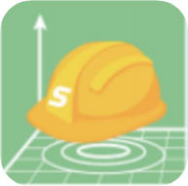

**SingularPad**

**Surveying Software**

**User Guide**

*V1.04, modified on 2024.08.16*

Proprietary Notice

Information in this document is subject to change without notice and does not represent a commitment on the part of SingularXYZ Intelligent Technology Ltd. The software described in this document is furnished under a license agreement or non-disclosure agreement. The software may be used or copied only in accordance with the terms of the agreement. It is against the law to copy the software on any medium except as specifically allowed in the license or non-disclosure agreement.

No part of this manual may be reproduced or transmitted in any form or by any means, electronic or mechanical, including photocopying and recording, for any purpose without the express written permission of a duly authorized representative of SingularXYZ Intelligent Technology Ltd.

Corporate Office

SingularXYZ Intelligent Technology Ltd.

Address: Floor 2, Building A, No. 599 Gaojing Road, 201702 Shanghai, China Tel: +86-

21-60835489

Fax: +86-21-60835497

Website:[https://www.singularxyz.com](https://www.singularxyz.com/)

E-mail:[singularxyz@singularxyz.com](mailto:singularxyz@singularxyz.com)

**Technical Assistant**

If you have any questions that can’t be solved in this manual, please contact your local SingularXYZ

distribution partner. Alternatively, request technical support from SingularXYZ Intelligent Technology Ltd.

Support Email: [support@singularxyz.com](mailto:support@singularxyz.com)

Support Skype: [Support.SingularXYZ](https://join.skype.com/invite/uYy6GDGZyNjU)

Your feedback on this manual will help us improve it with future revisions.

©2021 SingularXYZ Intelligent Technology Ltd. All rights reser

**CONTENTS**

目录

1 Introduction 1

1.1 Installation environments 1

2 User Interface 2

2.1 Project interface 3

2.2 Device interface 3

2.3 Survey Interface 3

2.4 Tool Interface 4

2.5 Floating Window 5

2.6 RTK WorkFlow 6

3 Project 6

3.1 Create Project 6

3.2 Connect receiver 8

3.3 Quick setup your receiver 10

3.3.1 Start your receiver as Base 11

3.3.2 Start your receiver as Rover 12

4 RTK Survey-field Data Collect 14

4.1 Point survey 14

4.2 Detail survey 17

4.3 Control point survey 18

4.4 Point stakeout 18

4.5 Line stakeout 20

4.6 CAD mapping and stakeout 22

4.7 Line stakeout 24

4.8 DSM stakeout 25

4.9 Stakeout road 26

4.9.1 Broken Mileage 27

4.9.2 Centerline 28

4.9.3 Vertical Profile 33

4.9.4 Standard cross section 34

4.9.5 Slope data 36

4.9.6 Bridges and Culverts 36

4.9.7 Conical Slope 37

4.9.8 Road stakeout 37

4.9.9 Electric Line Survey 40

4.10 Points database 44

4.11 Data export/import 45

4.11.1 Import points data 45

4.11.2 Export points data 47

5 Total Station 49

5.1 Connect to total station 49

5.2 Set station 50

# Introduction

SingularPad is professional Android-based surveying software developed by SingularXYZ Intelligent Technology Ltd. SingularPad is fully functional as a field surveying software, equipped with complete work modes and necessary functions for surveyors. Projection/datum configuration, GSM/radio/PDA CORS work modes, point survey/stake out/CAD sketch/COGO calculation and etc. can all be found in SingularPad.

## Installation environments

SingularPad is available,you can contact us to download.

SingularPad can only run in Android operating system, and the android device specification should beat least or better than the ones listed below:

• CPU: core 2.1 GHz (currently support ARM cortex only)

• At least 4G RAM

• Android System version: ≥4.2

• Screen: 4.5 inches

• Screen resolution: 960*640

• Hardware: Bluetooth/Wi-Fi/GPRS

# User Interface

SingularPad has user-friendly interfaces, which provide you a convenient and effective

surveying experience. SingularPad is designed with more advanced features, such as more

import formats, more calculation tools, stakeout accuracy analysis, auto-sketching by codes,

CAD layer editing and etc.

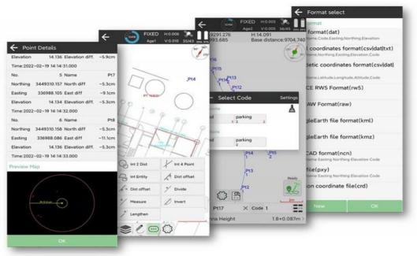

And users can customize the information display content and measurement function menu according to their own usage scenarios, so that the software can better meet the needs of their own applications.

There are four main interfaces, **Project, Device, Survey** and **Tools** interface. Each main

interface includes different functions.

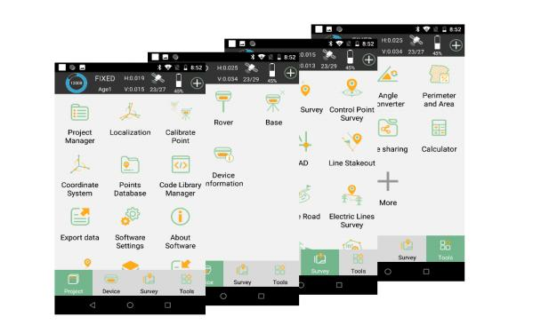

## Project interface

The interface mainly includes Project Manager, Localization, Calibrate Point, Coordinate system and Import/Export data.

• Project Manager: Build/Open/Delete a project.

• Localization: Transfer the WGS84 coordinates to local grid coordinates.

• Calibrate Point: Once change Base coordinate during one project, need do this.

• Coordinate System: Select and manage the datum.

• Points Database: Points manage; check points measured, key in known points and other function.

• Code Library Manager: Management codes in list.

• Import data: Import points file (including CASS, Local coordinates, Geodetic coordinates, SurvCE RW5,FG RAW, Google Earth file and NETCAD format ,PXY file and Carlson coordinate file).

• Export data: CASS, Local Coordinates and Geodetic coordinates, CAD, SHP, Google Earth file (based on WGS84 or Local) etc. you can also export measurement report and stake point report.

## Device interface

This interface is related to setup the GNSS in RTK mode, and check the receiver information.

• Communication: Connect receiver

• Rover: Setup receiver work as rover

• Base: Setup receiver work as base

• Static: Log raw data

• Inspection accuracy : Get points and inspect their accuracy

• Device Settings: Set the rate of output

• Restart Positioning: Get a new coordinate

• Device Information: Show firmware, hardware, status and so on.

## Survey Interface

This interface contains all survey modes, such as the most used function Point Survey, Point Stakeout and Stake Road function.

• Topo survey: Measure points

• Detail Survey: Show local gird coordinate and Lat, Lon coordinate

• Control Point Survey: Measure control points

• Point Stakeout: Stake out points

• CAD: Import dxf or dwg file; edit layers and choose points/lines to stake out

• Line Stakeout: Stake out lines

• DSM Stakeout: Stake out elevation in an area

• Road stakeout: Edit roads and Stake out them

## Tool Interface

The interface mainly includes Coordinates converter, File sharing, Calculator and COGO function.

• Coordinates Converter: Local coordinate, Geodetic coordinate and spatial coordinates are interchangeable

• Angle Converter: Different angle formats are interchangeable, such as dd (Decimal), dd. mmssss, Radian

• Perimeter and Area: Input some points form a face and calculation its area and perimeter

• Calculator: Just like the calculator in your phone

• File sharing: Share files with share code and QR code

• Coordinate inverse calculation: The known coordinates of points A and B, calculate the plane distance, vector, azimuth, elevation difference, ratio of slope and ratio(1:N)

• Point line calculation: The known coordinates of starting point A, end point B and side point C,P is the drop foot, calculate the start distance(AC),end distance(BC),start vertical distance(AP),end vertical distance(BP),Offset distance(CP),Offset angle(α) and corner angle (β)

• Vector: The latitude and longitude coordinates of the starting point A and the end point B are known, and the distance between the two points can be calculated

• Two lines angel: The known point O, point A and point B, find the angle α between straight line OA and OB

• Intersection calculation: The known starting point A and terminal point B of line AB , the known starting point C and terminal point D of line CD, calculate the coordinate of intersection point P

• Resection: The known coordinates of point A and point B, and the known distances of L1 and L2, calculate another coordinate of point P and the angles of triangle ABP

• Forward intersection: he known coordinates of point A and point B, and the known angles of α and β, calculate another coordinate of point P and the sides’ length of triangle ABP

• Coordinate positive calculation: The known coordinates of starting point A and end point B, the known length L of line AP and the angle α between line AB and line AP, calculate the coordinate of point

• Offset point calculation: The coordinates of known line AB starting point A and terminal B, the station distance L1 and offset distance L2 are known, calculate the coordinate of point P

• Extend point calculation: The coordinates of known line AB starting point A and terminal B, the extend distance L1 is known, calculate the coordinate of point P

• Equal point calculation: The coordinates of known line AB starting point A and terminal B, the line is divided into several segments averagely, calculate eachcoordinate

## Floating Window

• Status Bar

The icons and their descriptions are as Table 2-1:

**Table 2-1**

|  |  |
| --- | --- |
| Icon | Description |
|  | Indicates the receiver battery power |
|  | Rover device internet mode |
|  | Rover internal radio mode |
|  | 27: number of the satellites used.  40: number of the satellites tracked; |
|  | Rover phone internet mode |

The positioning status and their descriptions are as Table 2-2:

**Table 2‑2**

|  |  |
| --- | --- |
| Status | Description |
| NONE | The receiver is searching the satellites. |
| SINGLE | Single positioning solution. |
| FLOAT | The whole week ambiguity is not fixed. |
| FIXED | The whole is setup ambiguity is fixed, high accuracy. |
| BASE | The base is setup successfully. |
| Age:*** | The diff delay, *represent the diff delay value. |
| H:…,V:… | Horizontal RMS, Vertical RMS. |

## RTK WorkFlow

This figure shows the workflow of your survey through SingularPad.

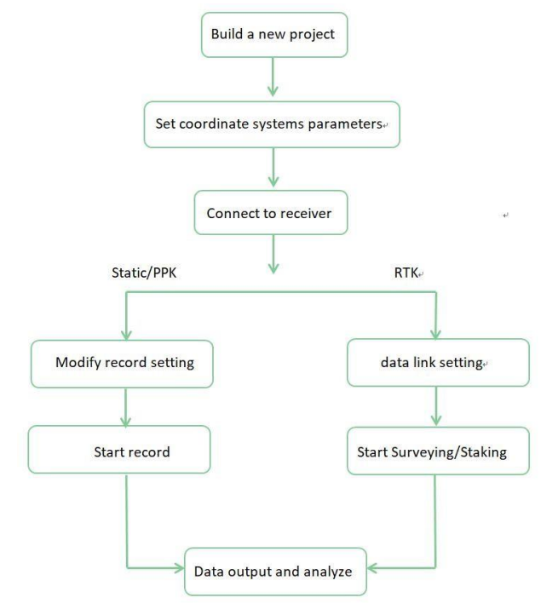

# Project

This section is three parts that include **Create Project**, **Connect receiver** and **How to Set Mode.**

## Create Project

Click Project manager, click the New button in the lower left corner of the screen and input project name, set coordinate systems parameters and save the project. In Project Manager interface, you can click previous projects in the Project List to remove or open it.

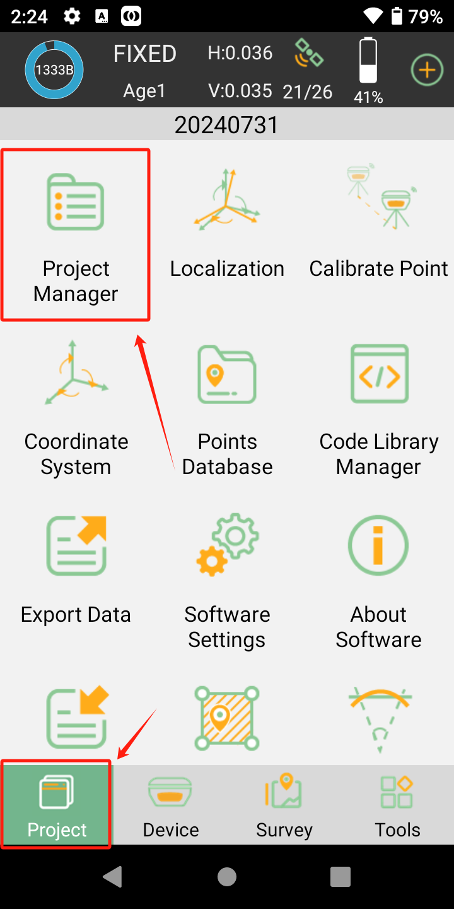 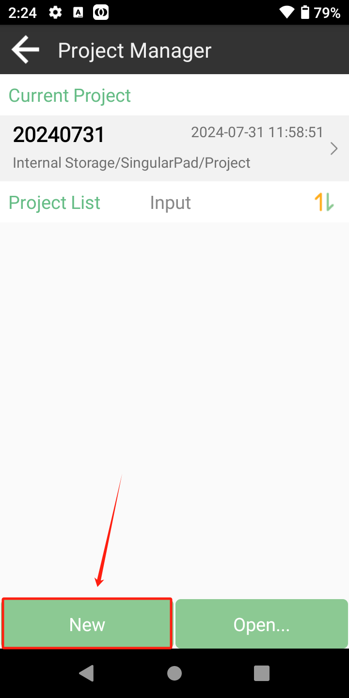

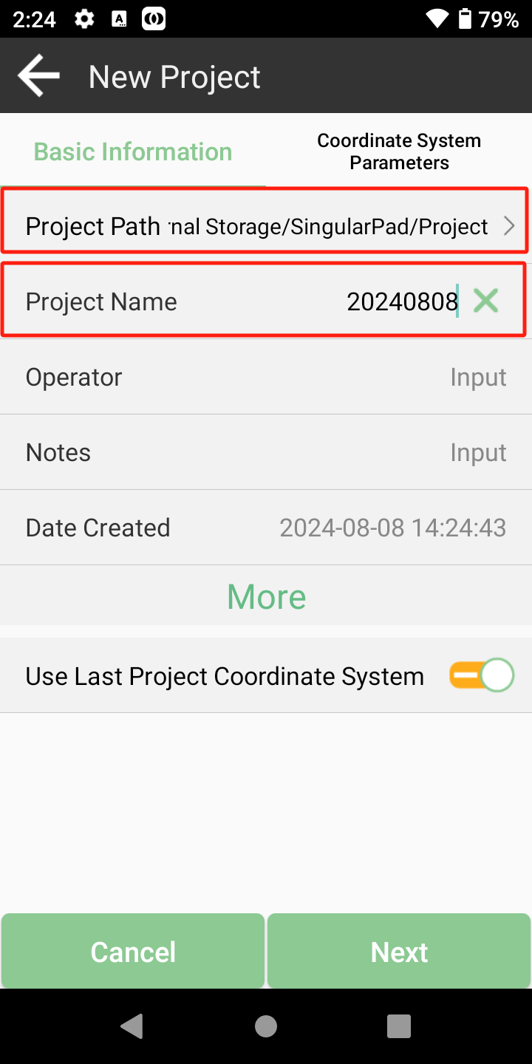 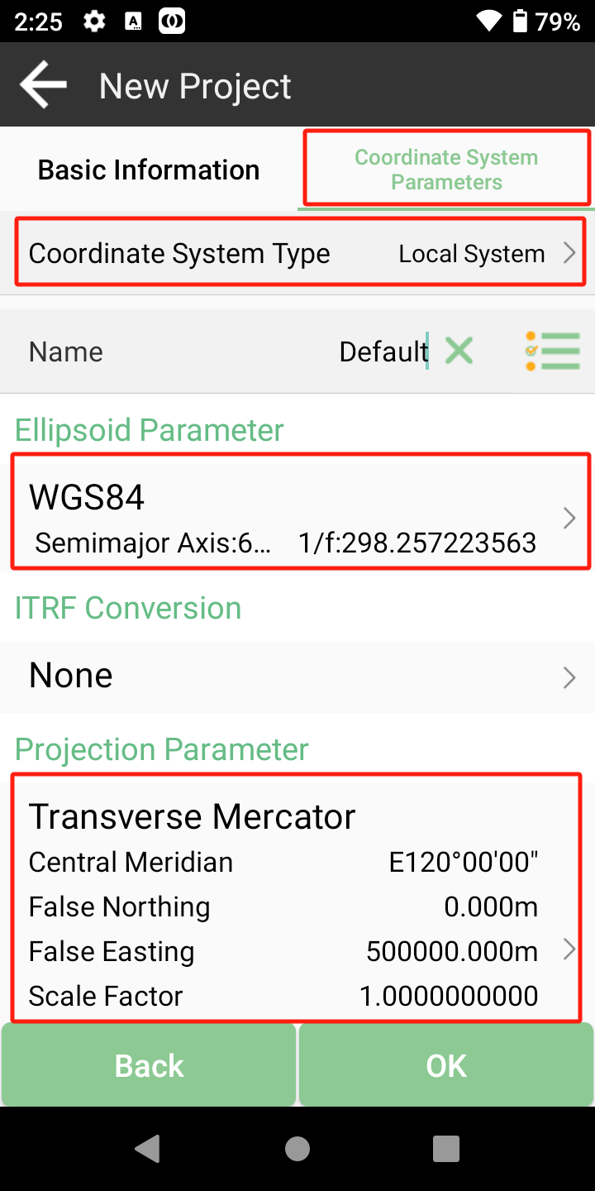

In the Basic Information, Select Project Path and input Project Name. In the Coordinate System Parameters, Select Coordinate System Type, Ellipsoid Parameter and Projection Parameter.

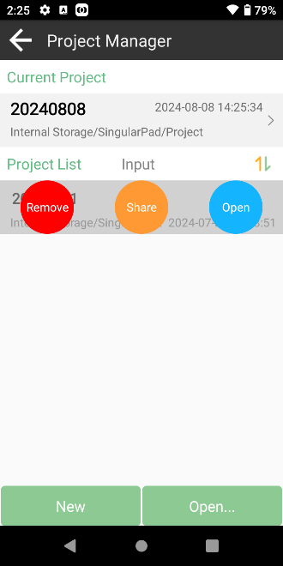

If you have added one project, you can click the project name in the main interface to check the current project details, including Project Name, Project Path and Coordinate systems parameters. And you can edit and share it.

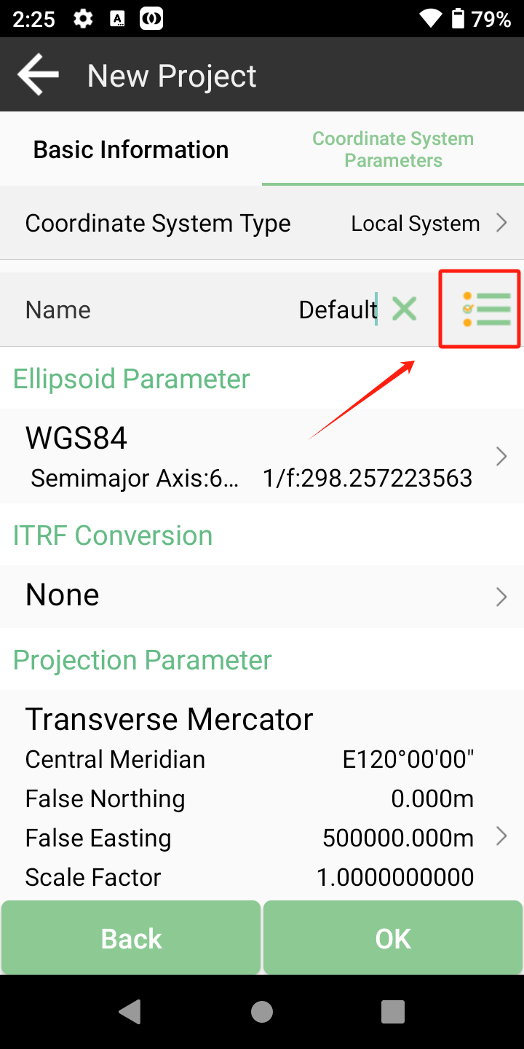 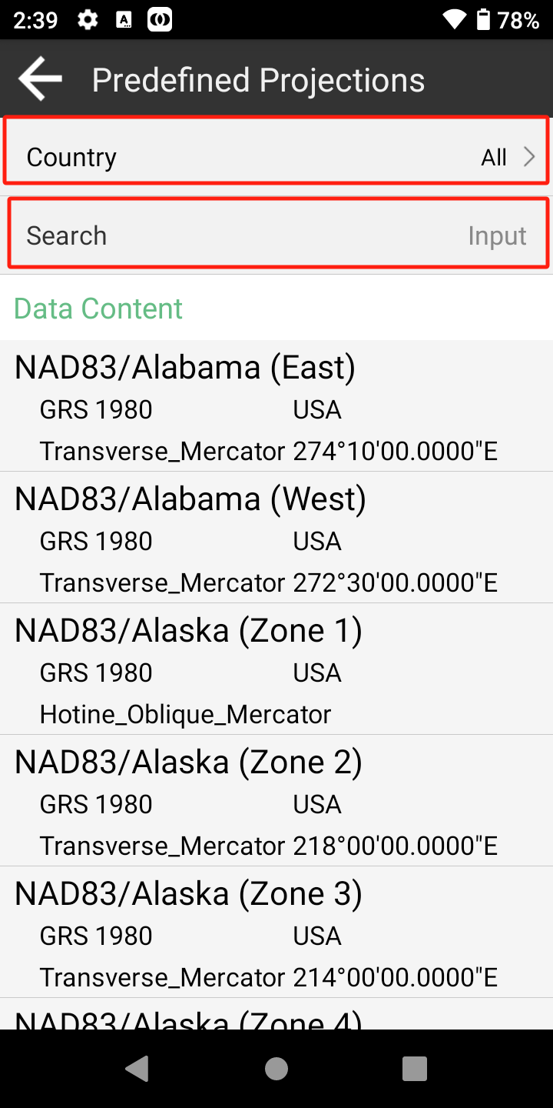

If you want to select Coordinate System that you need, Click to search, and you can select Country.

How to create a user defined datum: If you cannot find datum you want in the list, follow instructions to add one: select ellipsoid para, projection para, datum para, and input horizon adjustment, vertical adjustment and local offsets based on your request. Save and apply it. Meanwhile you can share the coordinate system with your workmates.

## Connect receiver

After creating a new project, switch to Device, click Connection. You can connect SingularPad with SingularXYZ X1 GNSS receivers. Or choose other devices.

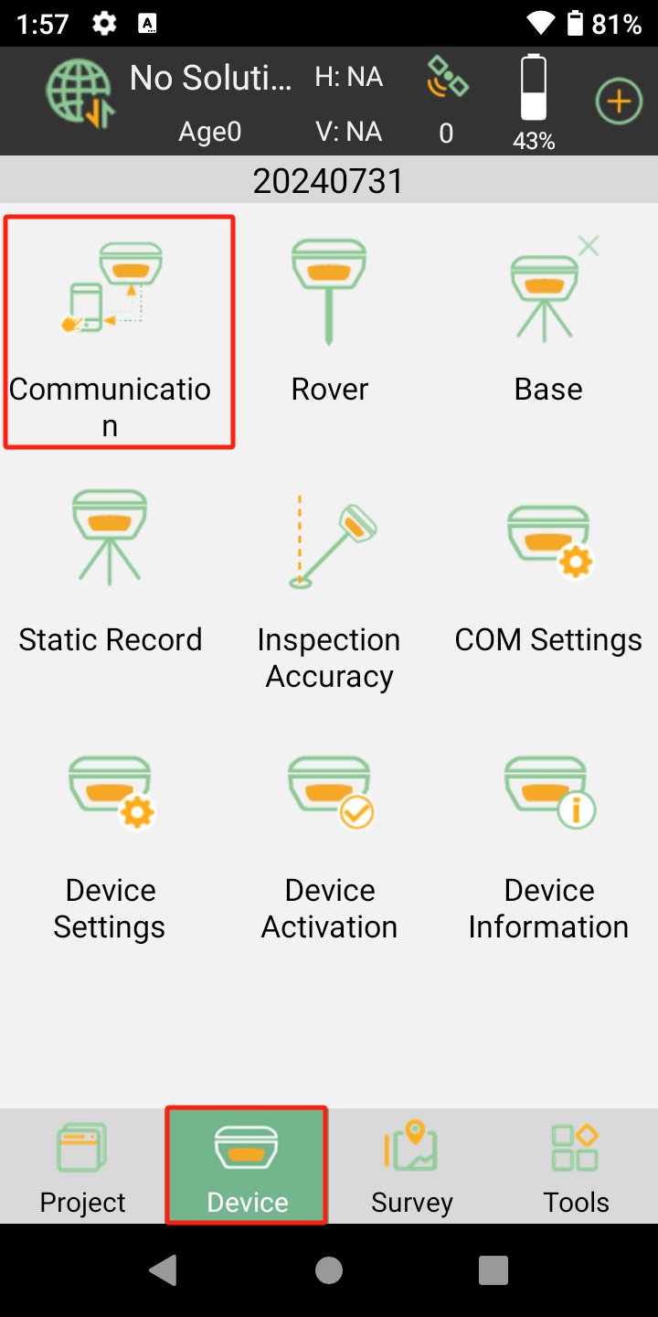 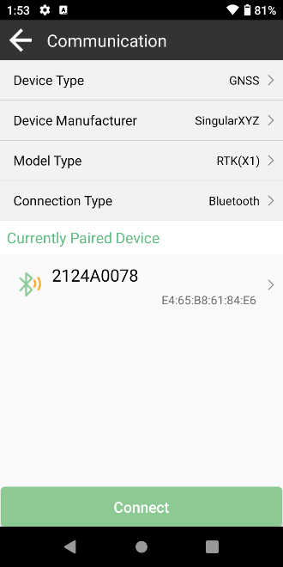

Tap [Model Type] to select model type:

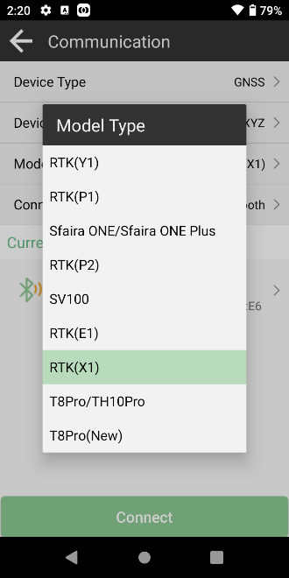

There are four connection types: Bluetooth , USB , Demo and Debug.

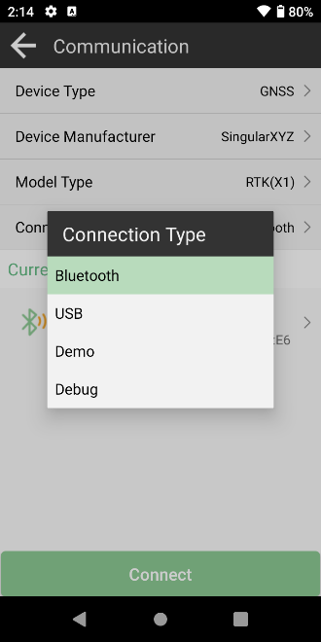

**Bluetooth**: After connecting SingularXYZ receiver, you can check some information of receiver (like firmware version) in Device Info. And some functions are only available for specified device. After connected successfully, the floating window will show the positioning status.

Tips: If you failed to connect with receiver through SingularPad, you can just follow prompt info to go into the device Bluetooth setting interface to make sure Bluetooth paired successfully. Sometimes you need forget the device Bluetooth, restart the receiver or software and get pair again.

**Demo**: Simulate connecting SingularPad. On this model, some functions will not work.

## Quick setup your receiver

In SingularPad, you need only one step to start your receiver: Choose work mode and apply. There are some default work modes, three for Base and three for Rover. Choose one mode; you can check the detailed information. If the default work mode suits for you, you can just click Apply to start your receiver. Usually, you need to add one mode yourself.

### Start your receiver as Base

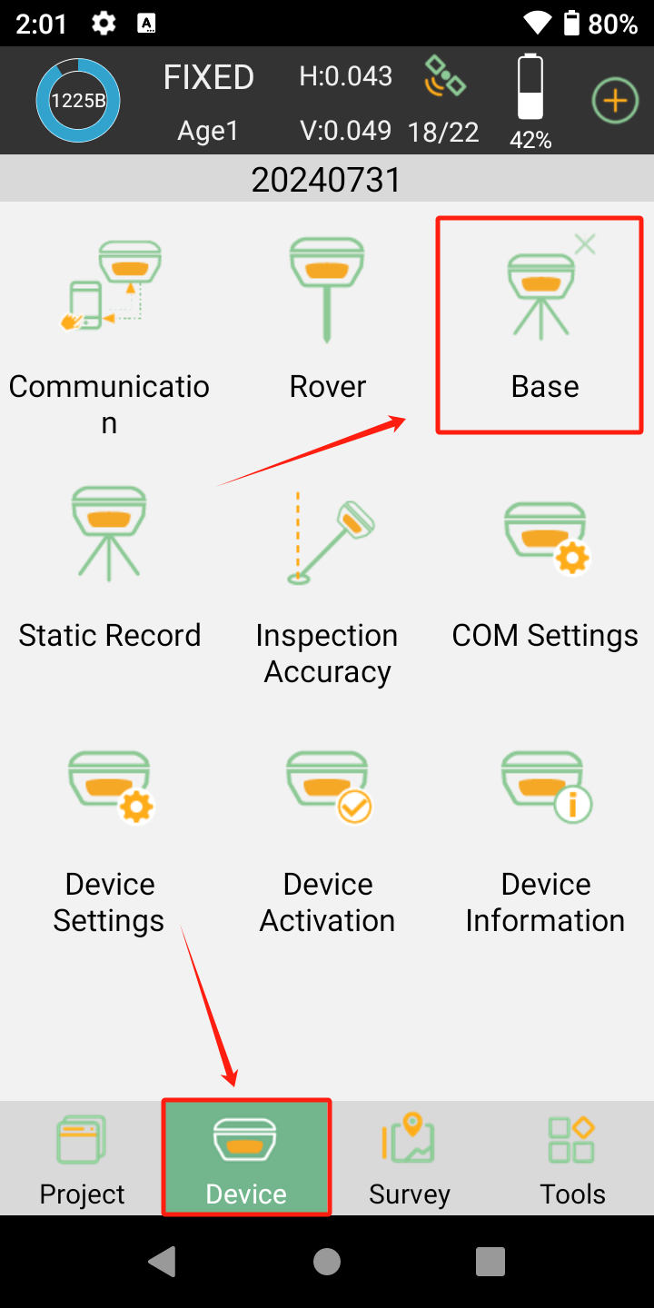

There are four modes you can choose, **Device Internet**, **Internal Radio**, **External radio** and **Internal Radio + Device Internet**.

Internal Radio: This mode uses internal radio to transmit the correction data from Base to Rover. You need to set Base and Rover with same protocol and frequency.

The following steps give an example of internal radio transmission.

**• Protocol**: Supports Transparent, MAC, South or TRIM450S and CSS(LU) for Base transmission.

**• Frequency**: select a channel or customize a frequency, the range of frequency is 438.125-447.125MHz.

• **Power**: Supports High, Medium and Low.

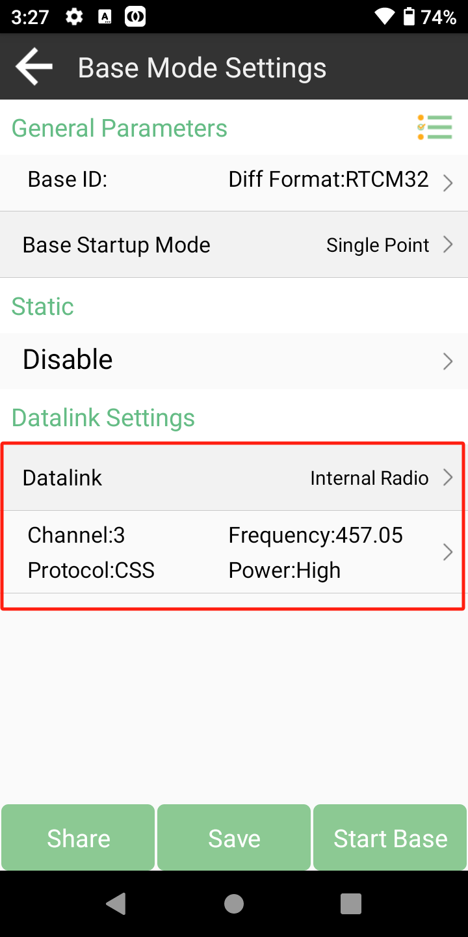 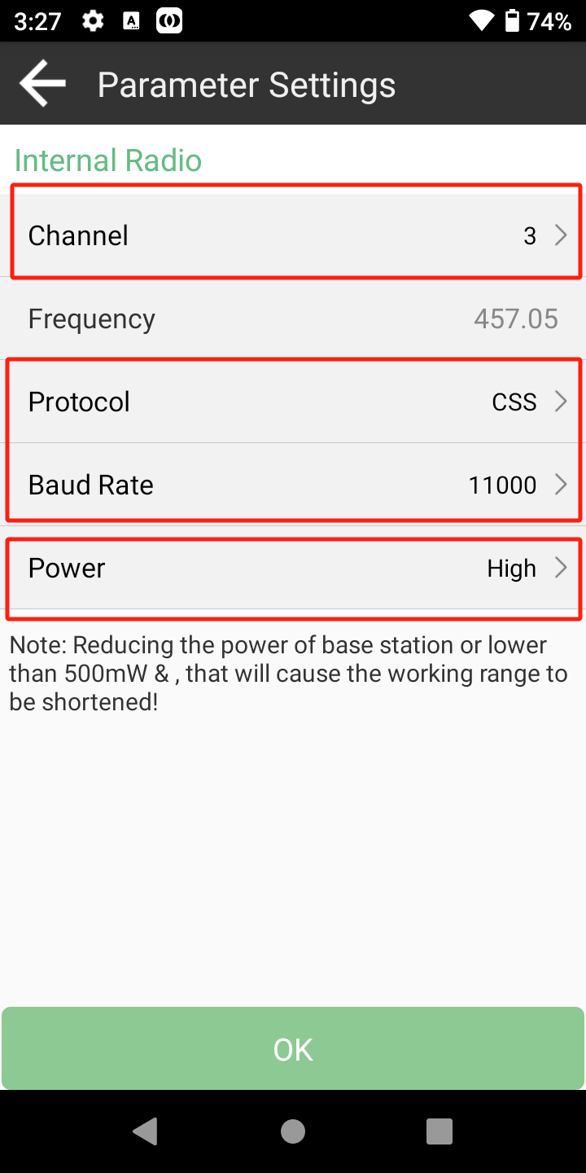

External Radio: This mode uses external radio to transmit the correction data from Base to Rover. You need set Base and Rover with same protocol and frequency. The steps to start external radio mode is similar with internal radio mode, but you need select the protocol and frequency on the external radio, not In SingularPad.

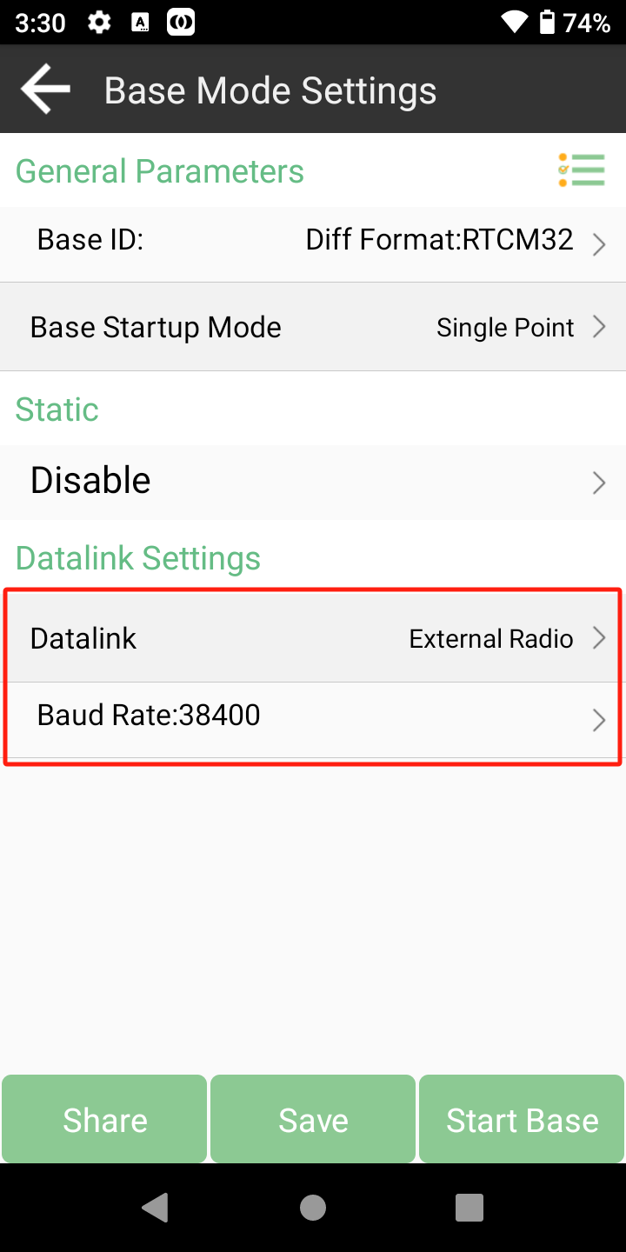 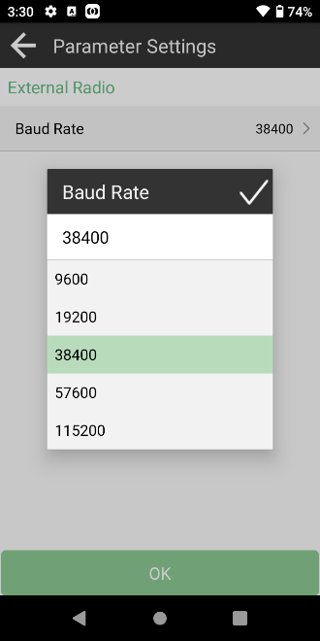

Internal GSM: This mode uses GPRS (internet data) to transmit the correction data from Base to Rover. You need insert a SIM card to Base, set the Base to log on server (with static IP address), and the Rover receives the correction data by Ntrip protocol. The following figures show an example of Base configuration with internal GSM transmission.

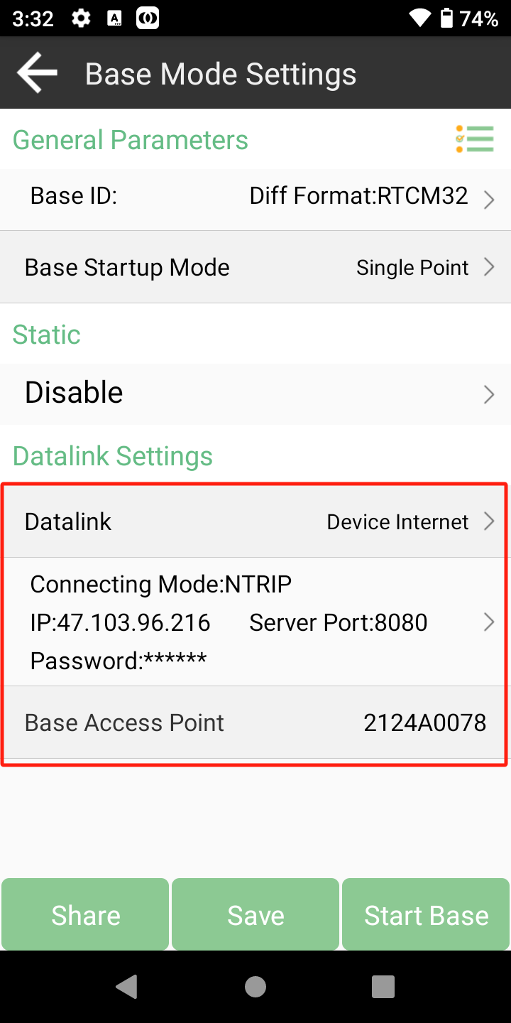 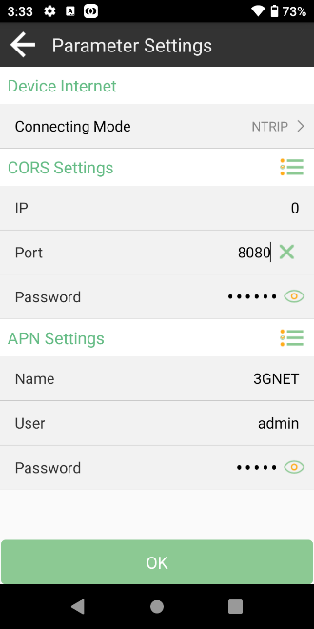

Internal Radio + Device Internal: This mode uses GPRS (internet data) and Radio to transmit the correction data from Base to Rover. You need insert a SIM card to Base, set the Base to log on server (with static IP address) and use Radio to transmit data.

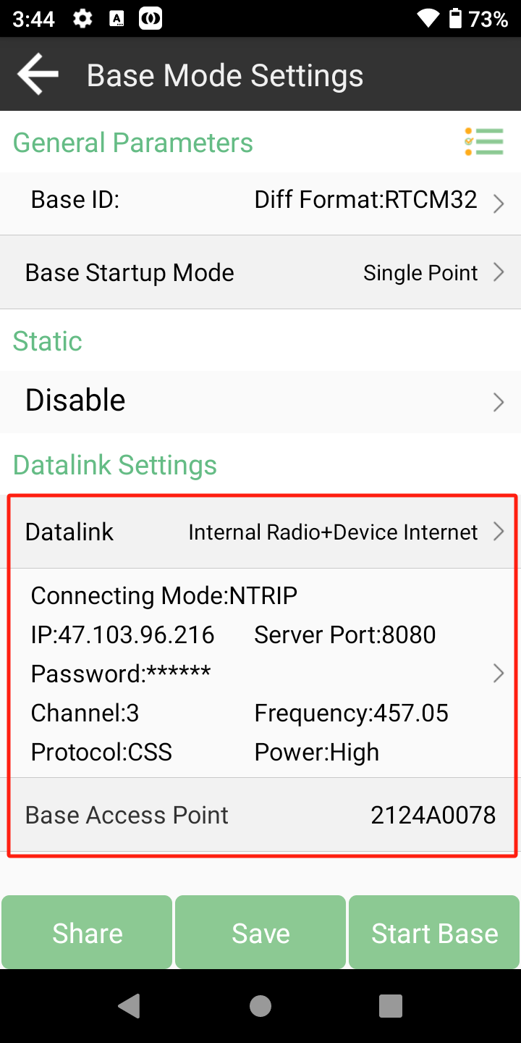 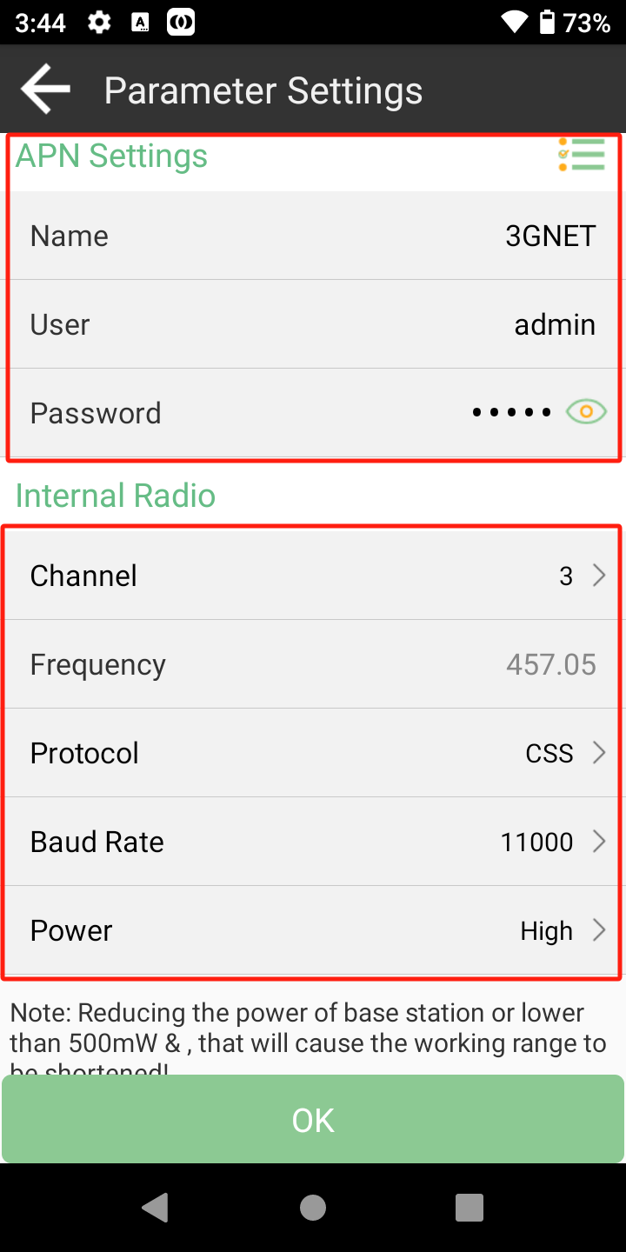

### Start your receiver as Rover

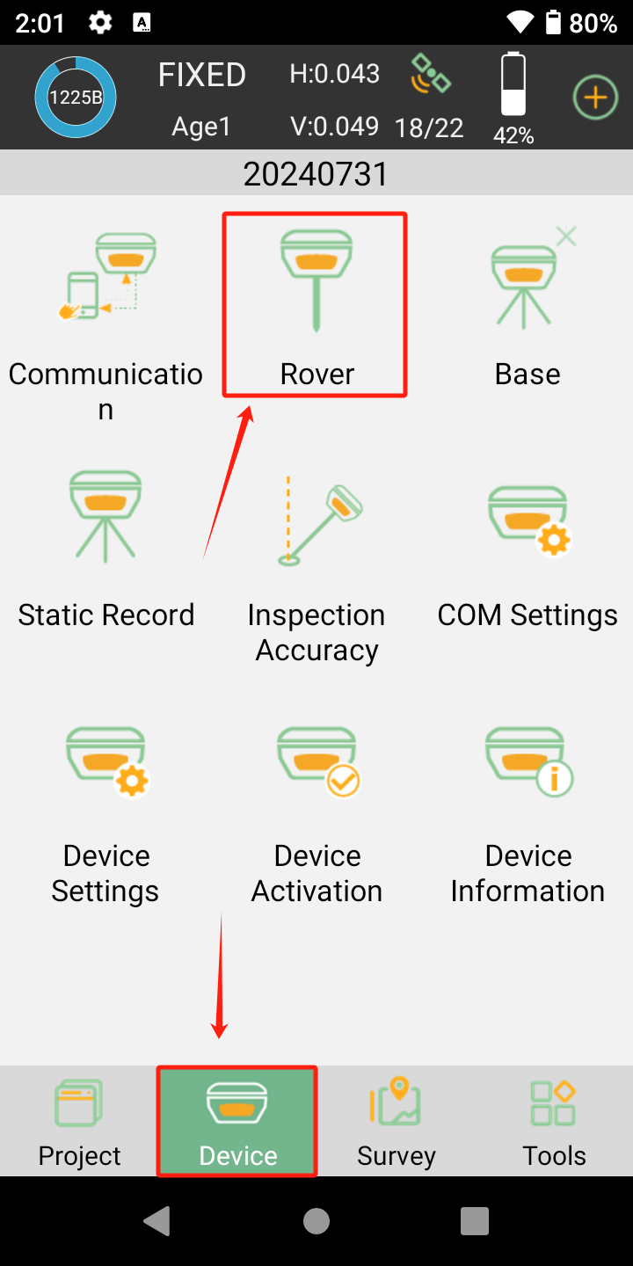

This chapter shows how to tart receiver as rover with Internal Radio, Device Internet and Phone Internet mode.

Internal Radio: Select the same protocol and frequency with the Base receiver, and then the receiver status will turn single to be fixed. The following steps show an example of internal radio.

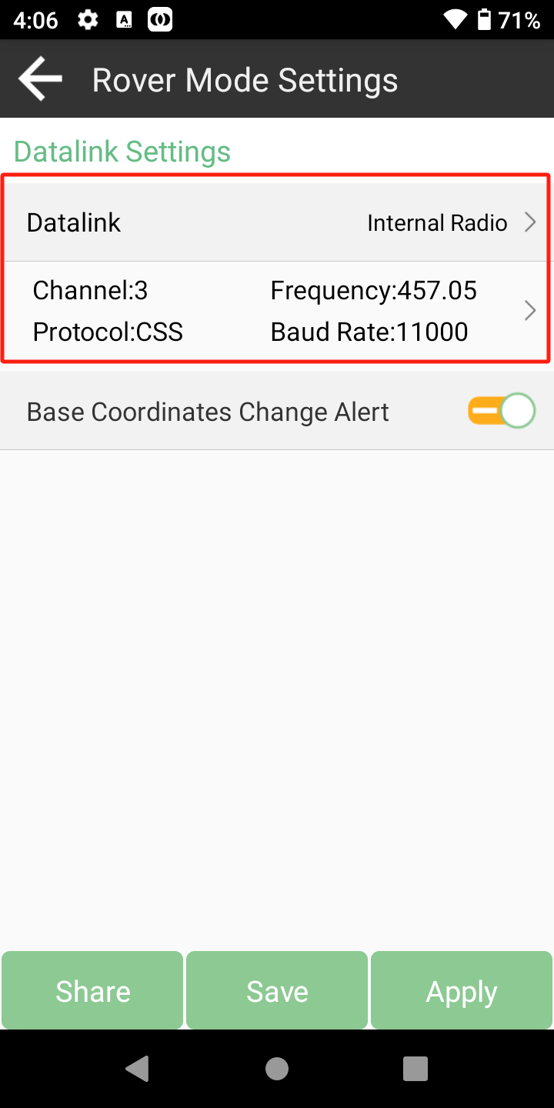 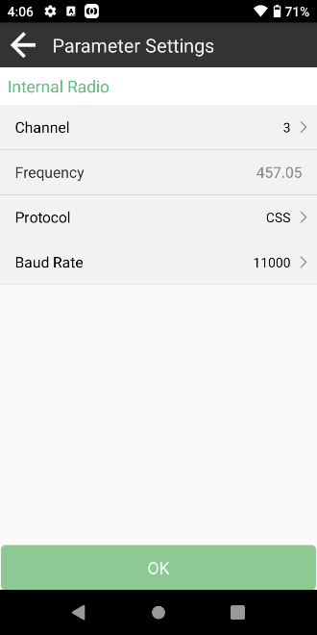

Device Internet/Phone Internet: For Device Internet mode, we need insert a SIM card to receiver, for Phone Internet mode, we need make sure controller can access to Internet. You should input the server IP and Port. In addition, enter User (login name) and Password to get mountpoint.

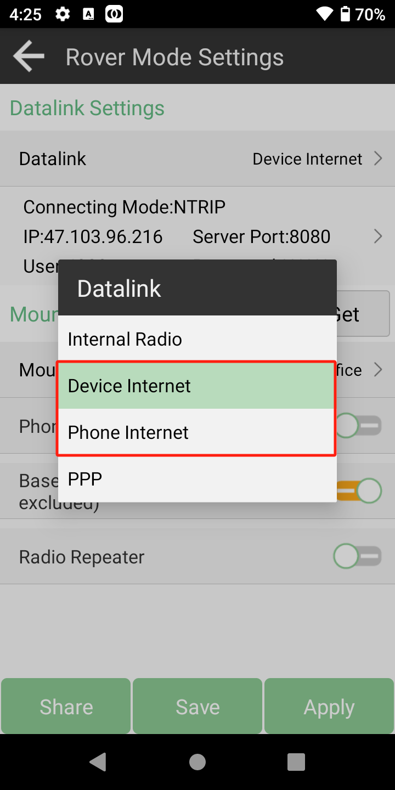 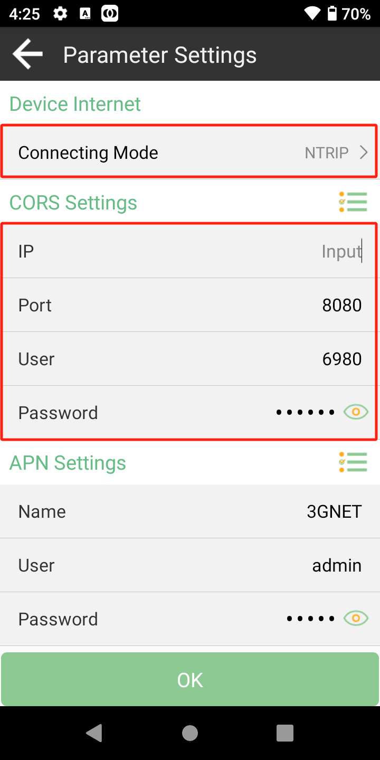

The protocol supports NTRIP, TCP Client • NTRIP: This is a common Ntrip protocol; you need to set the username and password. And Device Internet mode only supports Ntrip protocol. • TCP: This is used to directly obtain the corrections transmitted by TCP protocol.

PPP: Use specific satellite data for precise single point positioning, [Datalink] select PPP and press Apply.

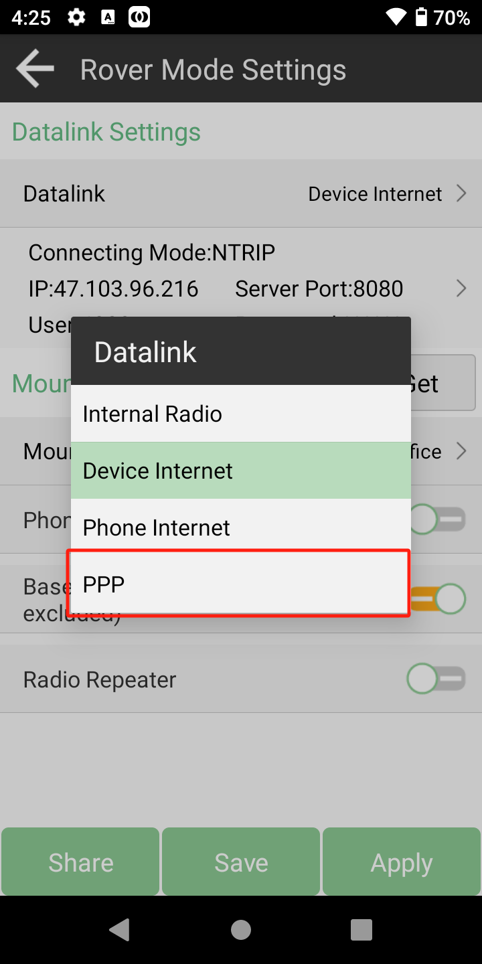 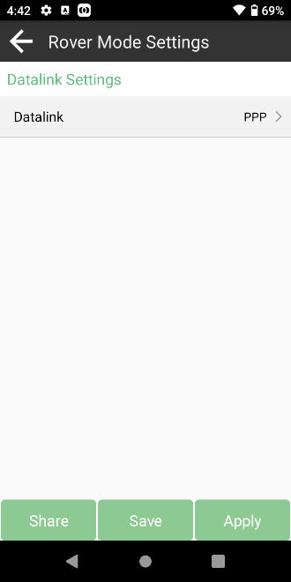

SBAS: Satellite-based augmentation system improves the positioning accuracy of the original satellite navigation system

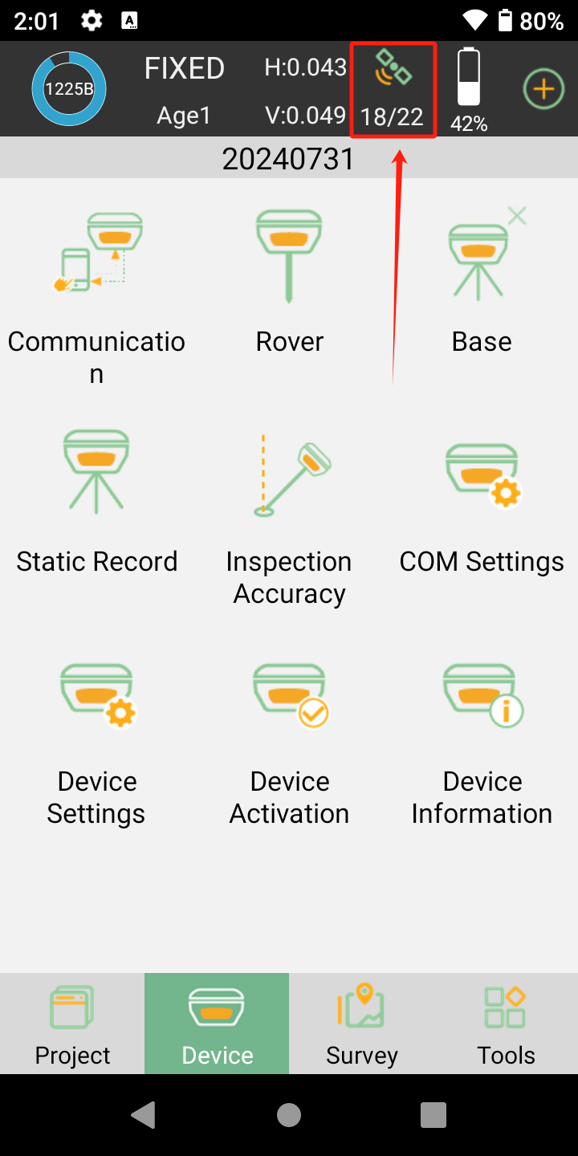 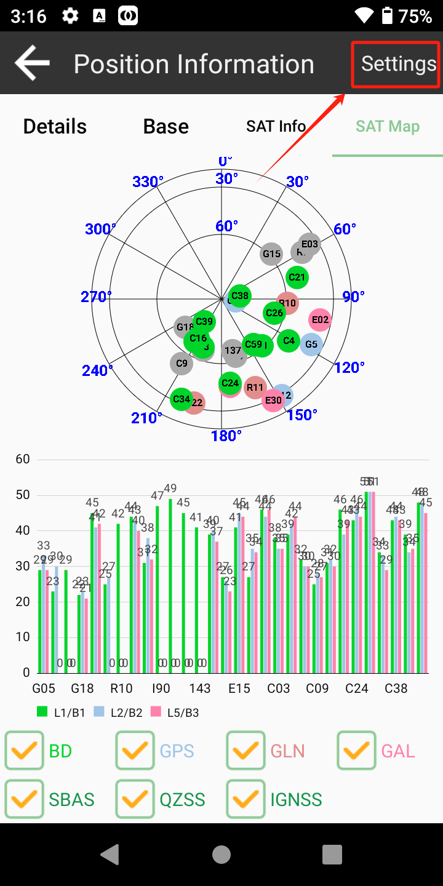 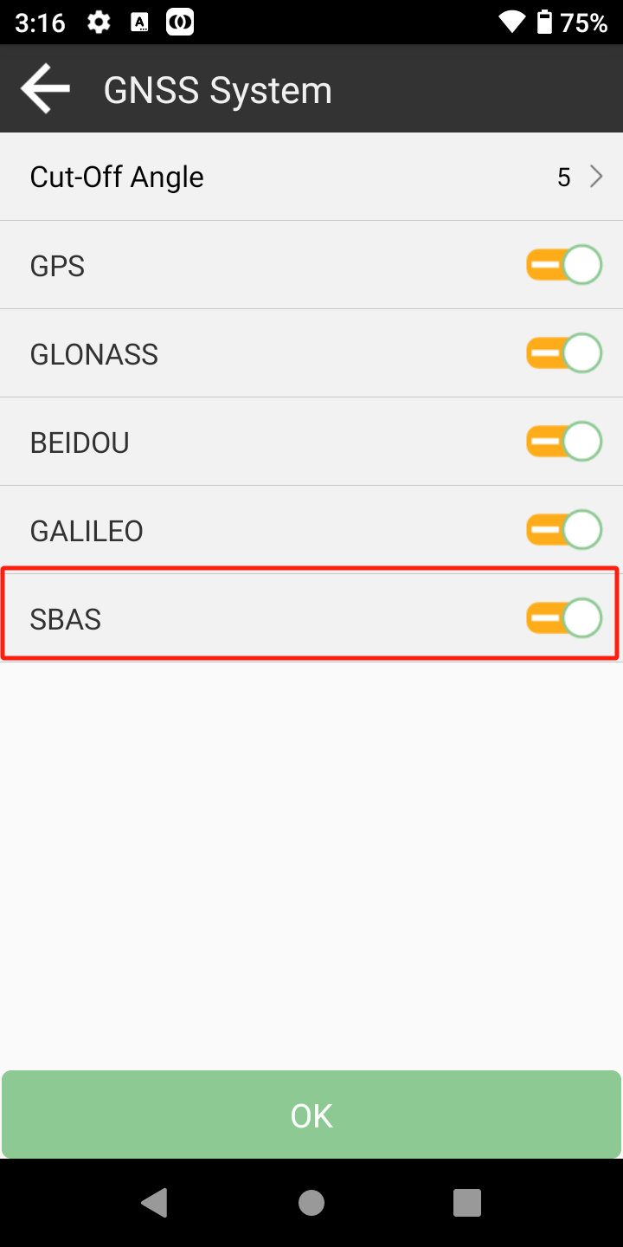

In SingularPAD, you just need three steps to open SBAS.

# RTK Survey-field Data Collect

This section describes the basic survey functions of SingularPad including Point Survey, Detail Survey, CAD and Stakeout. In the first, you have to connect to rover receiver and make it fixed.

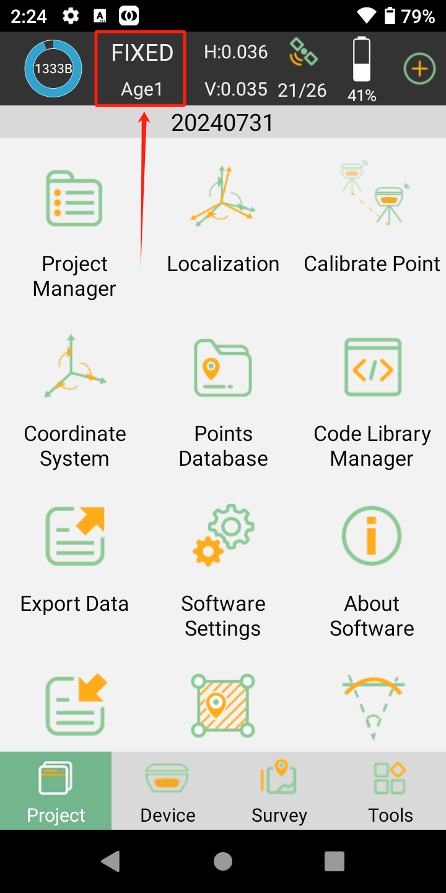

## Point survey

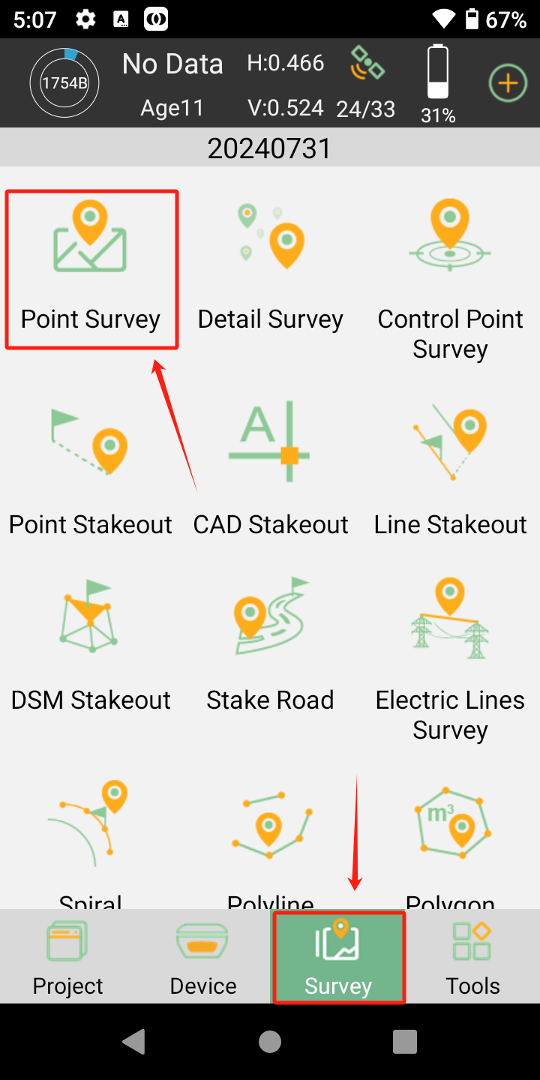

In the Survey interface, click **Point Survey**-> enter point name, code and antenna height,**->click**  to start or stop collecting data. Tilt Survey option will appear when receiver supports for tilt survey, it is available for SingularXYZ Y1 GNSS receiver. When the pole tilts within 60°, the built-in sensor based tilt measurement system precisely calculates the actual offset according to angle, which can not only meets the requirement of high precision measurement, but also relieves the users from continually checking whether the pole is plumb.

->**Click** to open IMU survey, when using it for the first time, you should follow the interface prompts to initialize the IMU module; it will take you a few seconds. You have been confirmed the antenna information, and it is correct.

If calibration expired or you first use the receiver, tap Calibrate and follow the guidance until succeed. During operation, make receiver can search the satellites. The angle should be less than 60°, for more accuracy, angle less than 30°will be better. When the pole tilts within 60°, the built-in sensor based IMU precisely calculates the actual offset, which accuracy can up to 2.5 cm.

If you power off the receiver or reset it, need to initialize again. After open IMU button, you can follow the guidance in interface to complete it. When you click IMU button to initialize, it will prompt you to confirm the pole height, default pole height is 1.8 meters. During operation, make receiver search satellites and get a fixed Of course, you can get some information from the floating window, like coordinate and base distance.

• Click, it will auto jump map center.

• Click, to show the layers or calibration: google map/open street map/map calibration

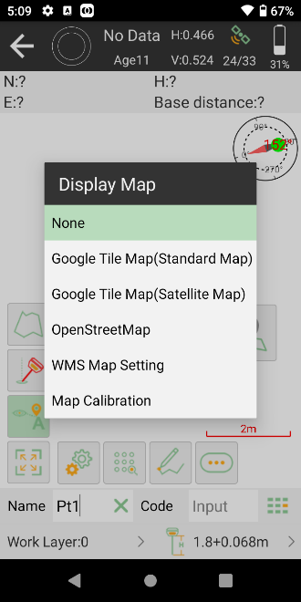

• Click , to show the whole points on the interface.

• Click, to check point coordinates, you can add, recover, import, and export the data. After you choose a point, you can check the details and take notes or photos

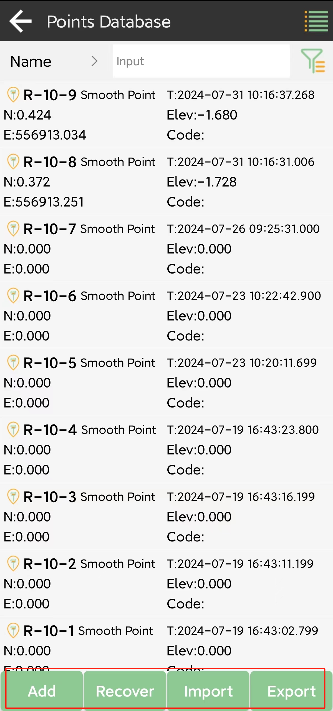 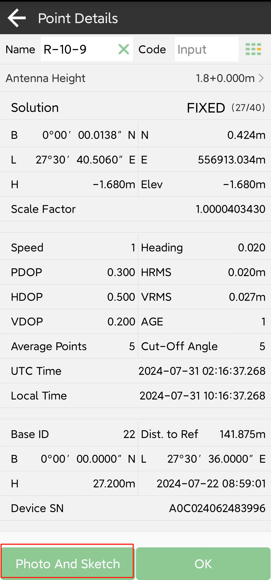

•Clickto set settings, display info and tool bar, in setting interface, you can edit receiver parameter, such as solution limit, HRMS limit, VRMS limit; in display info interface, you can add information to floating window you want below the interface; in tool bar interface, you can add or delete options to point survey interface. You can customize the interface to meet whatever layout needs you might have.

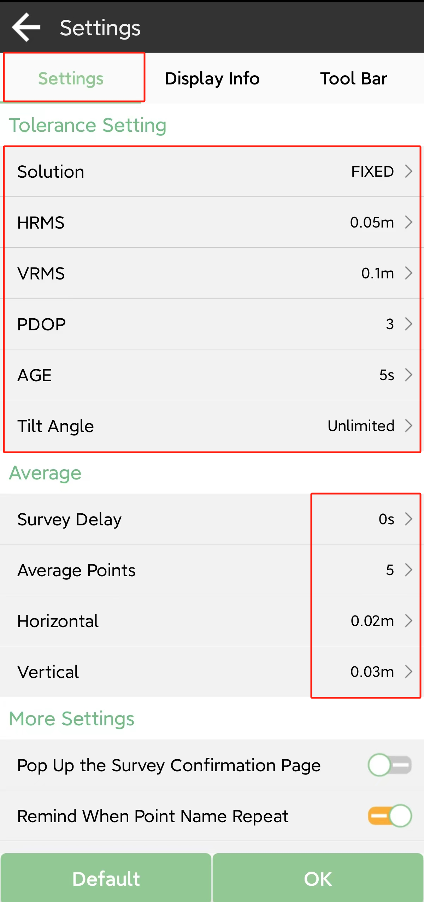 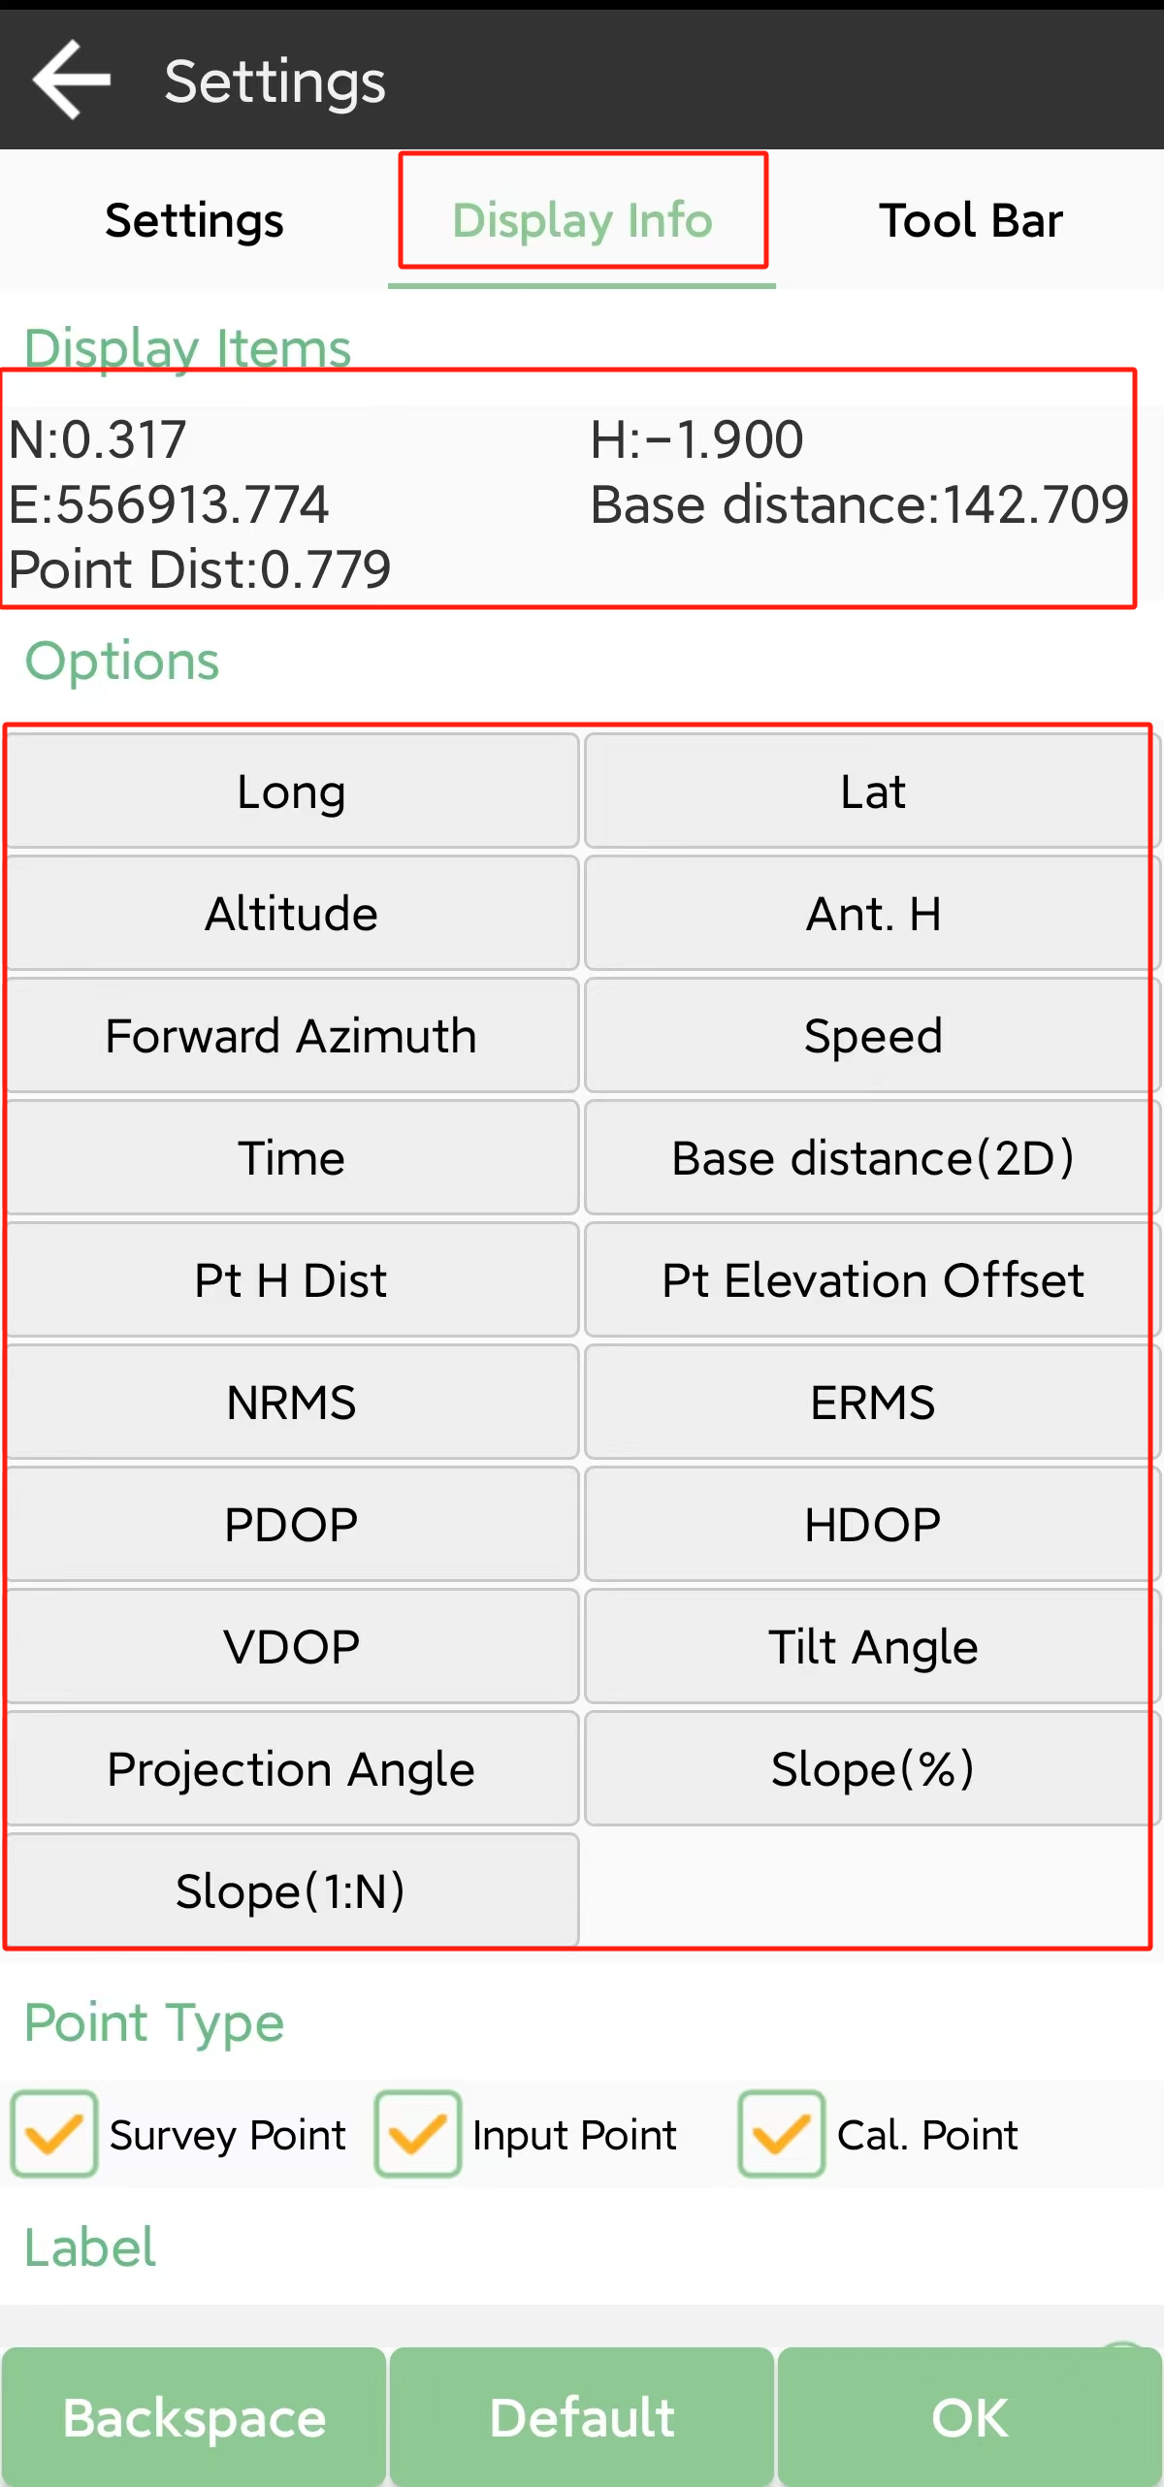

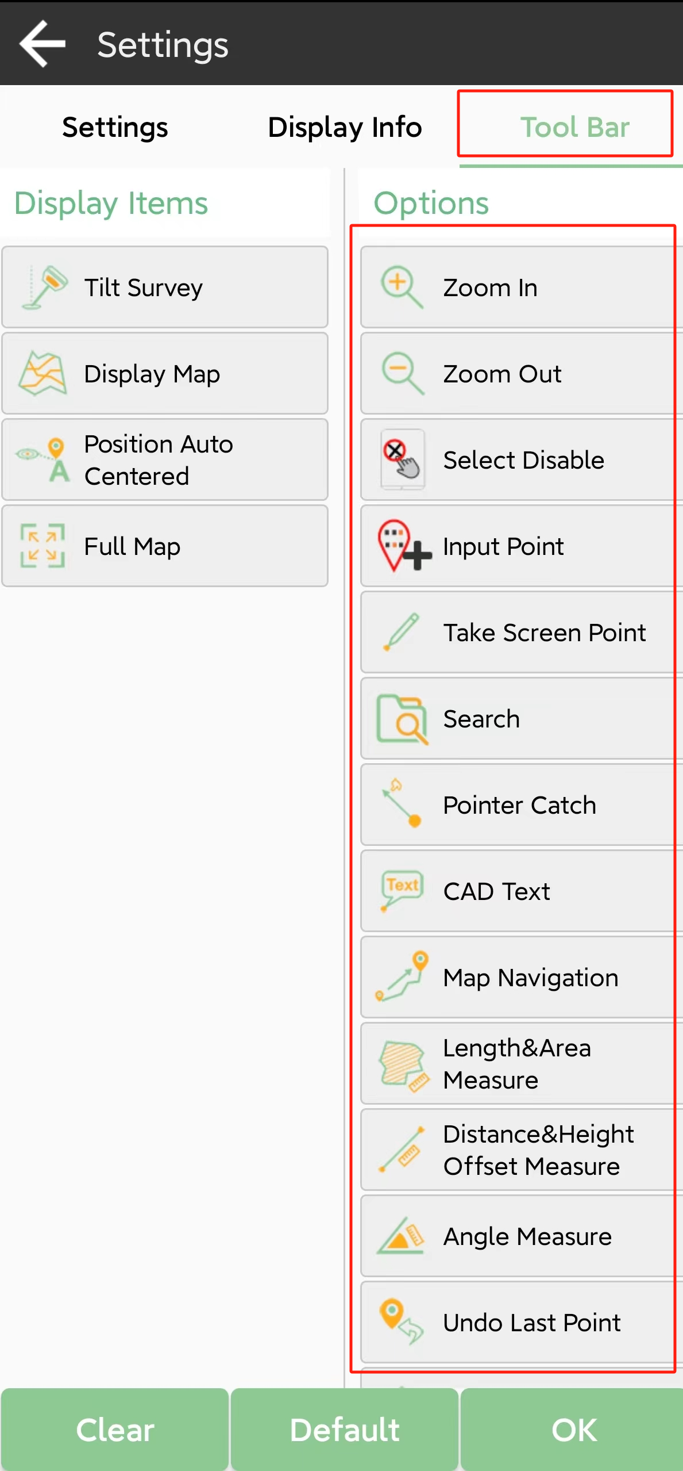 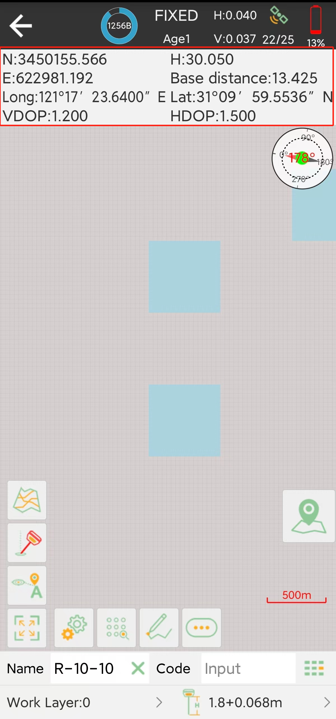

## Detail survey

Show both local coordinate and Latitude/Longitude when measuring.

• Clickto start or stop collecting data

• Clickto check point coordinates; you can add note, info, arrow drawing and photo.

• Clickto set settings, display info and toolbar

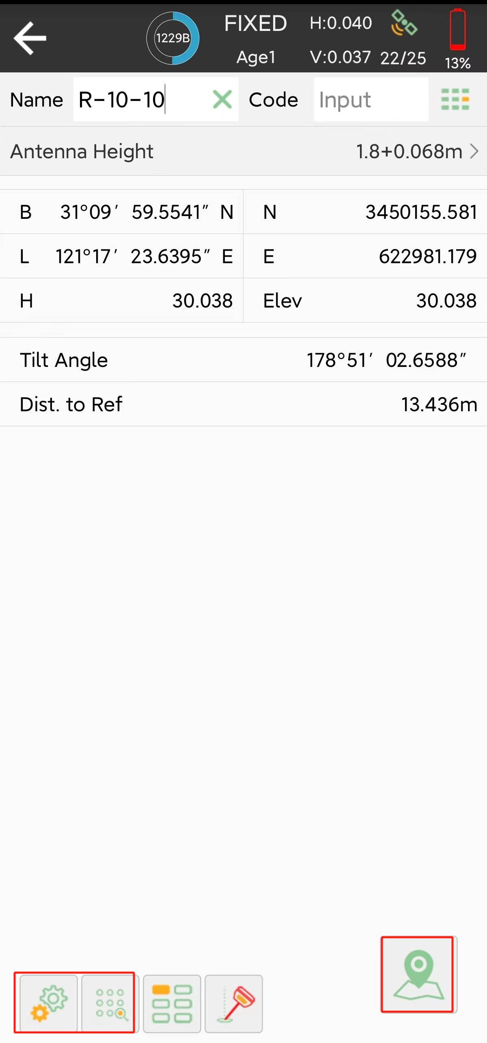

## Control point survey

By measuring the coordinates of the same point several times, an accurate coordinate is obtained.

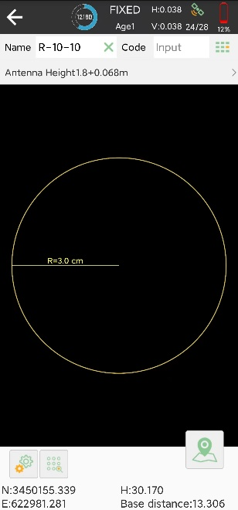

• Clickto average GPS count, interval, and repeat count.

## Point stakeout

Go into Stake point interface, add or import the point coordinates you need to stakeout, of course you can choose from the button library.

• Click Add to input coordinates.

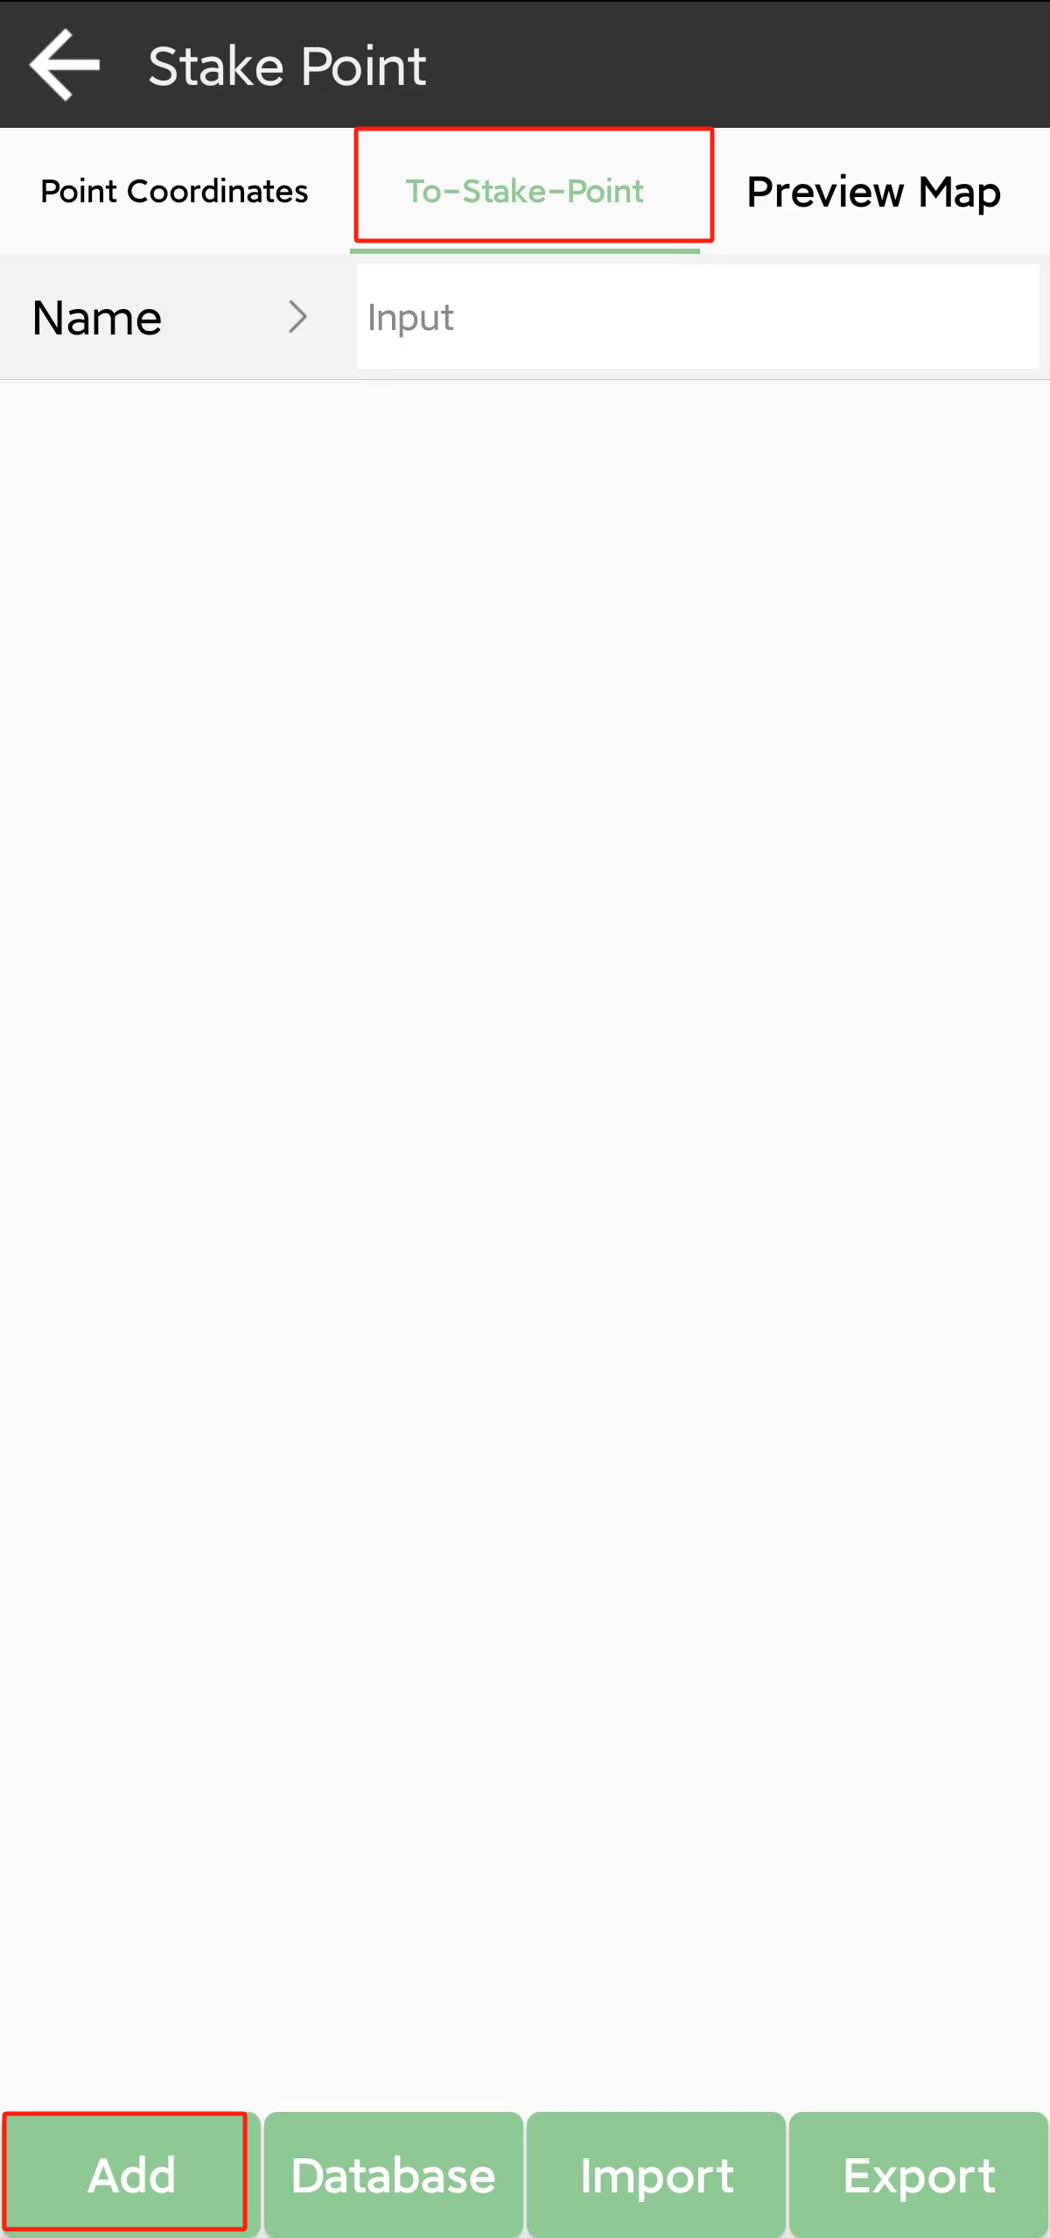 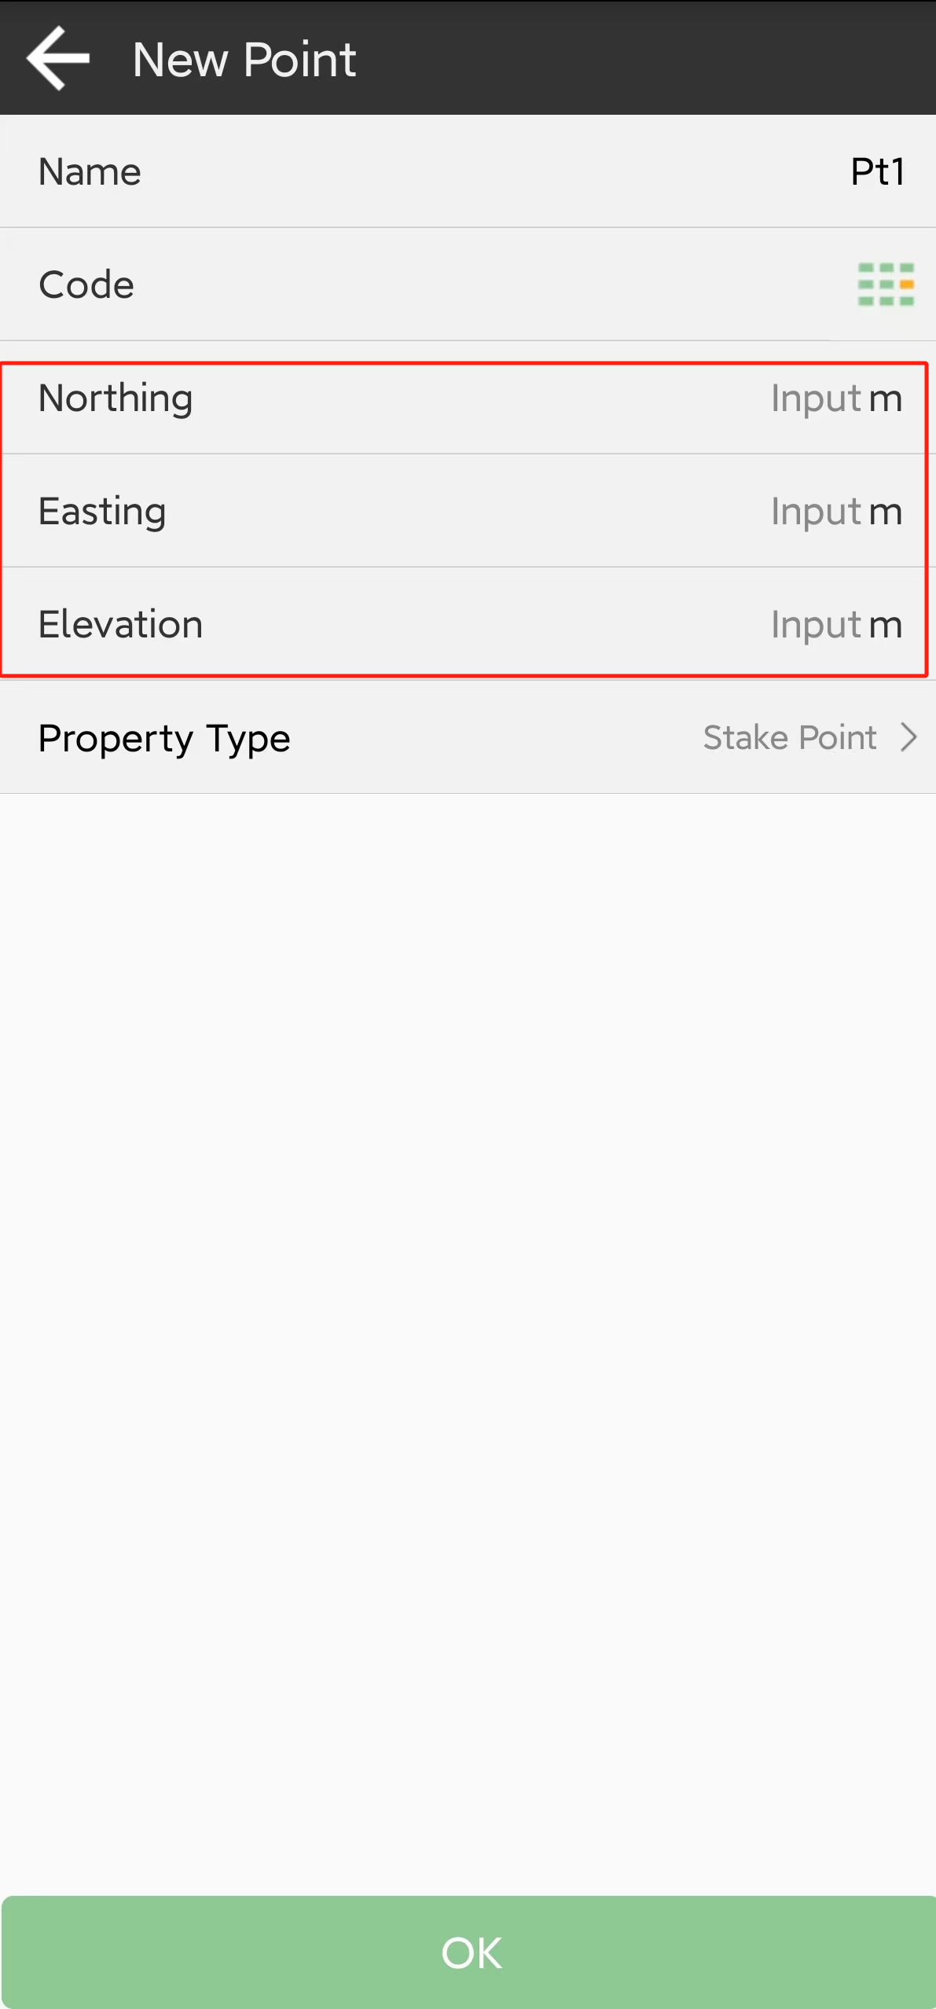

• Click button **Database** to choose one

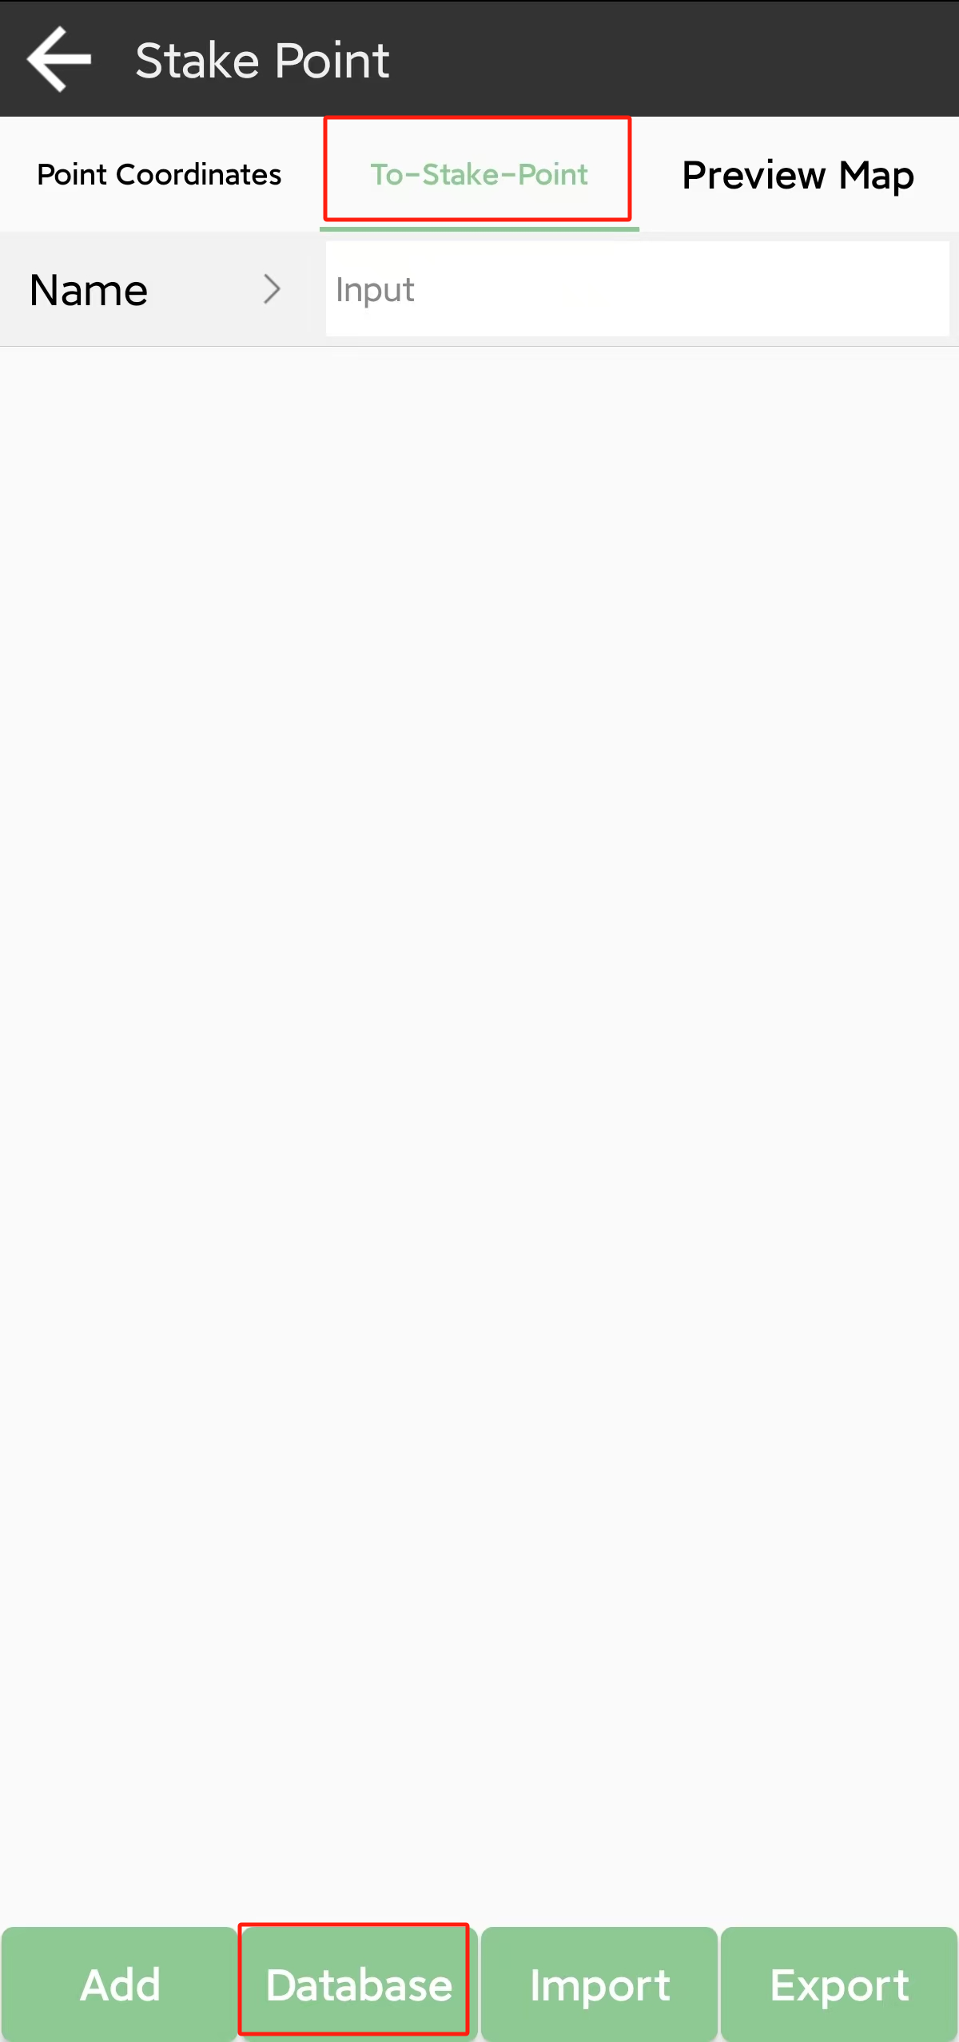 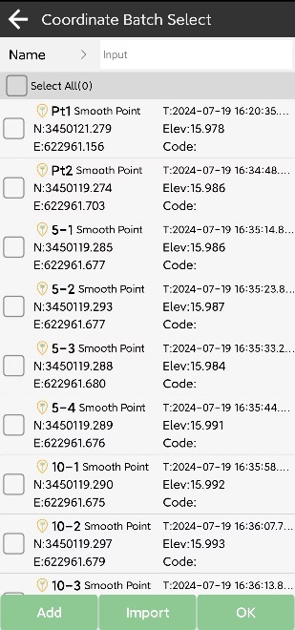

• Click Import to get coordinates with different kinds of files; you can also define a new form.

Choose a point to stake, SingularPad provides a navigation map when staking points/lines. If you are close to the target point enough, it will alarm you based on the alarm range you set. For Y1 receiver, you can use IMU staking function. In the IMU staking, you can open IMU function, and don’t need to keep the receiver vertical to the ground, and the tilt angle supports maximum to 60 degrees.

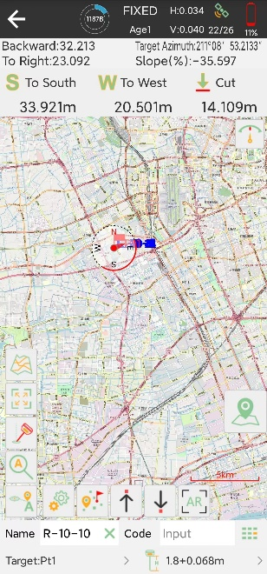

• There is a direction prompt on the floating window

• Clickto start or stop stake points

• Clickto open or close IMU

• Clickto scale automatically

• Click, jump to lasted point

• Click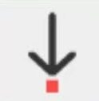, jump to next point

• Click, jump to previous point

• Click, to set stakeout settings, display info and tool bar, you can edit the prompt range and range error

• Click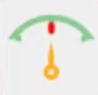to open compass

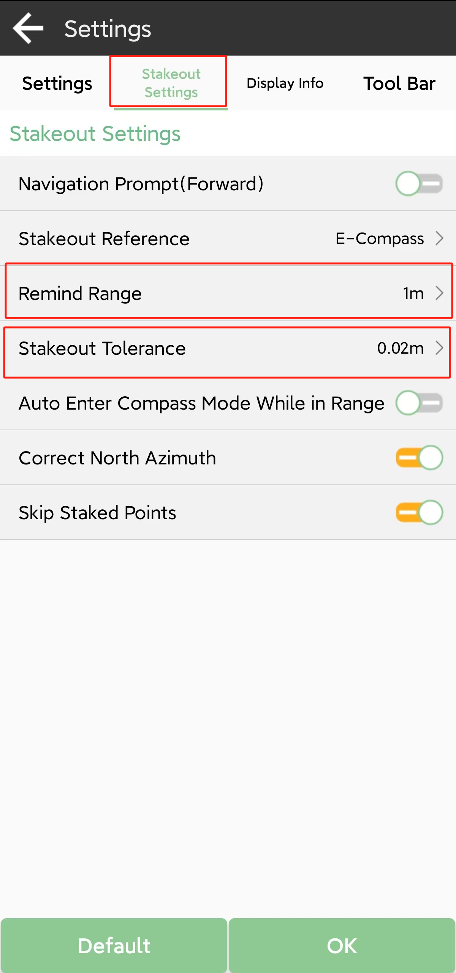 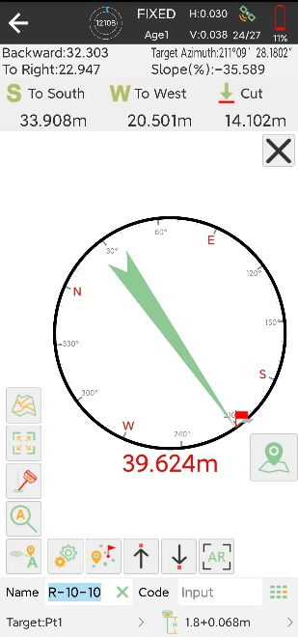

## Line stakeout

Go into Stake line interface, add or import lines you need to stakeout.

• Click Add to input line parameters, there are three types you can choose

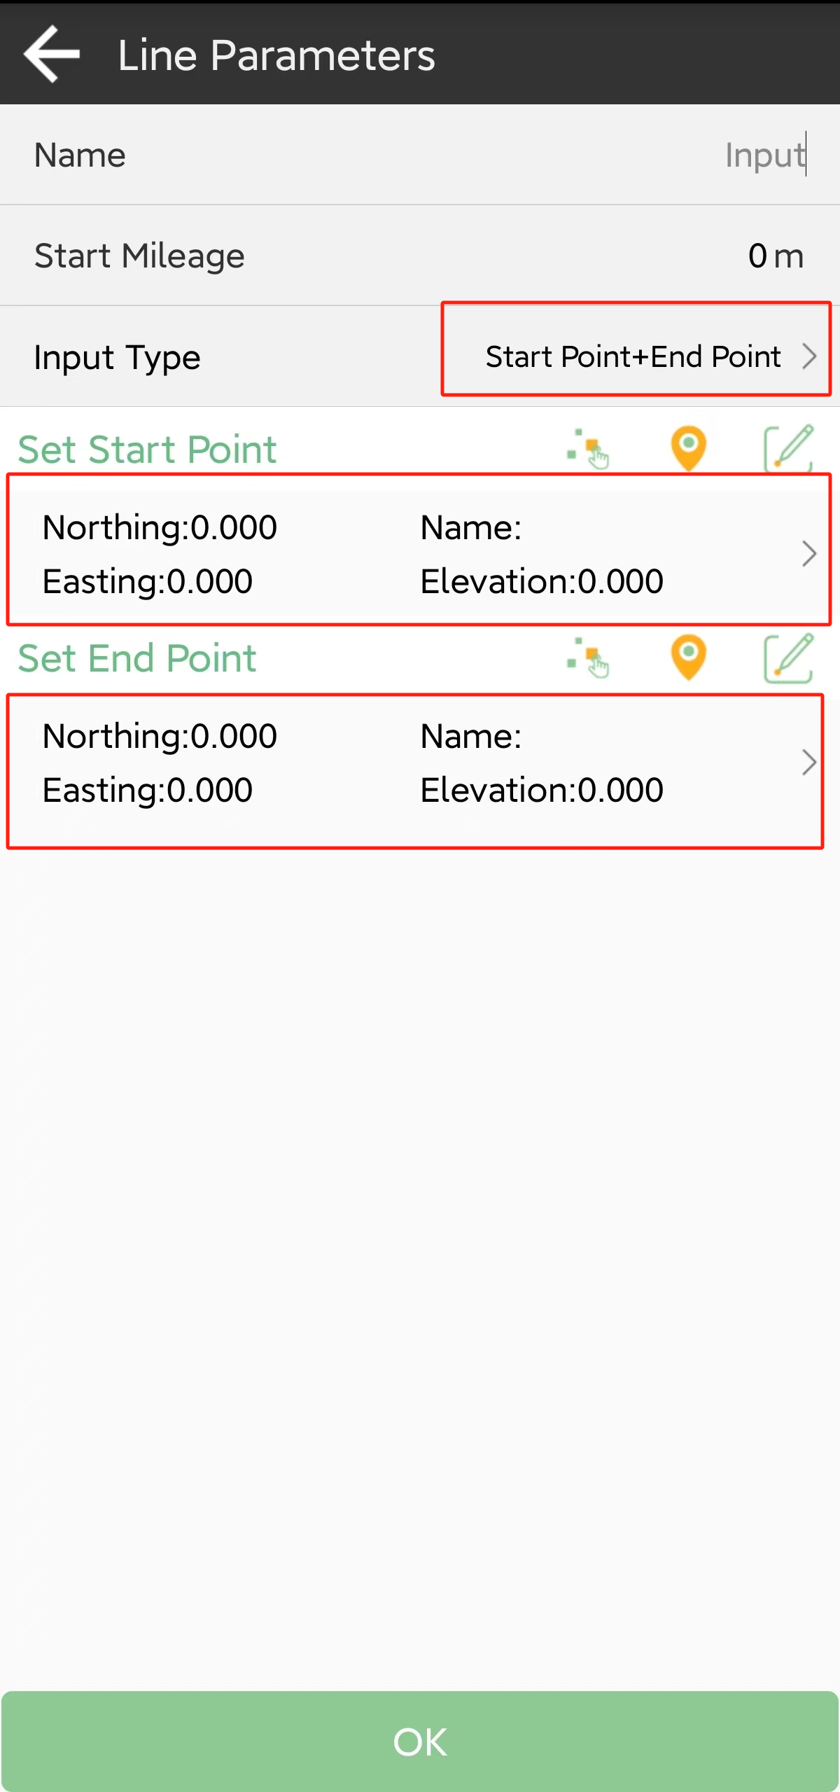 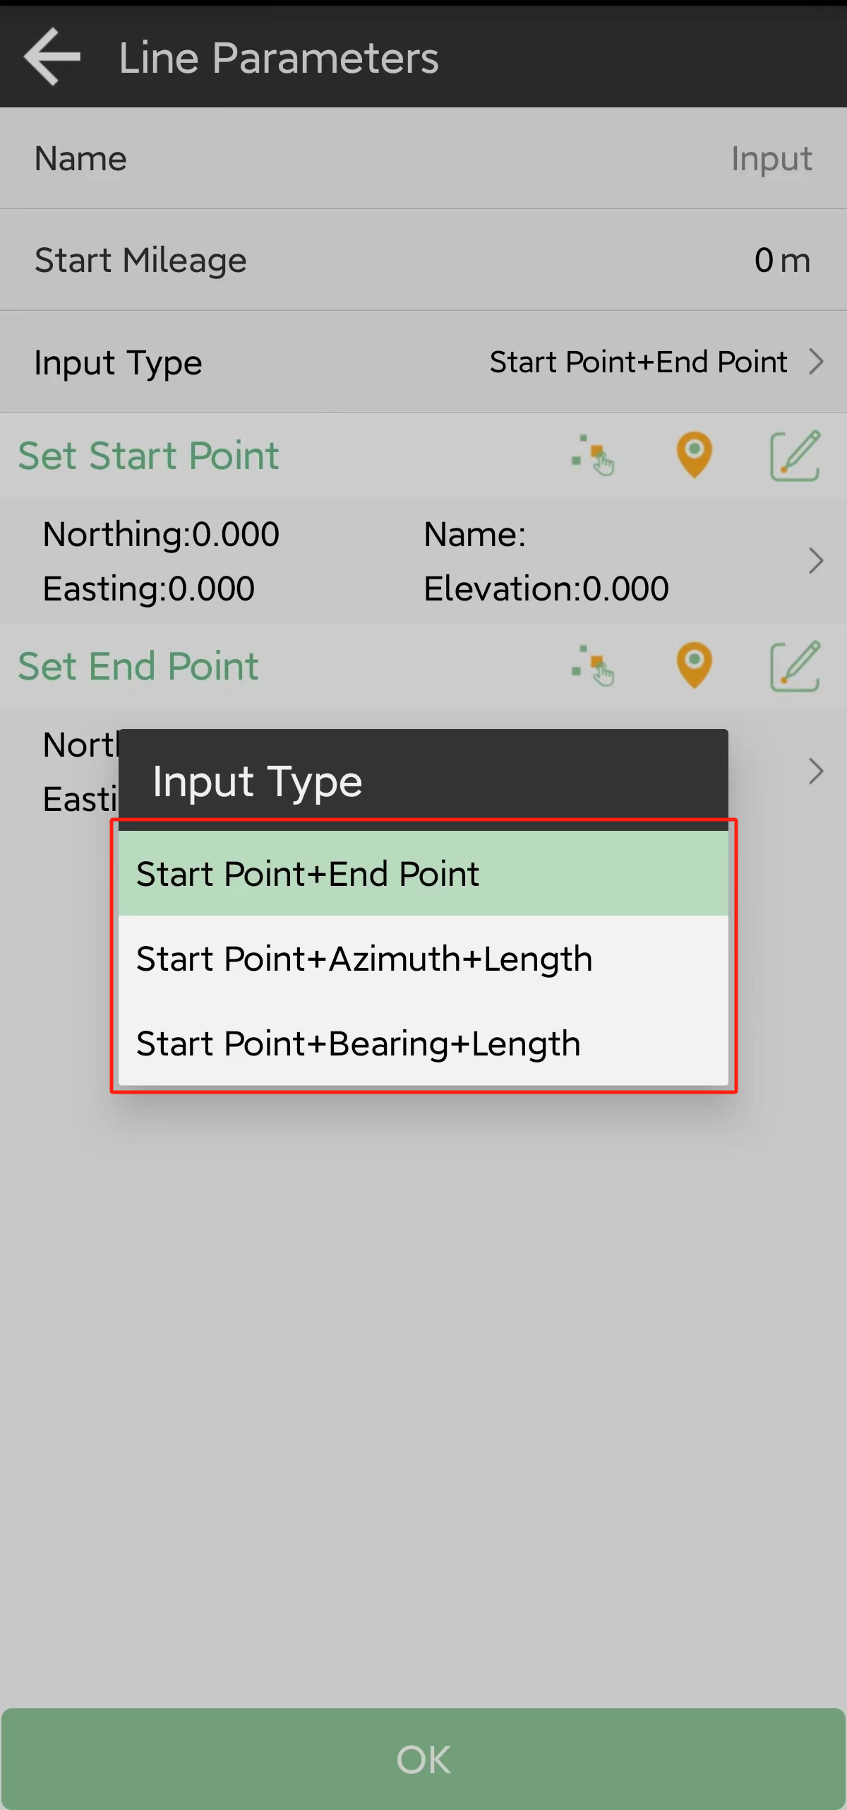

• Click Import to get coordinates with different kinds of files; you can also define a new format.

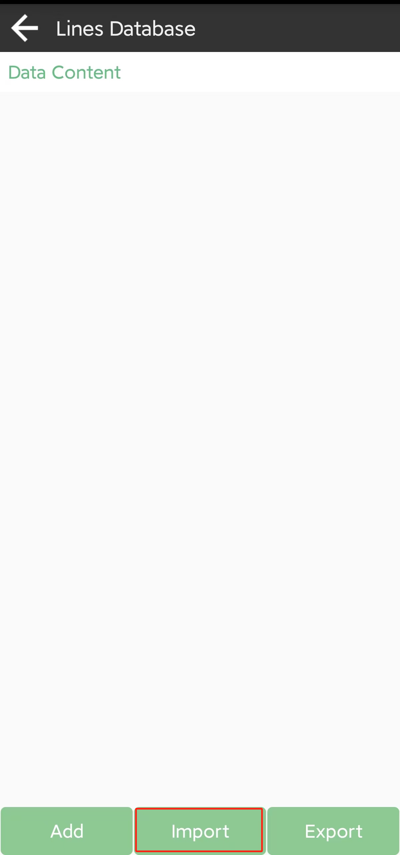 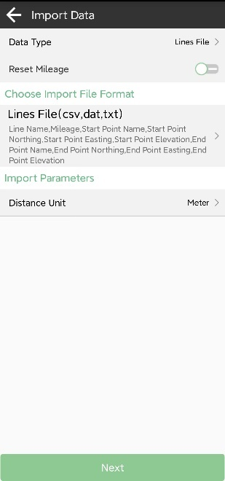

Choose a line to stake, set calculation mode and interval.

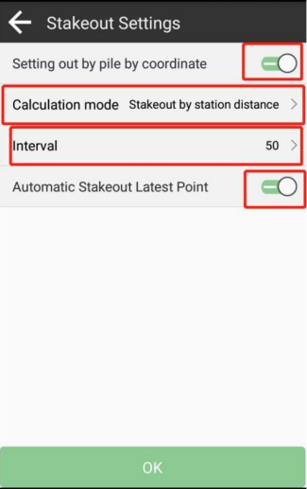 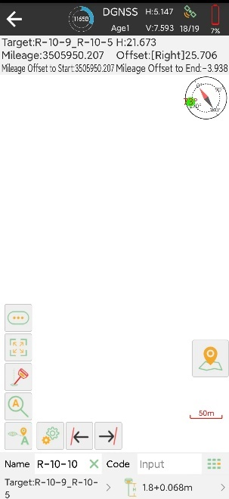

• Click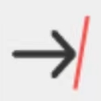, jump to next line

• Click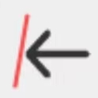, jump to previous line

## CAD stakeout

When using for the first time, the CAD interface has no layers and floating window to display the features you need to stake.

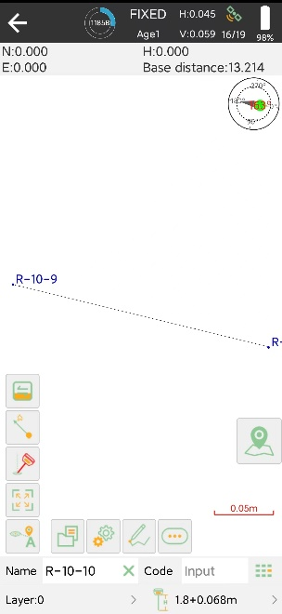

• Click to create or import a CAD file, supporting *.dxf, *.dwg format

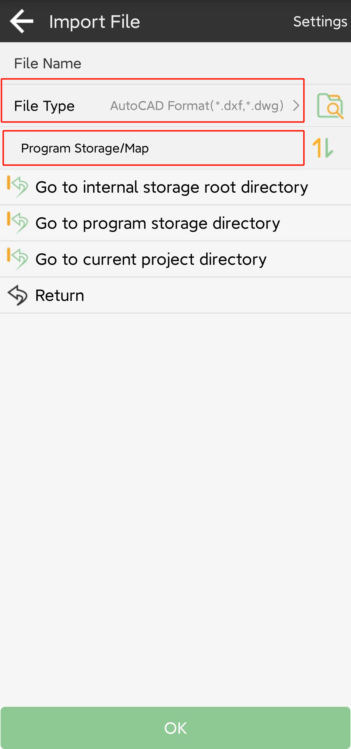

Find the file you want to stake and import it. After create or import one, you can scan and edit it in the CAD layer.

• Click to draw features, there are 12 types and methods you can choose, follow the prompts and draw.

• Clickto find tools; they can help you to work smoothly.

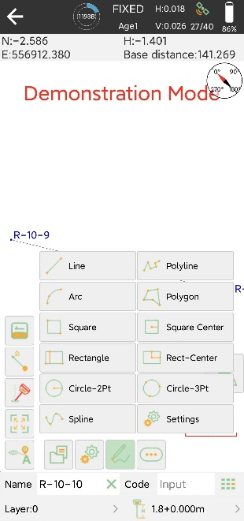 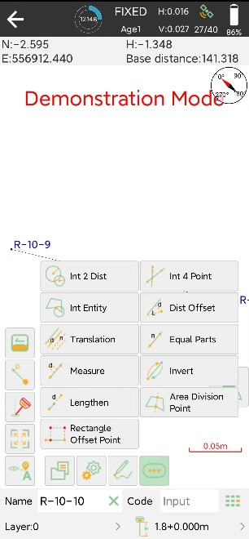

In the CAD interface, you can choose a feature you want to stake, it will show up in blue. You can know the details about it, including length, start point, end point and center point. And choose the way to stake.

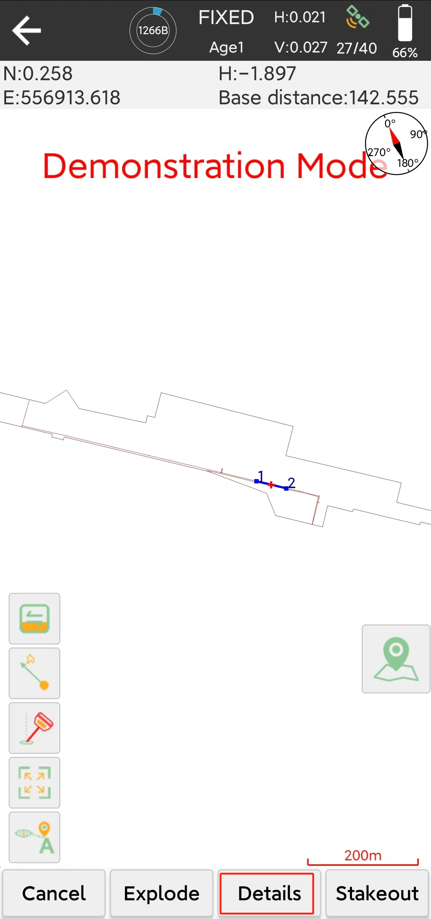 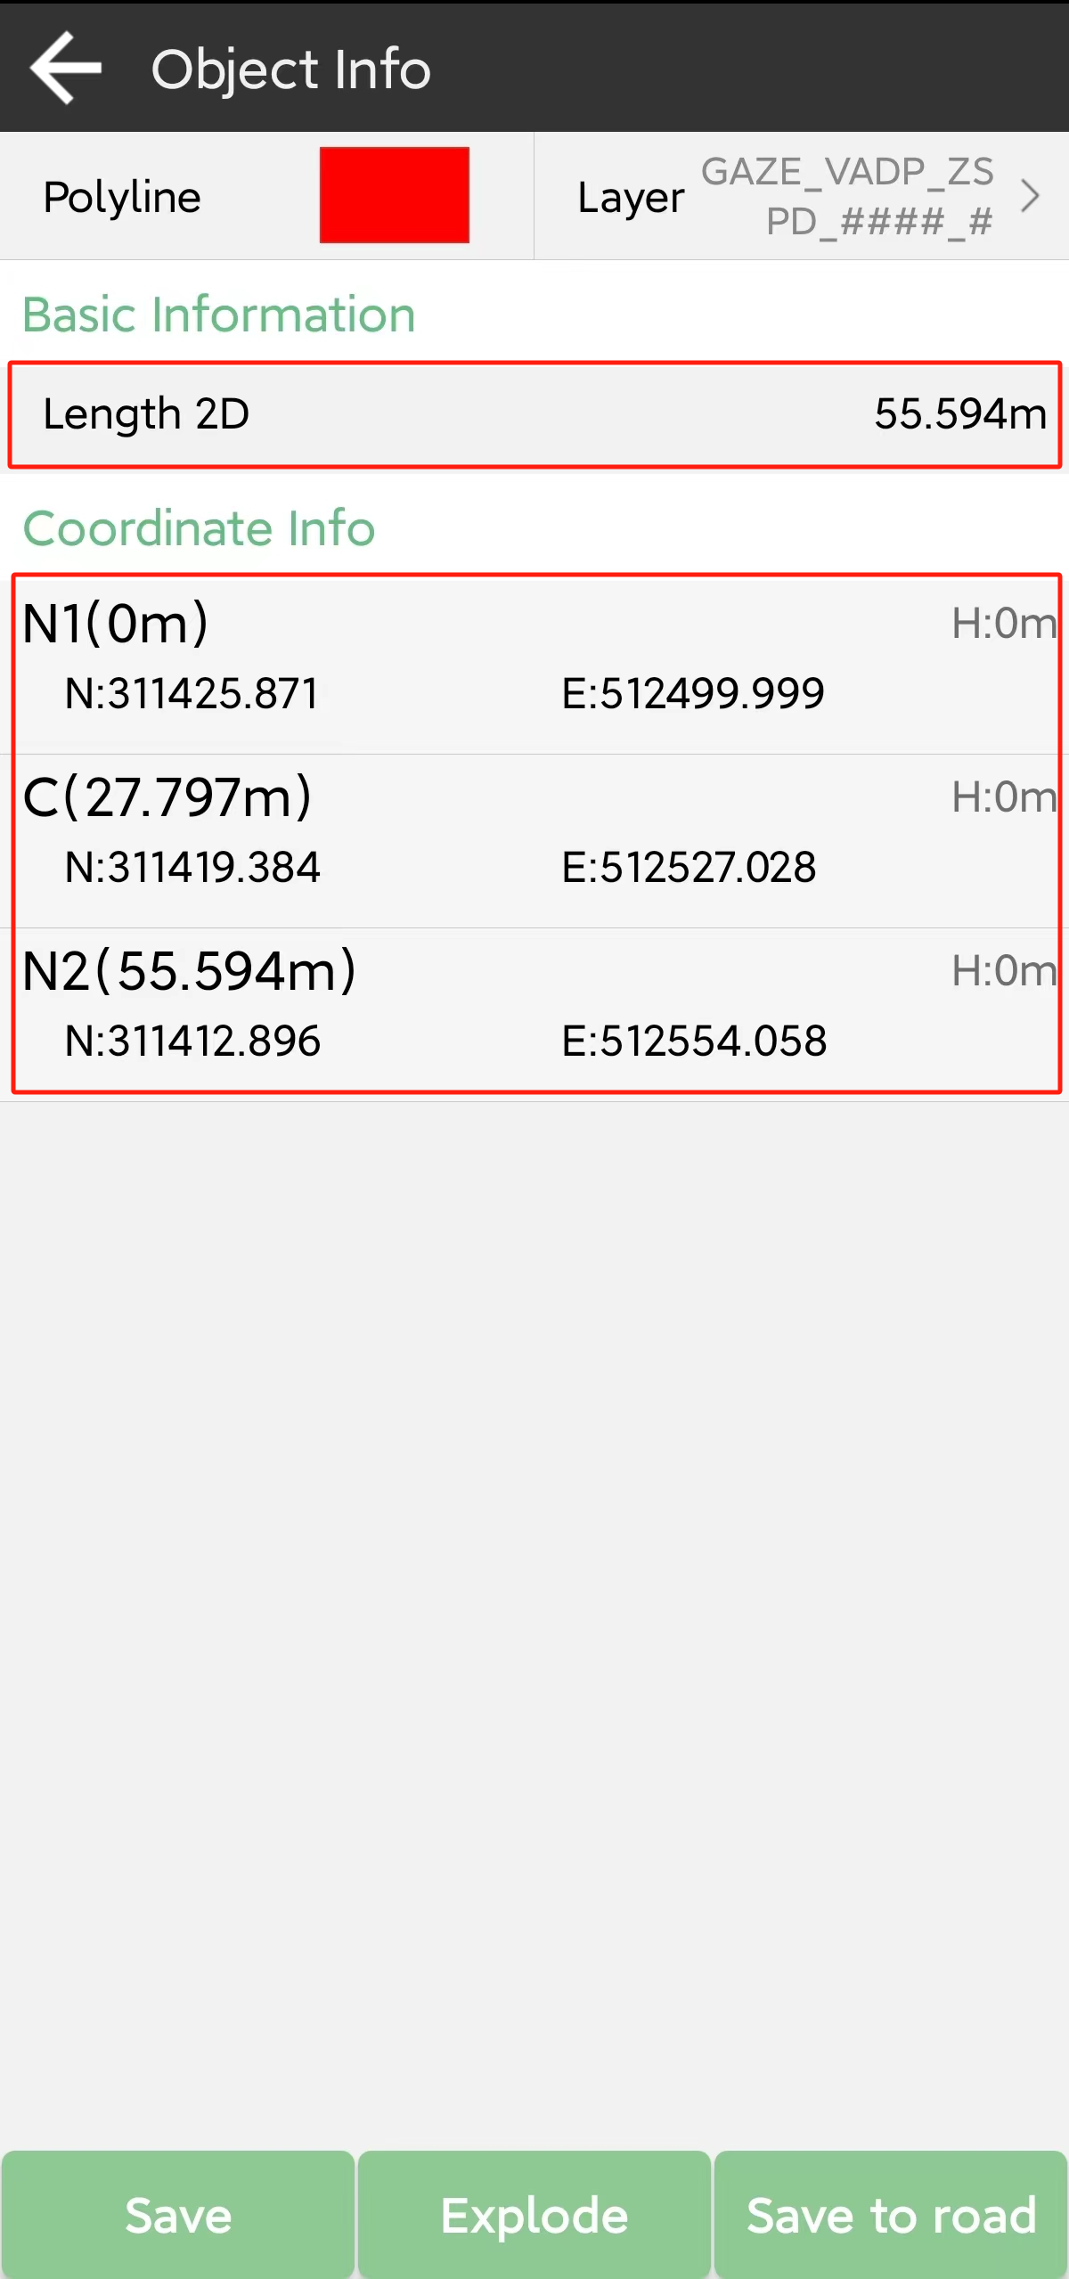

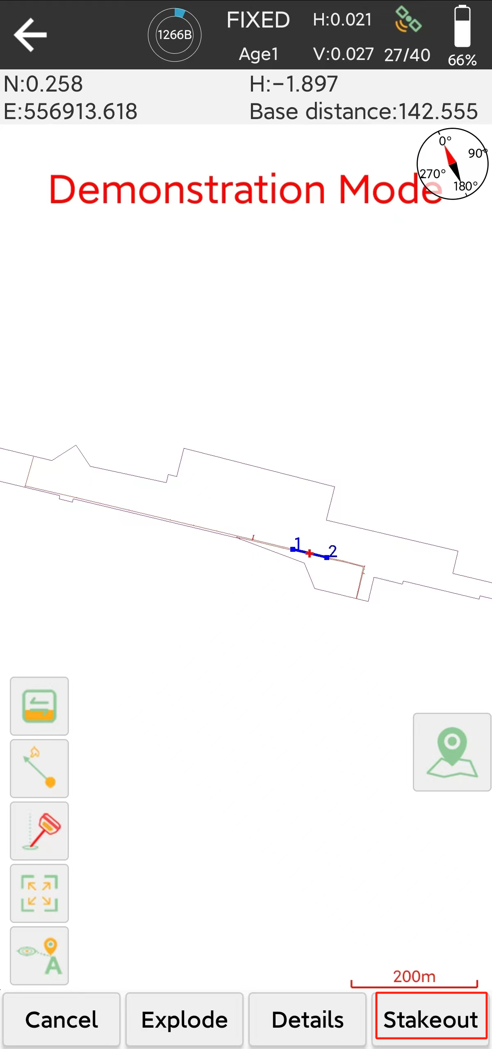 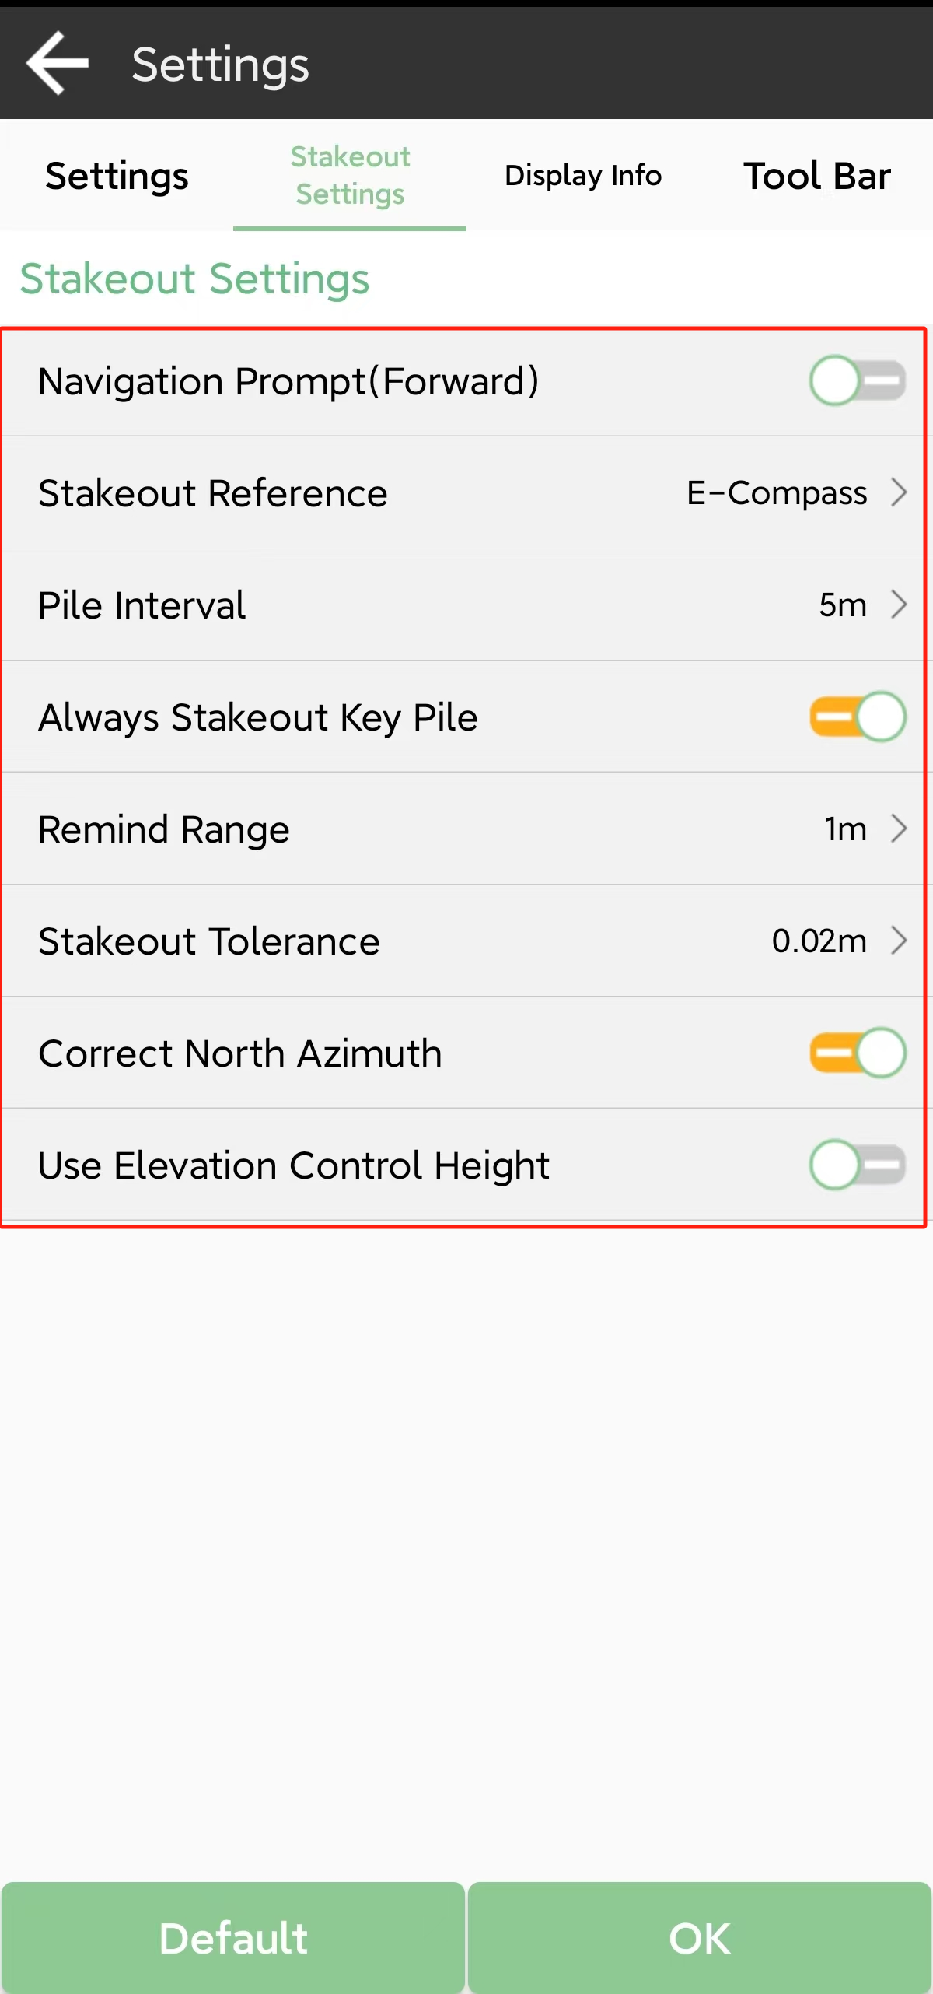

## Line stakeout

You can stakeout line in this interface, if you don’t open a surface before, then you need to add two point by surveying or importing. And can select coordinate in add interface.

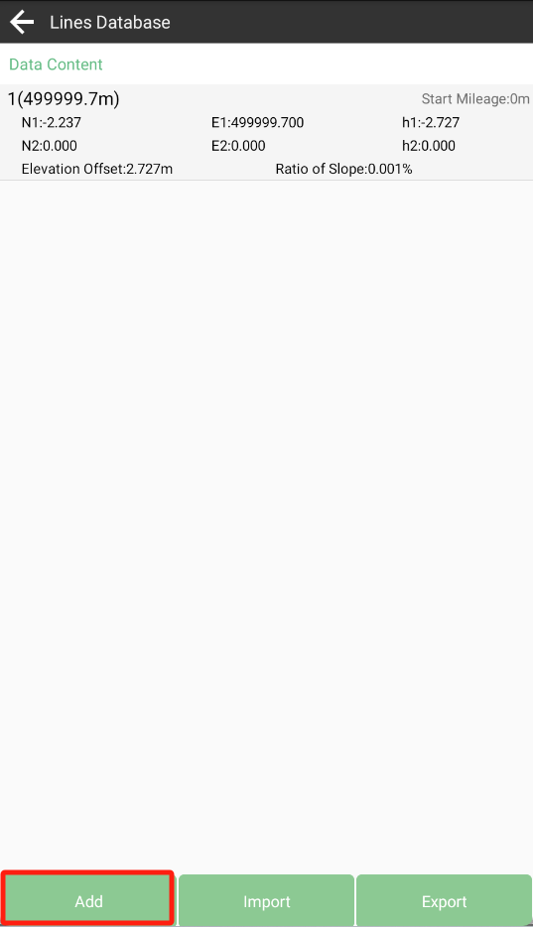 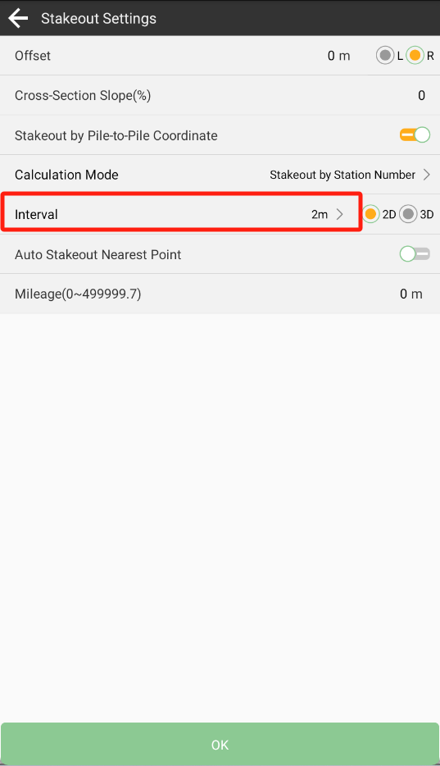

In the setting, you can set interval, such 2m, 3m.

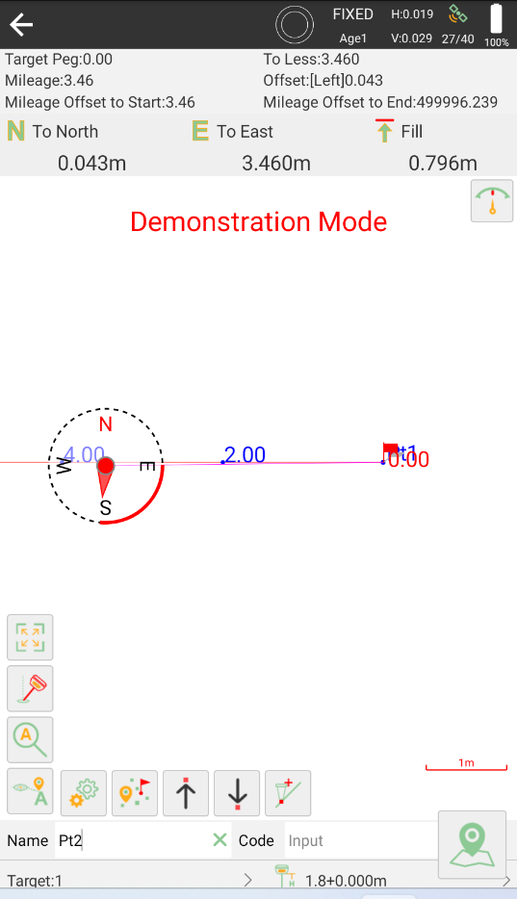

## DSM stakeout

You can stake the elevation using the design surface, if you don’t open a surface before, then you need to add one by adding, importing coordinates or choosing from the database.

You can get a preview map after adding points and don’t forget save it.

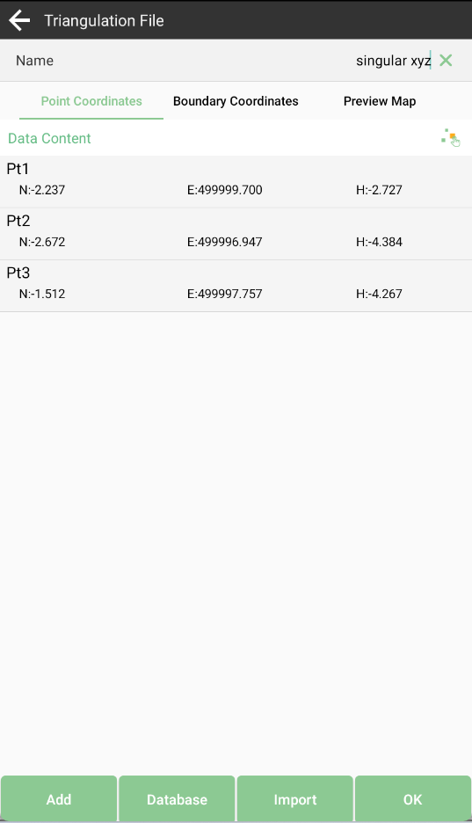 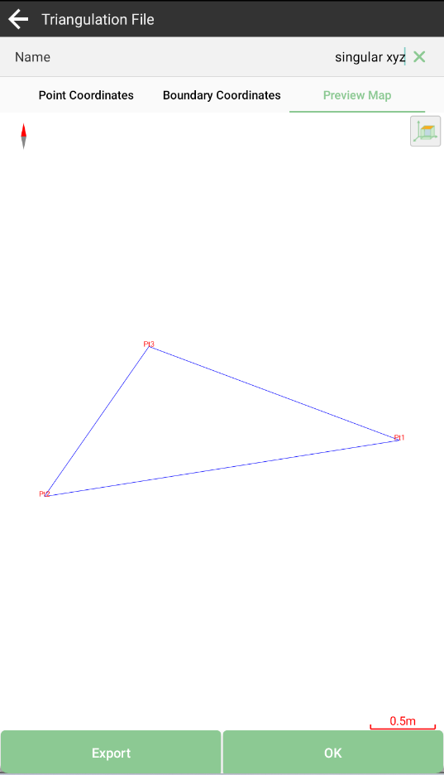

At the content list interface, you can find the surfaces you made, and you can edit, share and stake them. And if the current position is not within the range of the design surface, it will show “Out of Surface!” if the current position is within the range of the design surface, it will show the fill or excavation value.

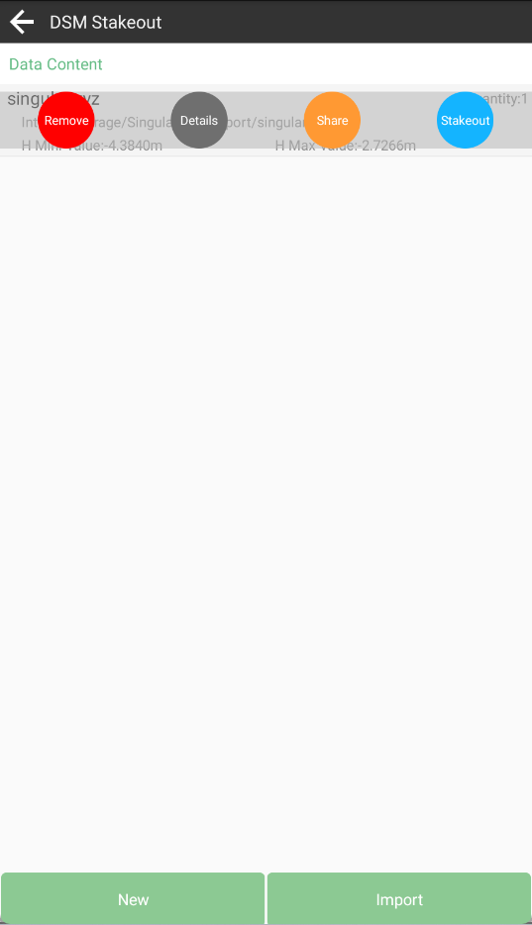 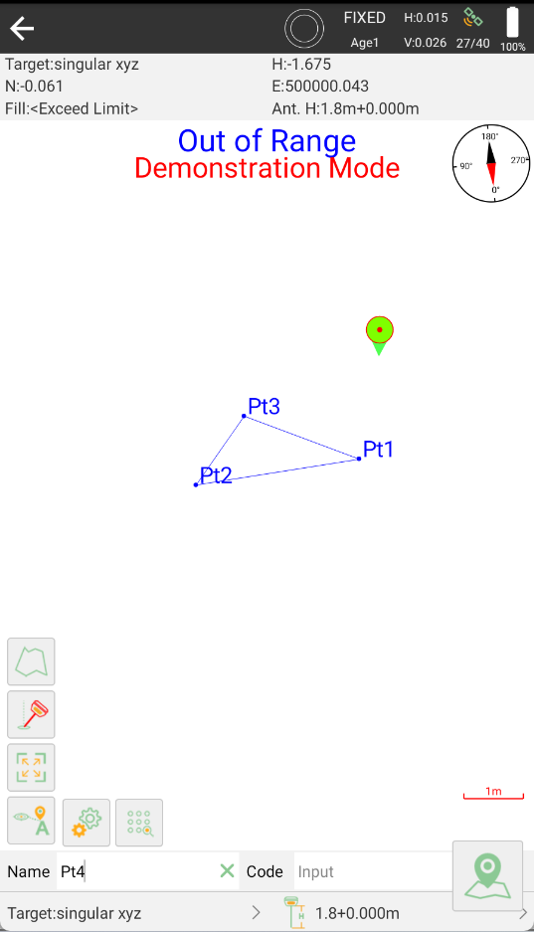

## Stakeout road

To stake road alignment, first you need design the road, including the broken station, center line, vertical profile, standard cross section and slop. You can design it by newing or importing.

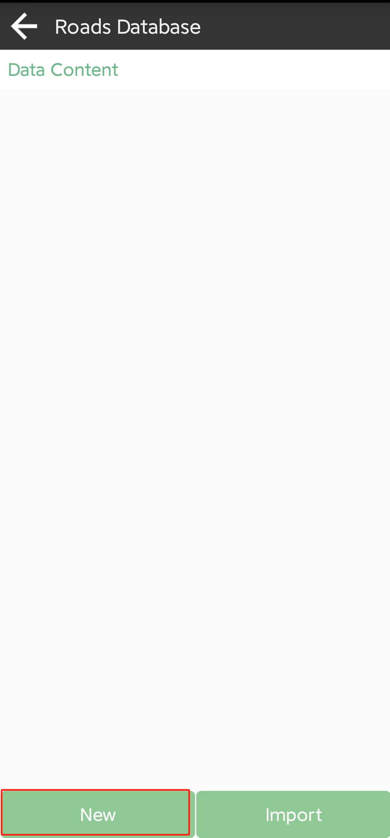 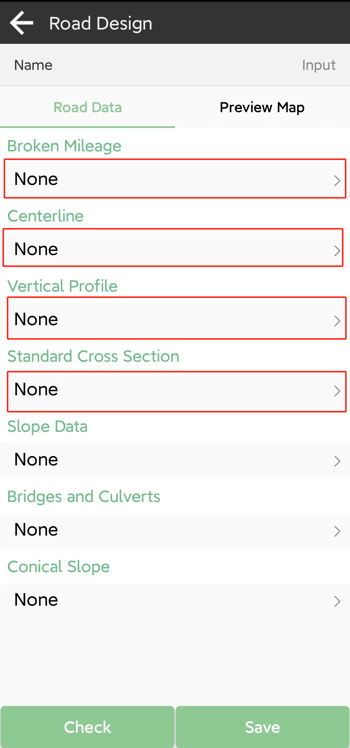

### Broken Mileage

Broken mileage refers to the phenomenon of discontinuity of pile numbers caused by local changes or section measurement. There are two main situations, one is that the front stake is larger than the back stake, and the other is that the front stake is smaller than the back stake. Classification of broken station has two types:

The first type, the front pile number is greater than the back pile number, for example: K112+943.305 = K112+900.001, and there will be duplicate piles. In this case, it is called a long chain. The distance between two long chains is the difference between the two piles, 43.304 meters.

The second type, the front pile is smaller than the back pile, for example: K115+309.227 = K115+320.001, there will be a discontinuity in the stake. This situation is called a short chain, and the distance between two short chains is also the difference between the two piles, 10.774 meters.

To sum up in a short sentence, it is: if the pile number is repeated, it is a long chain, and if the pile number is broken, it is a short chain. SingularPad supports long chain, short chain, and supports multiple broken stations at the same time. It is recommended that the user enter the broken station first before entering other parameters to avoid changing the broken station later and affect other parameters. Of course, you can also enter the broken later.

When you enter the broken station, it is entered as real number, for example, K1+234.000 = K1+238.000, the mileage before the broken station, you need to enter 1234, the mileage after broken station, you need to enter 1238;

K112+943.305 = K112+900.001, the mileage before the broken station, you need to enter 112943.305, the mileage after broken station, you need to enter 112900.001.

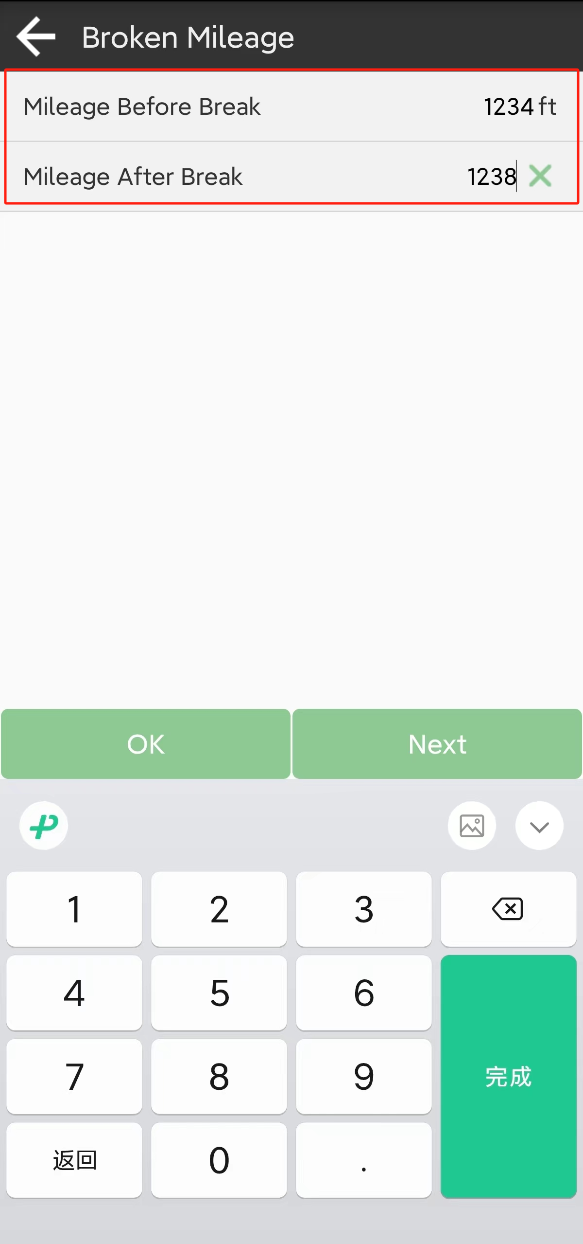 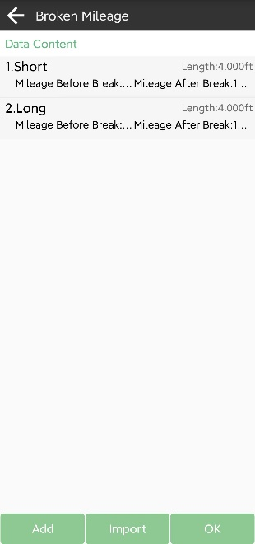

### Centerline

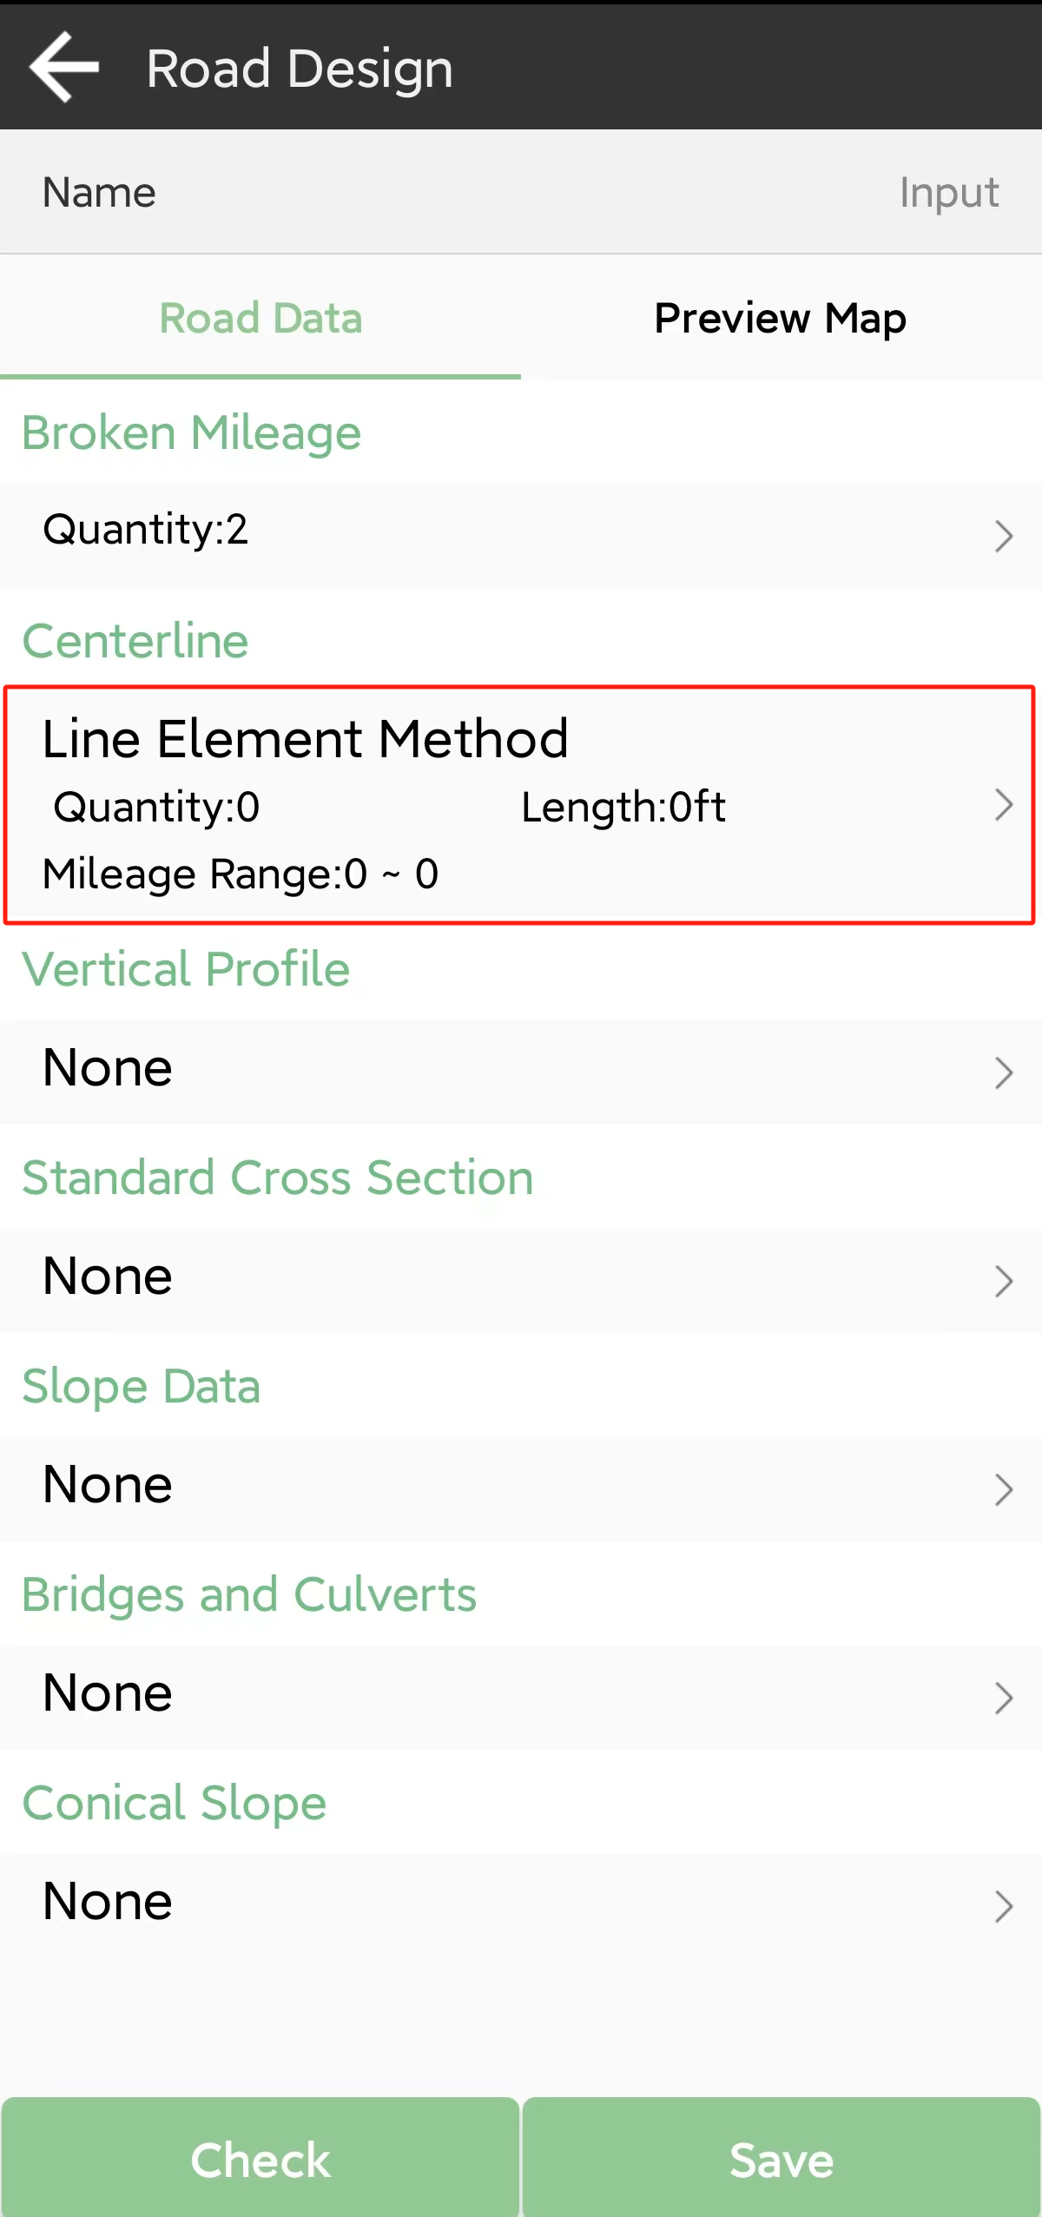 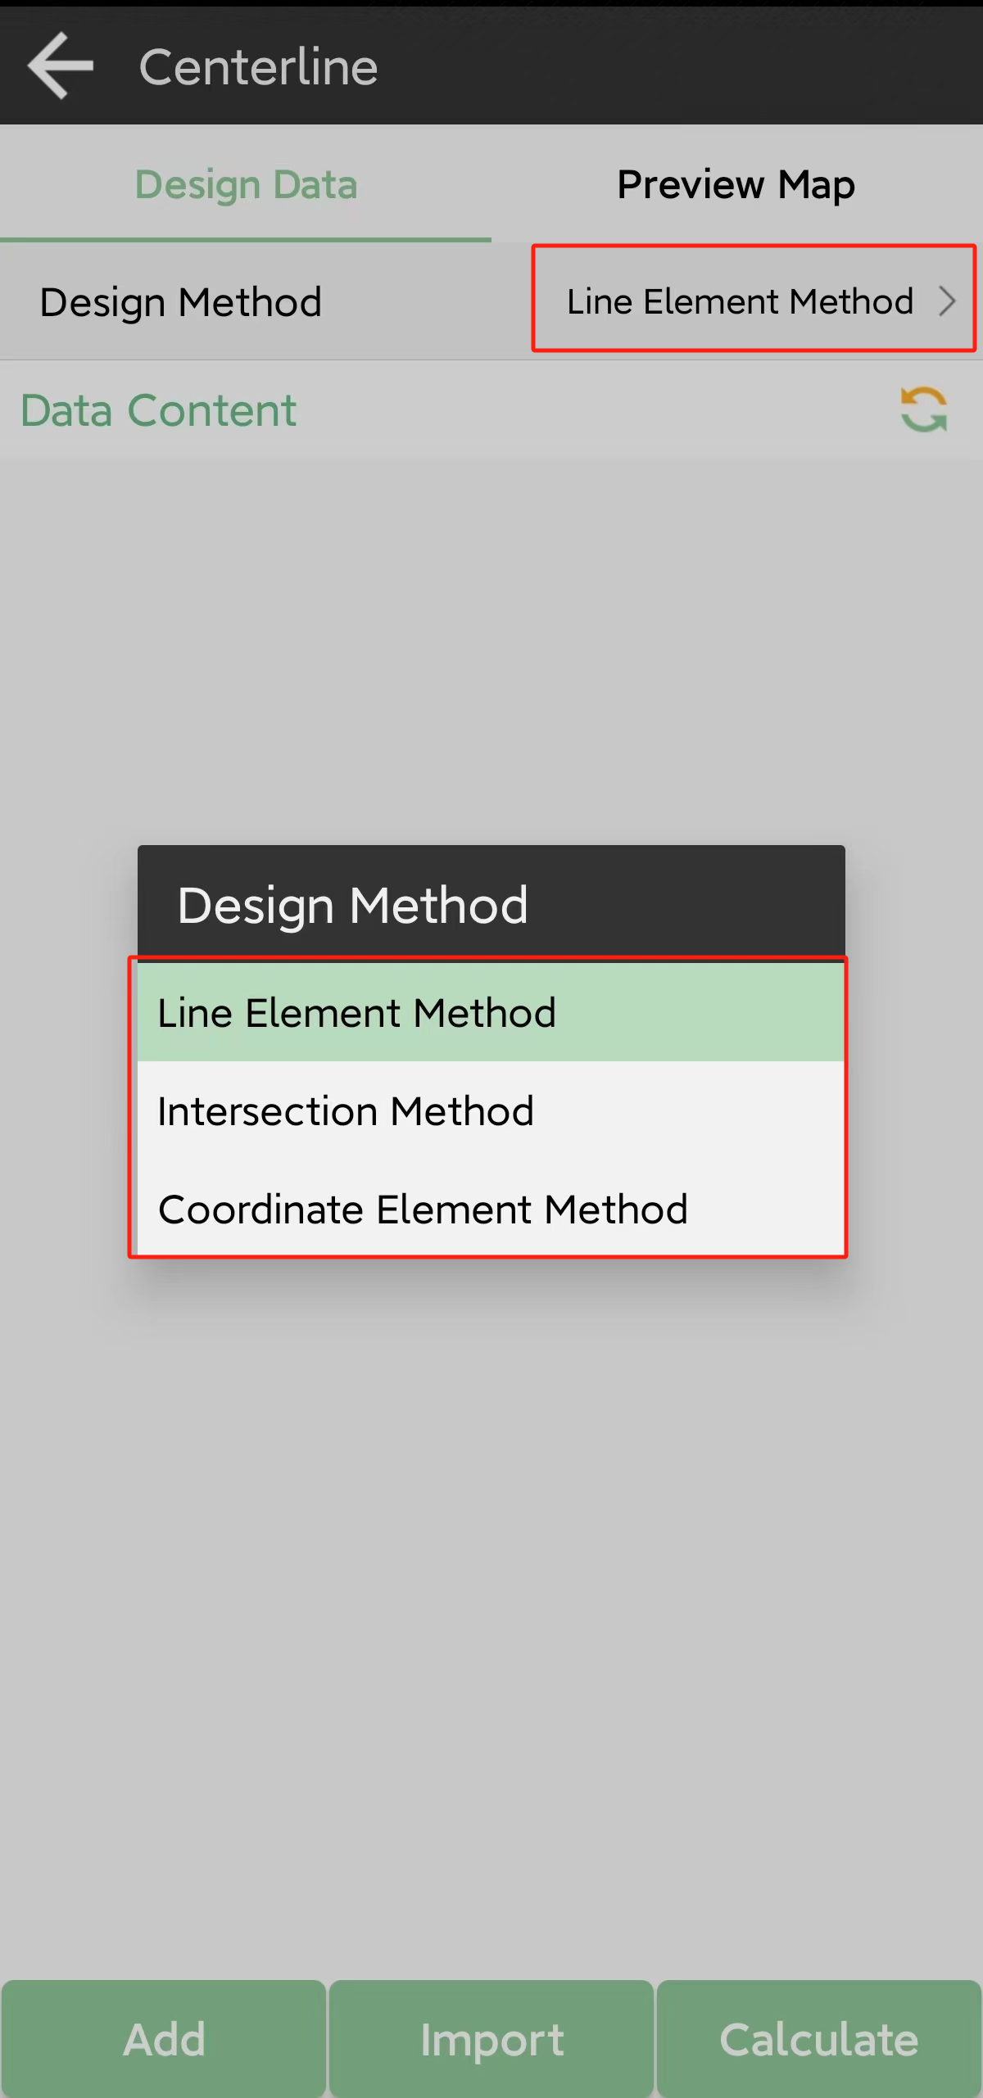

Intersection method

Intersection method refers to point of intersection, which mainly use point coordinates to define the alignment;

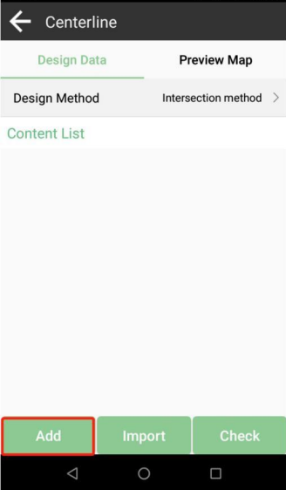 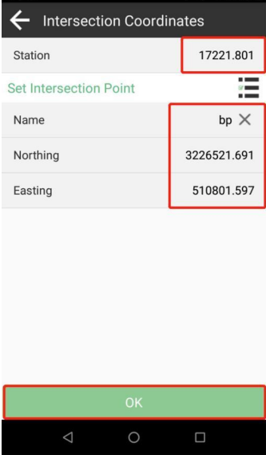

First tap Add to input the parameters of the start point and save it

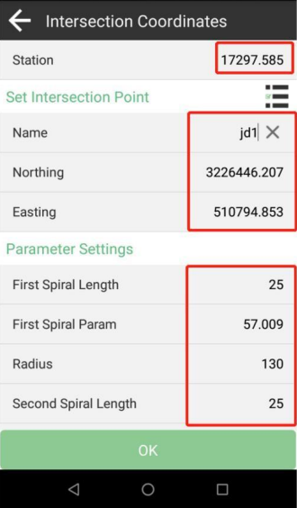 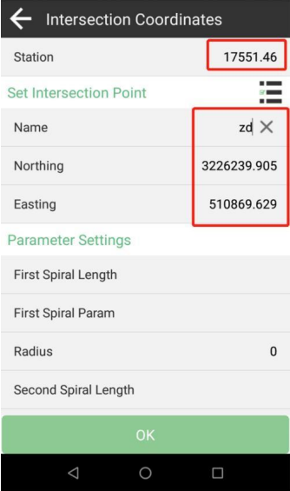

And input parameters of each station one by one, finally input the end point.

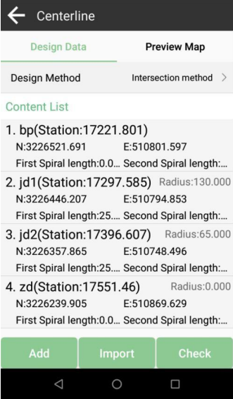 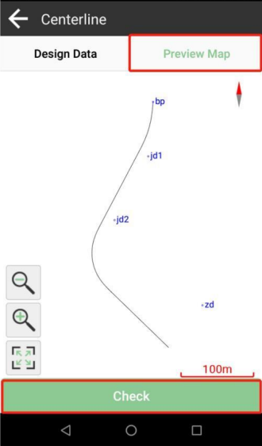

You can view details and get a preview map in the center line interface

Line element method

Line element method is more popular, which use element parameters such as line length, azimuth, Spiral and curve to define the alignment

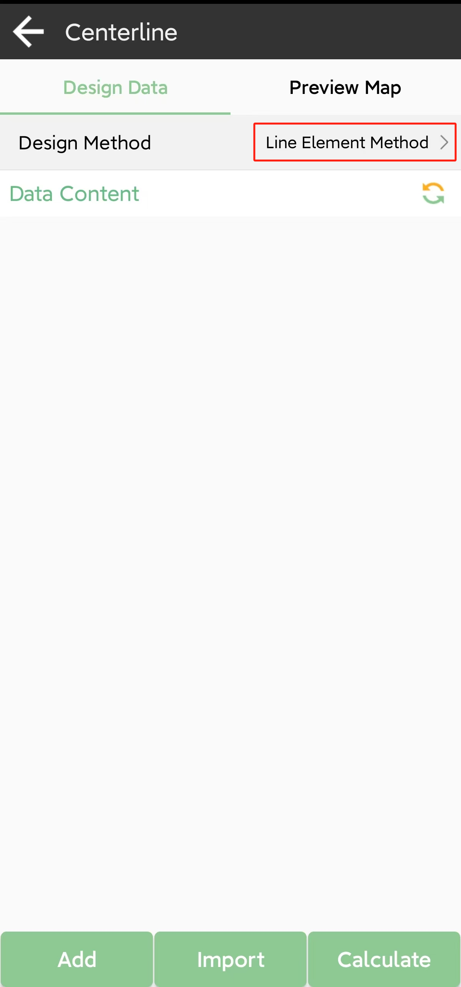 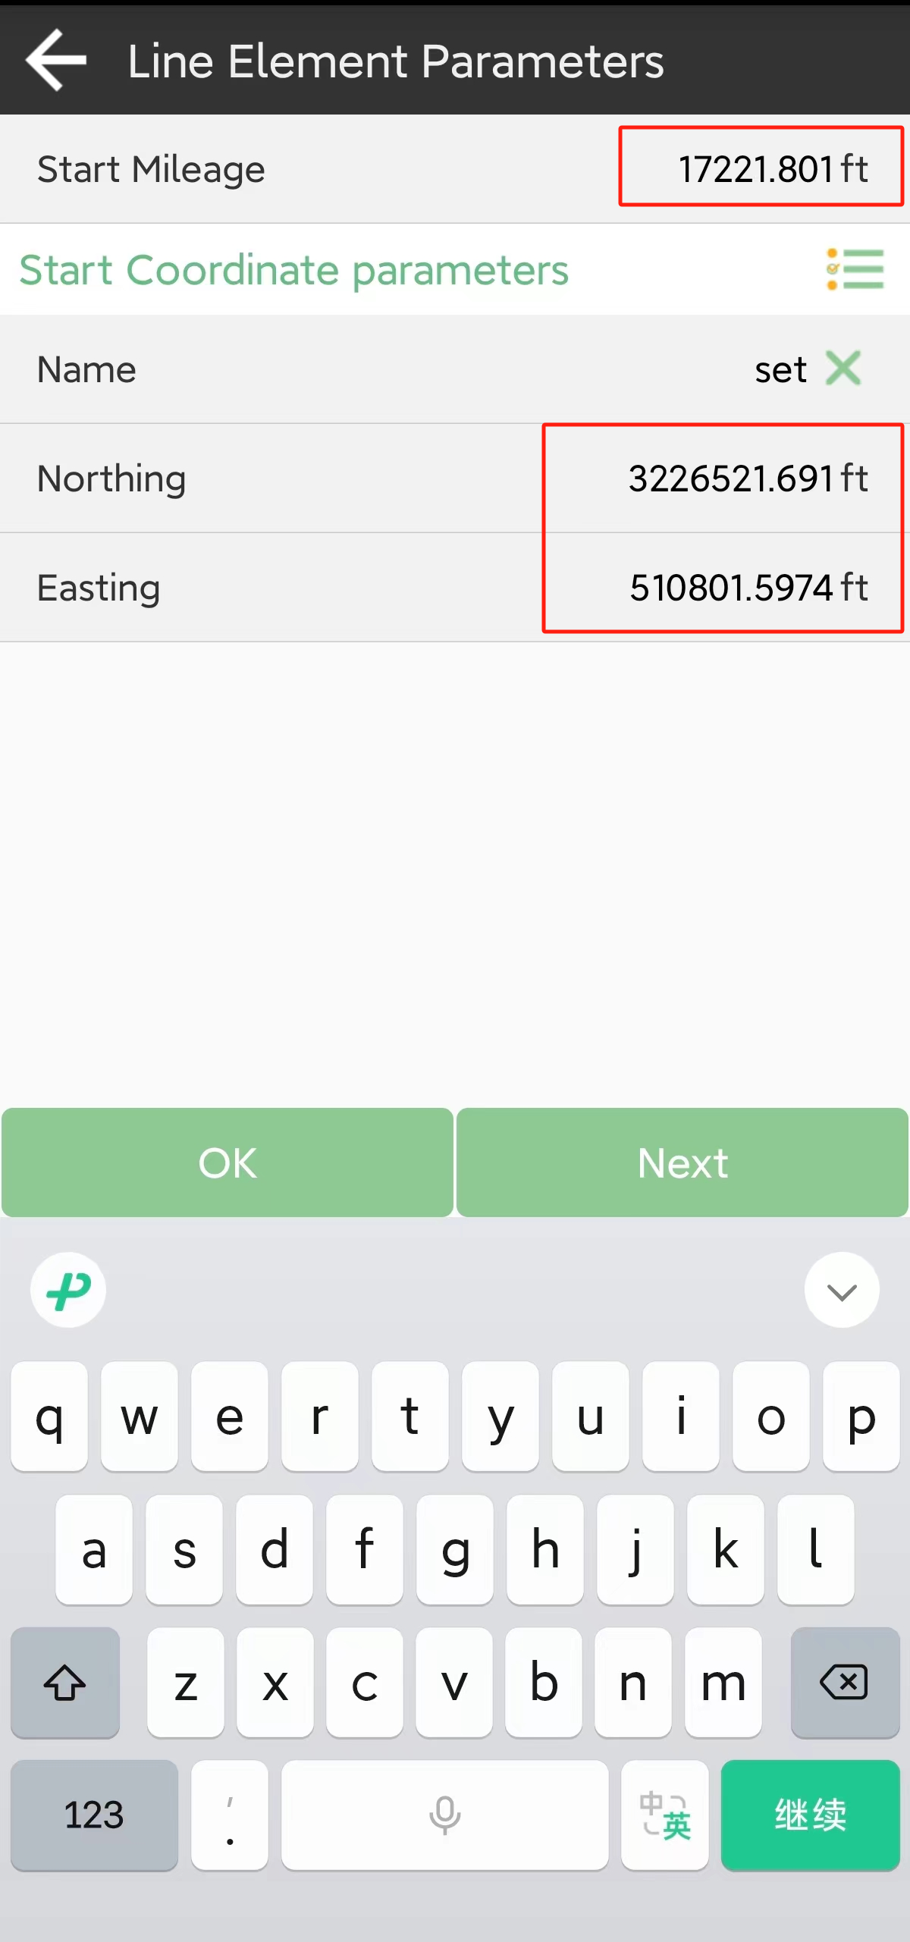

Firstly, choose line element method and add start station.

Next, enter parameters of the features one by one. Usually, after you finish one feature and tap click, it cycle in order of line spiral curve spiral. You can change according to the actual situation.

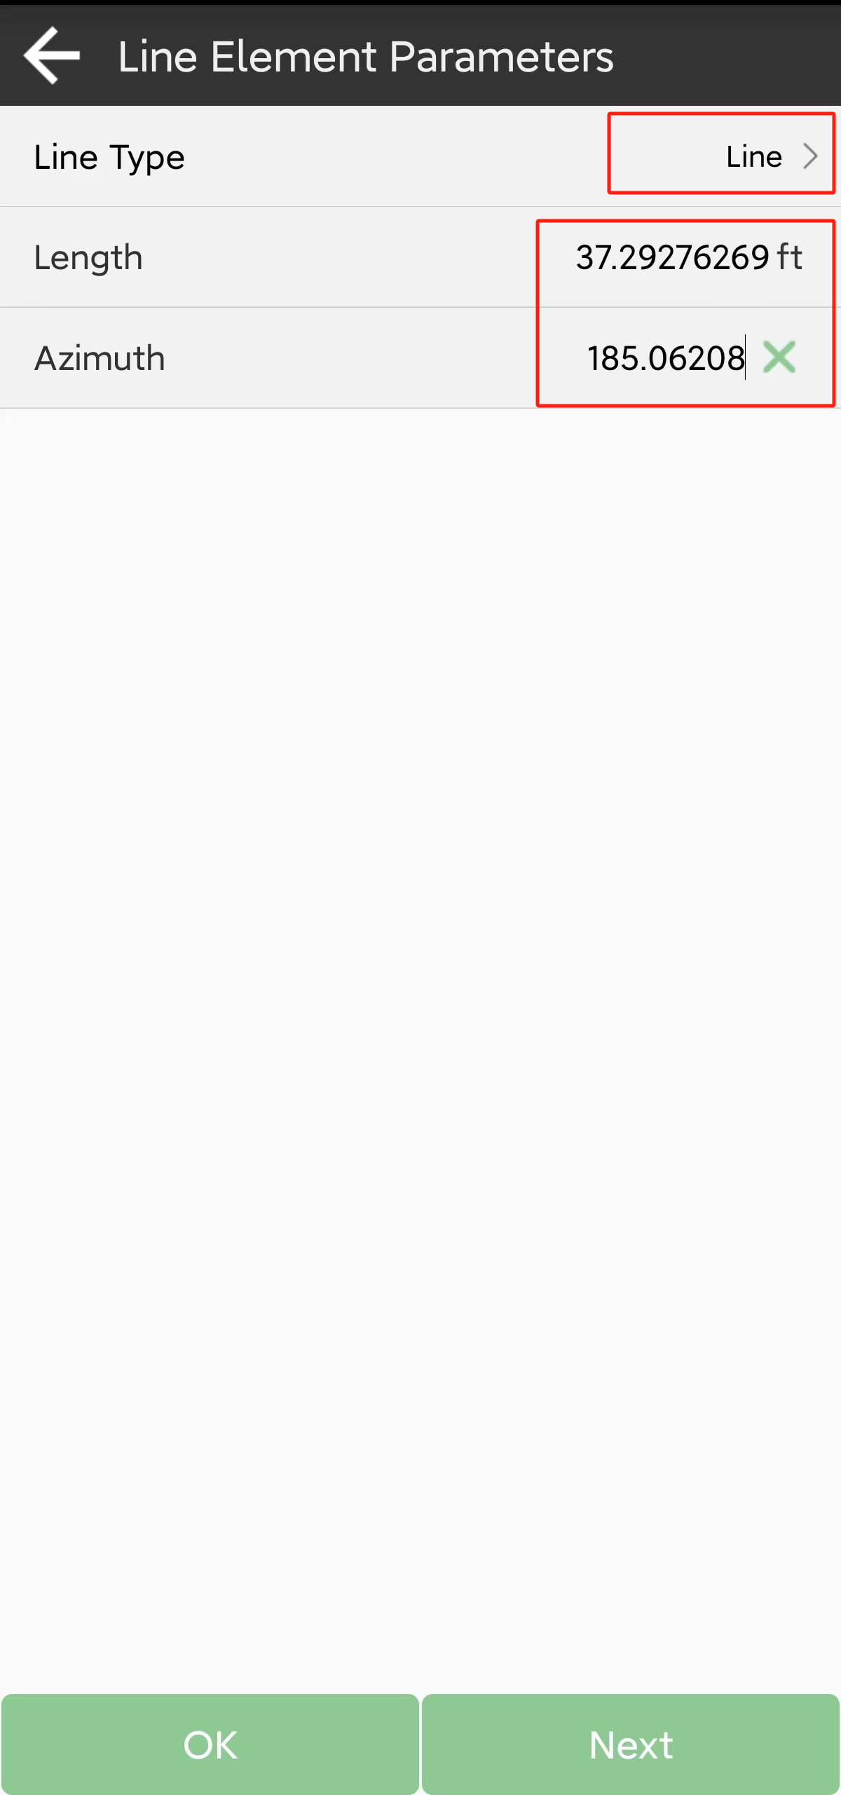 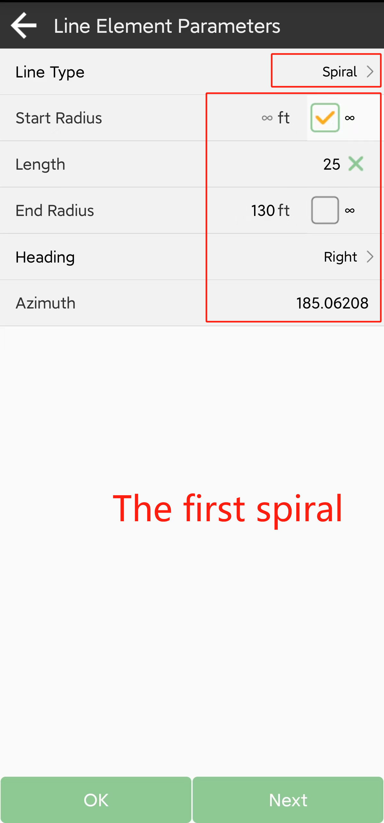

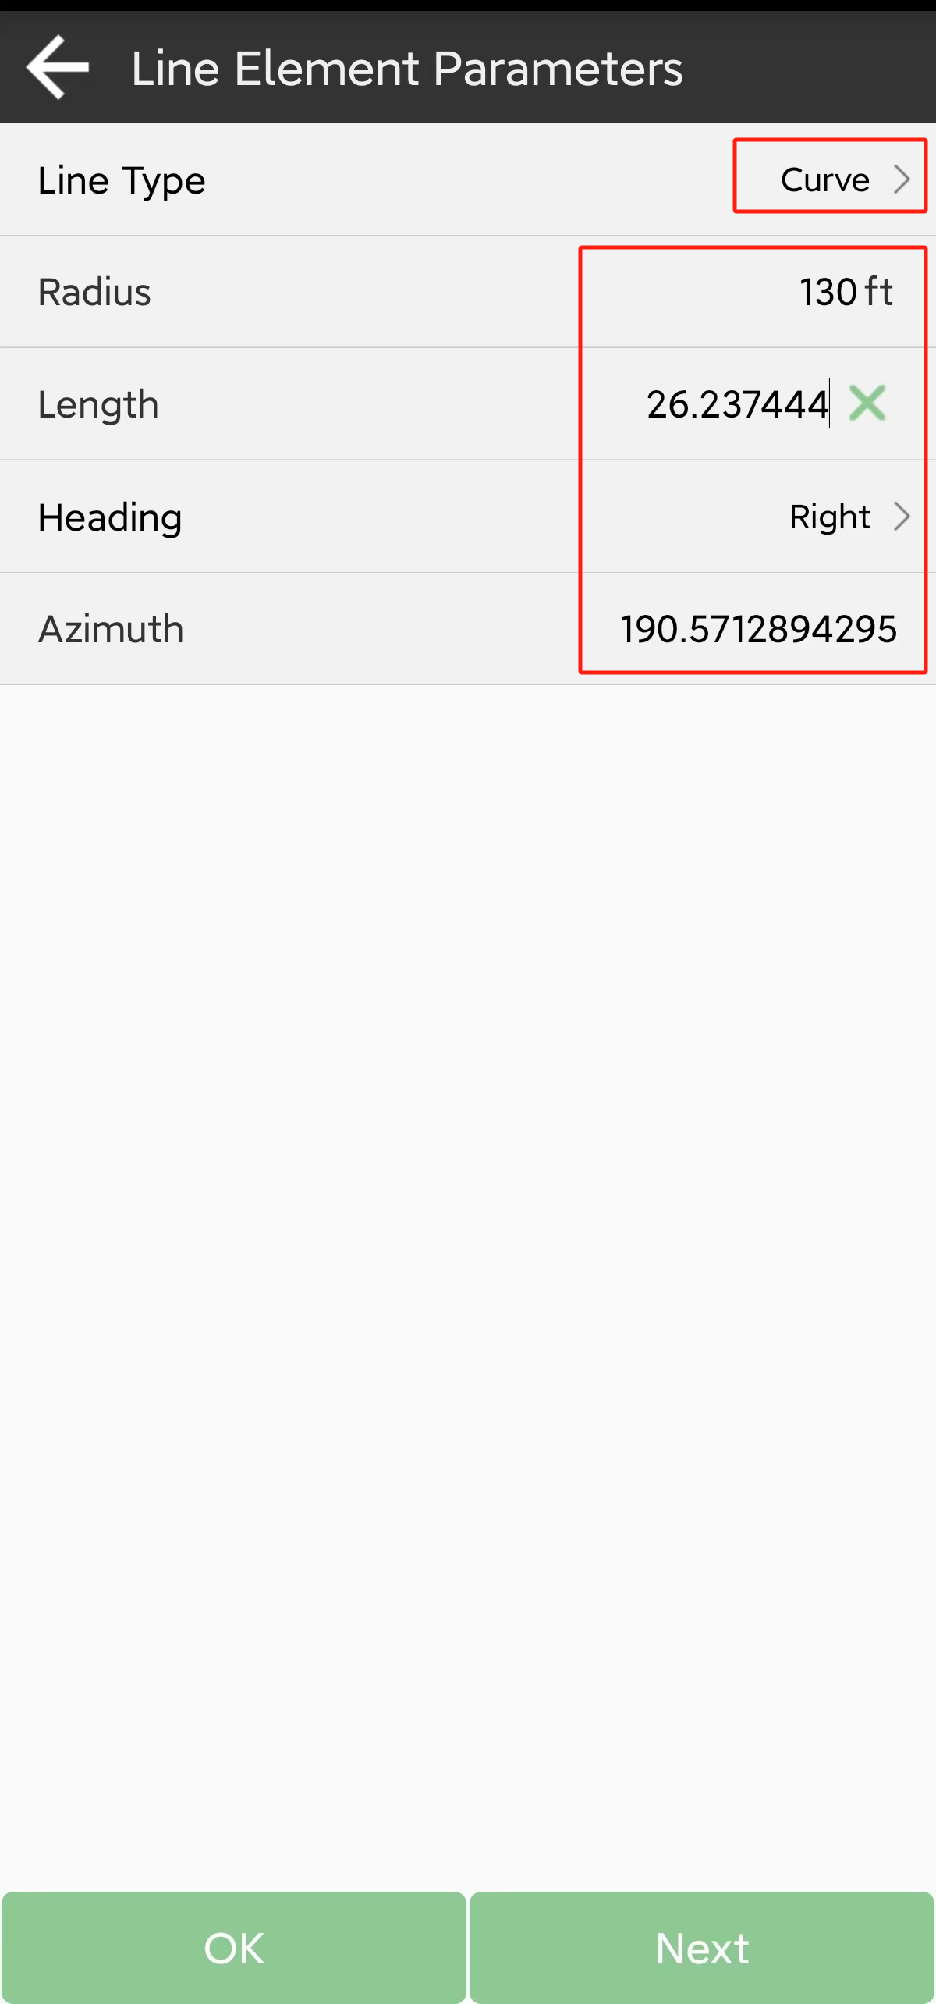 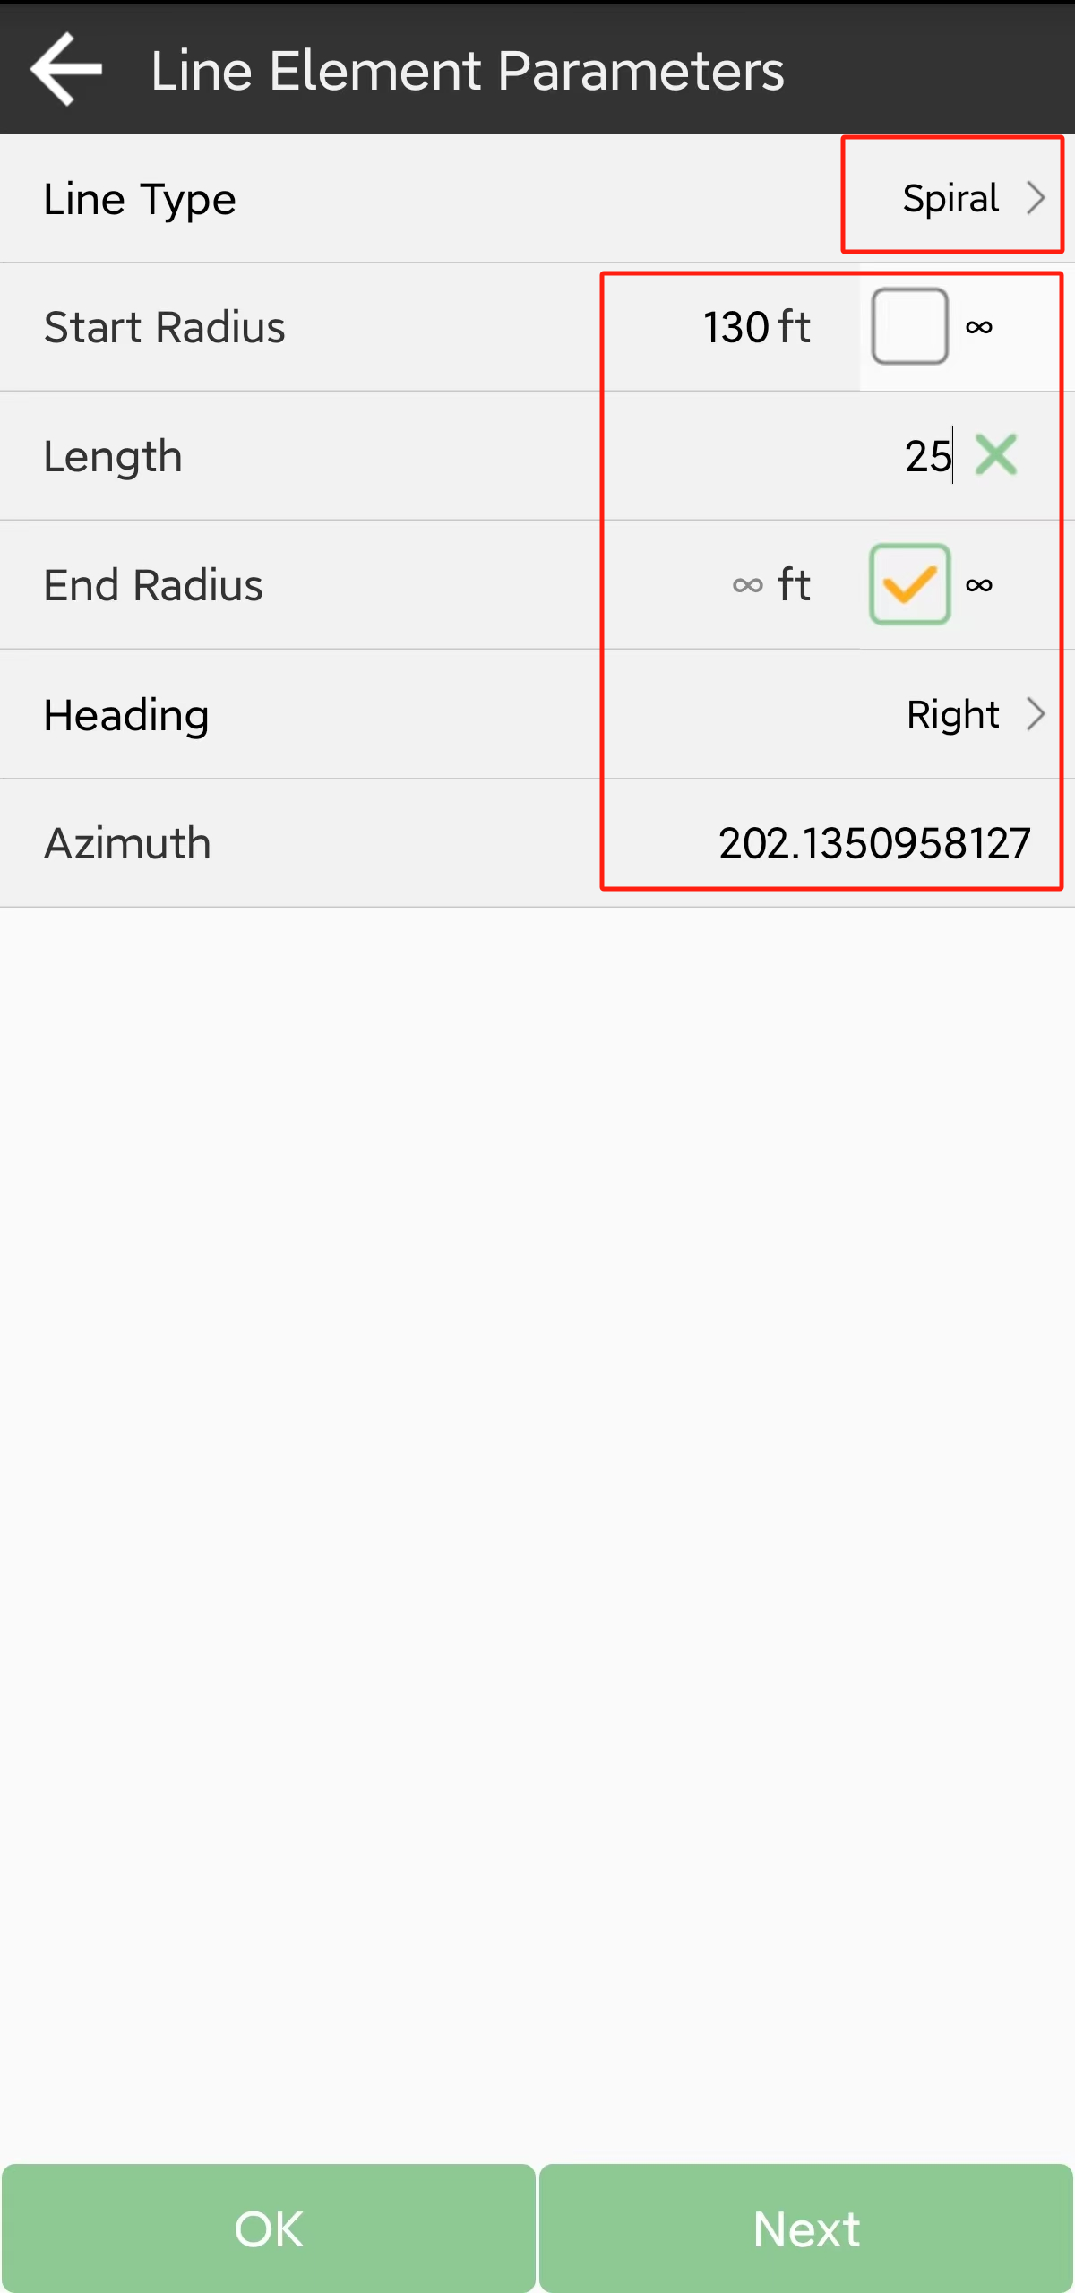

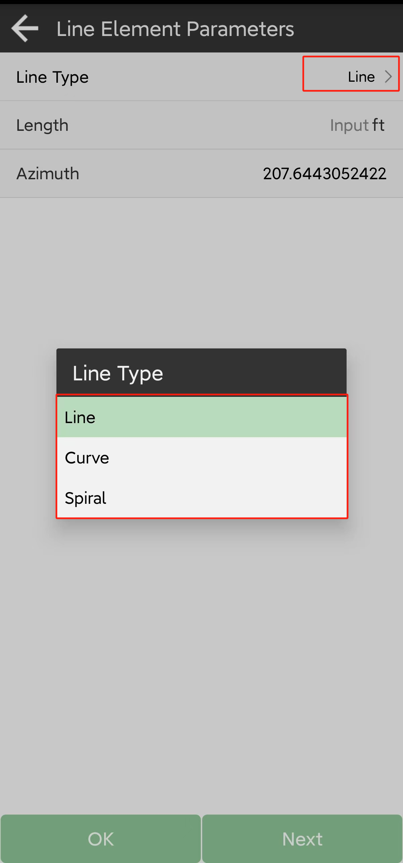

Tips: in most cases, the start radius of the fist spiral is infinite; end radius is the radius of next curve. The start radius of the fist spiral the radius of previous curve, end radius is infinite.

Also, you can calculate and edit it in the center line interface.

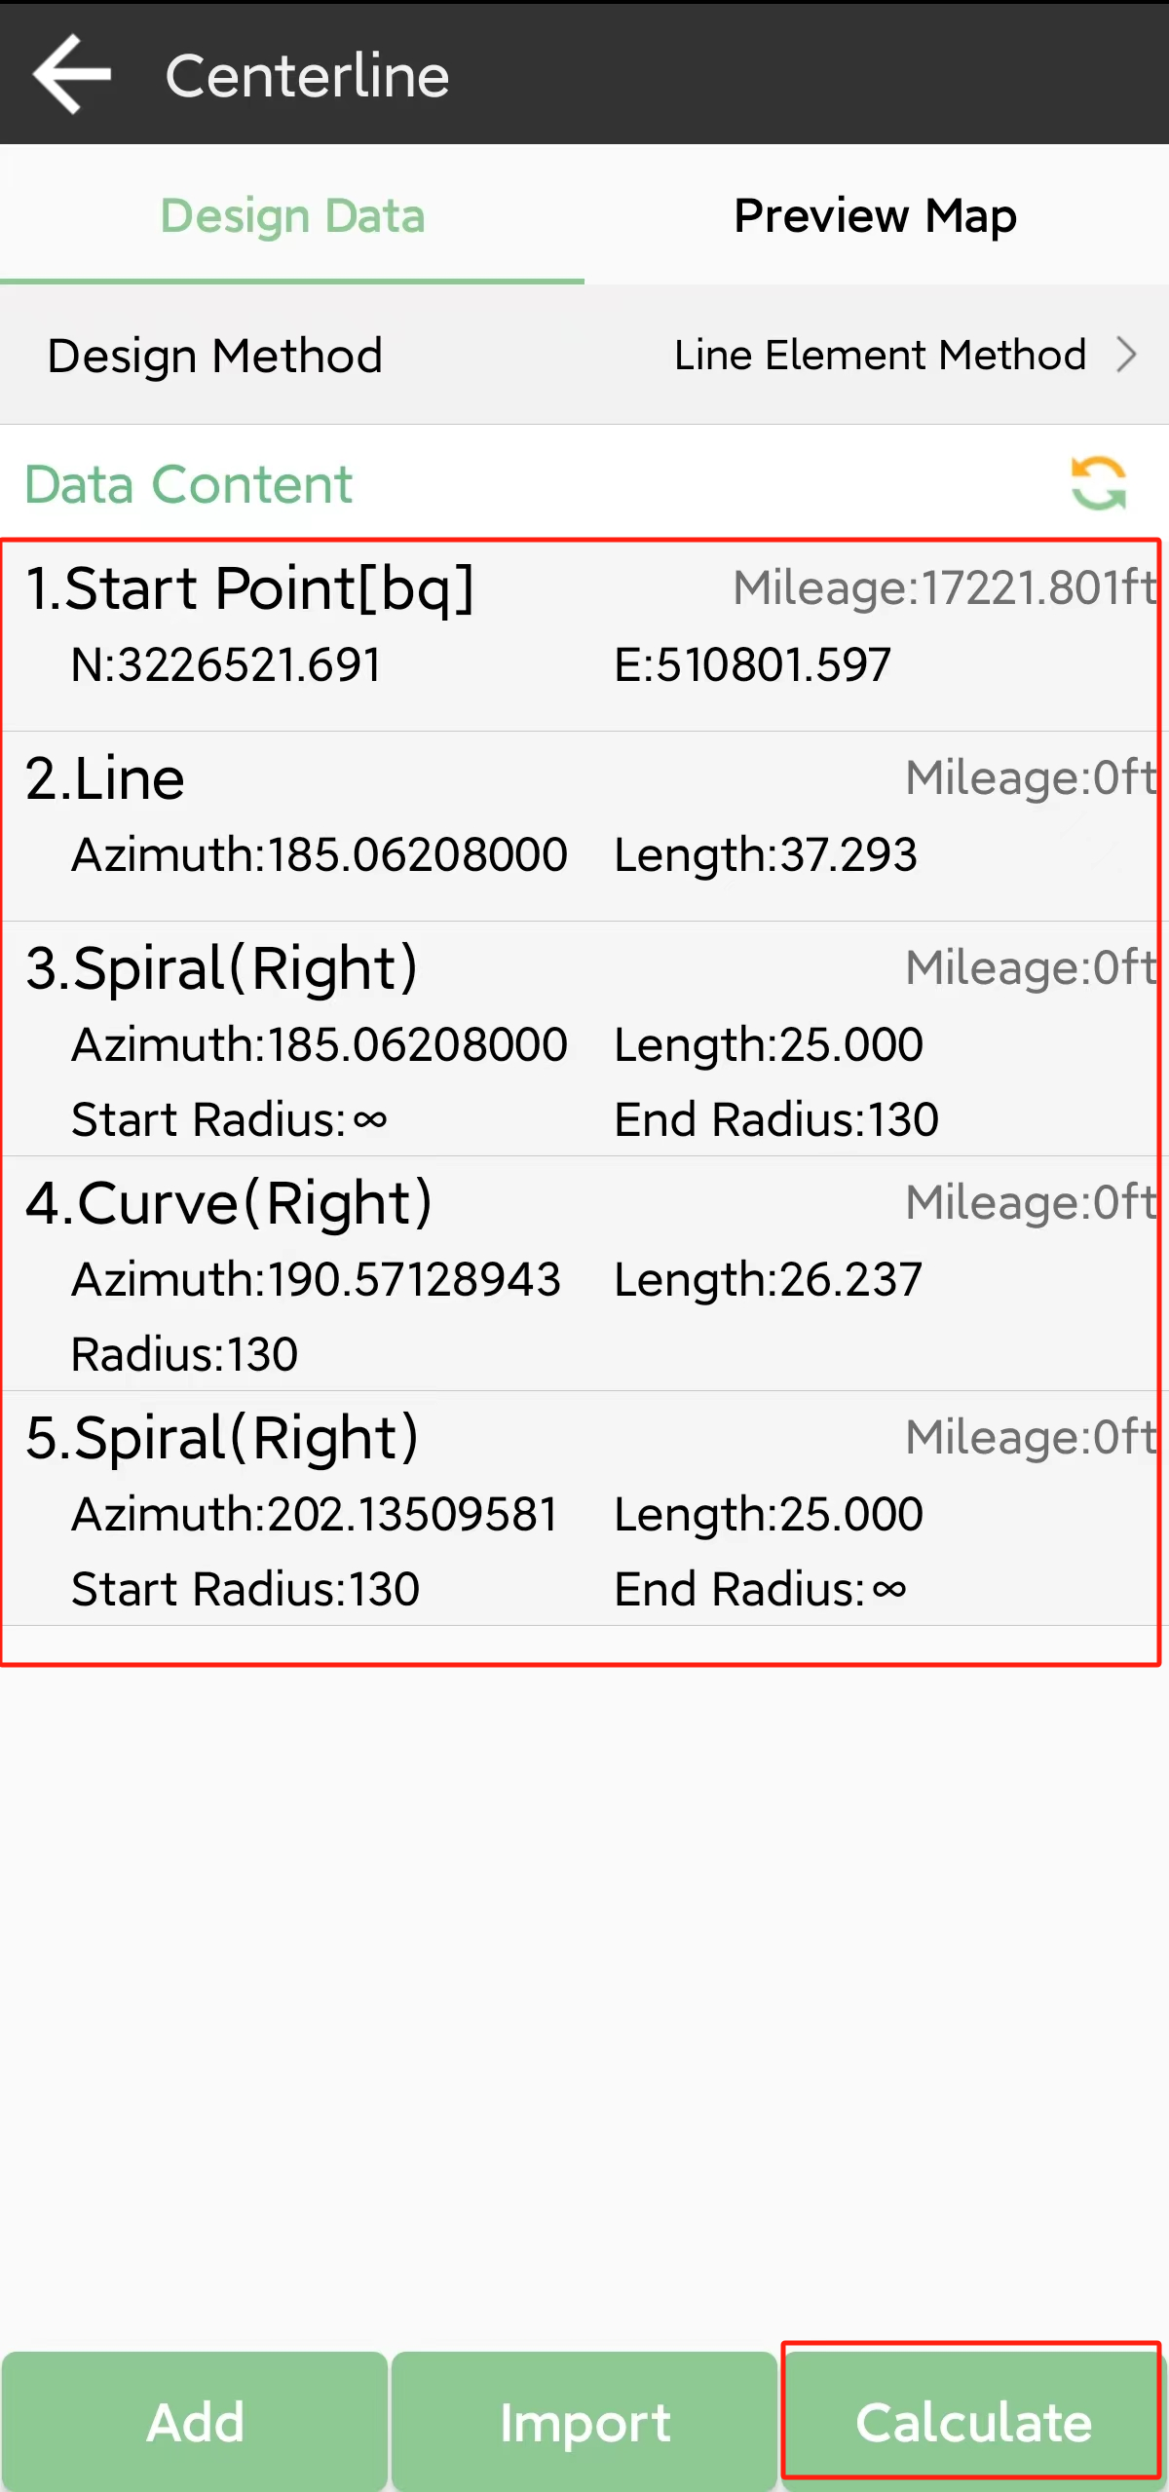 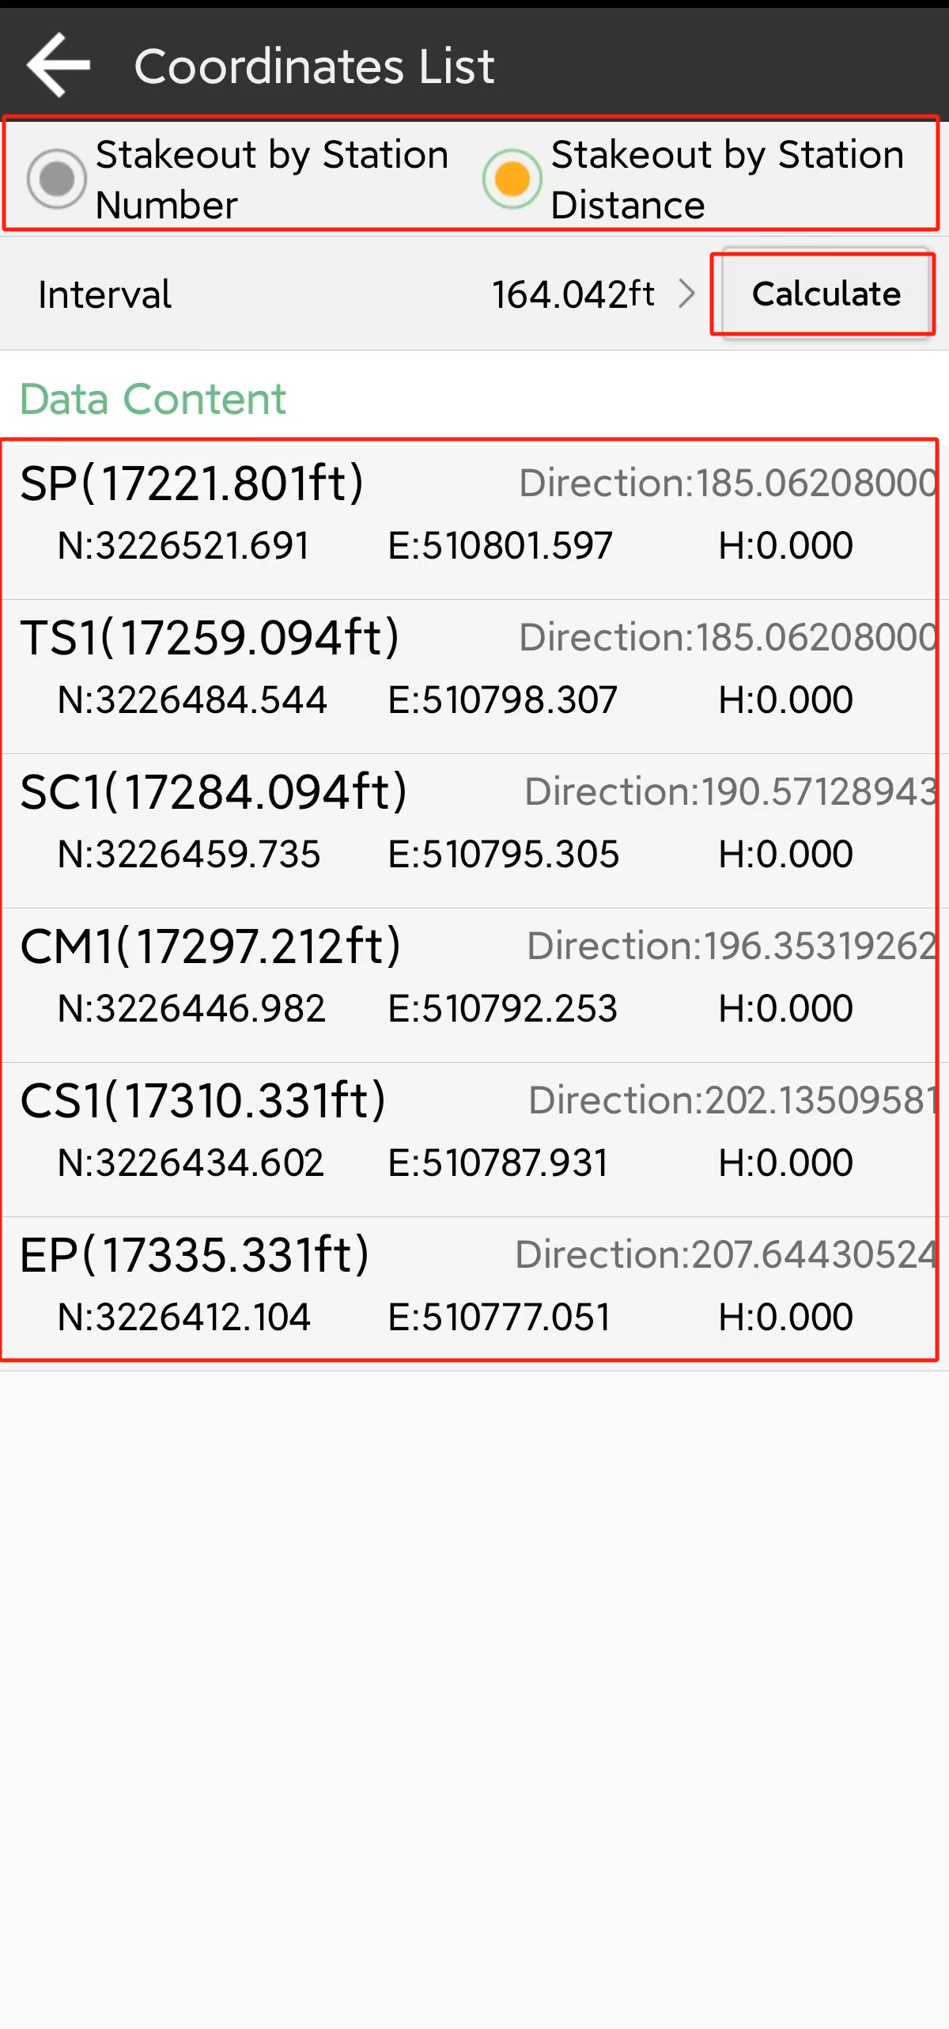

Coordinate element method

Coordinate element method can be used in the situation that the road is made up of lines and curves only.

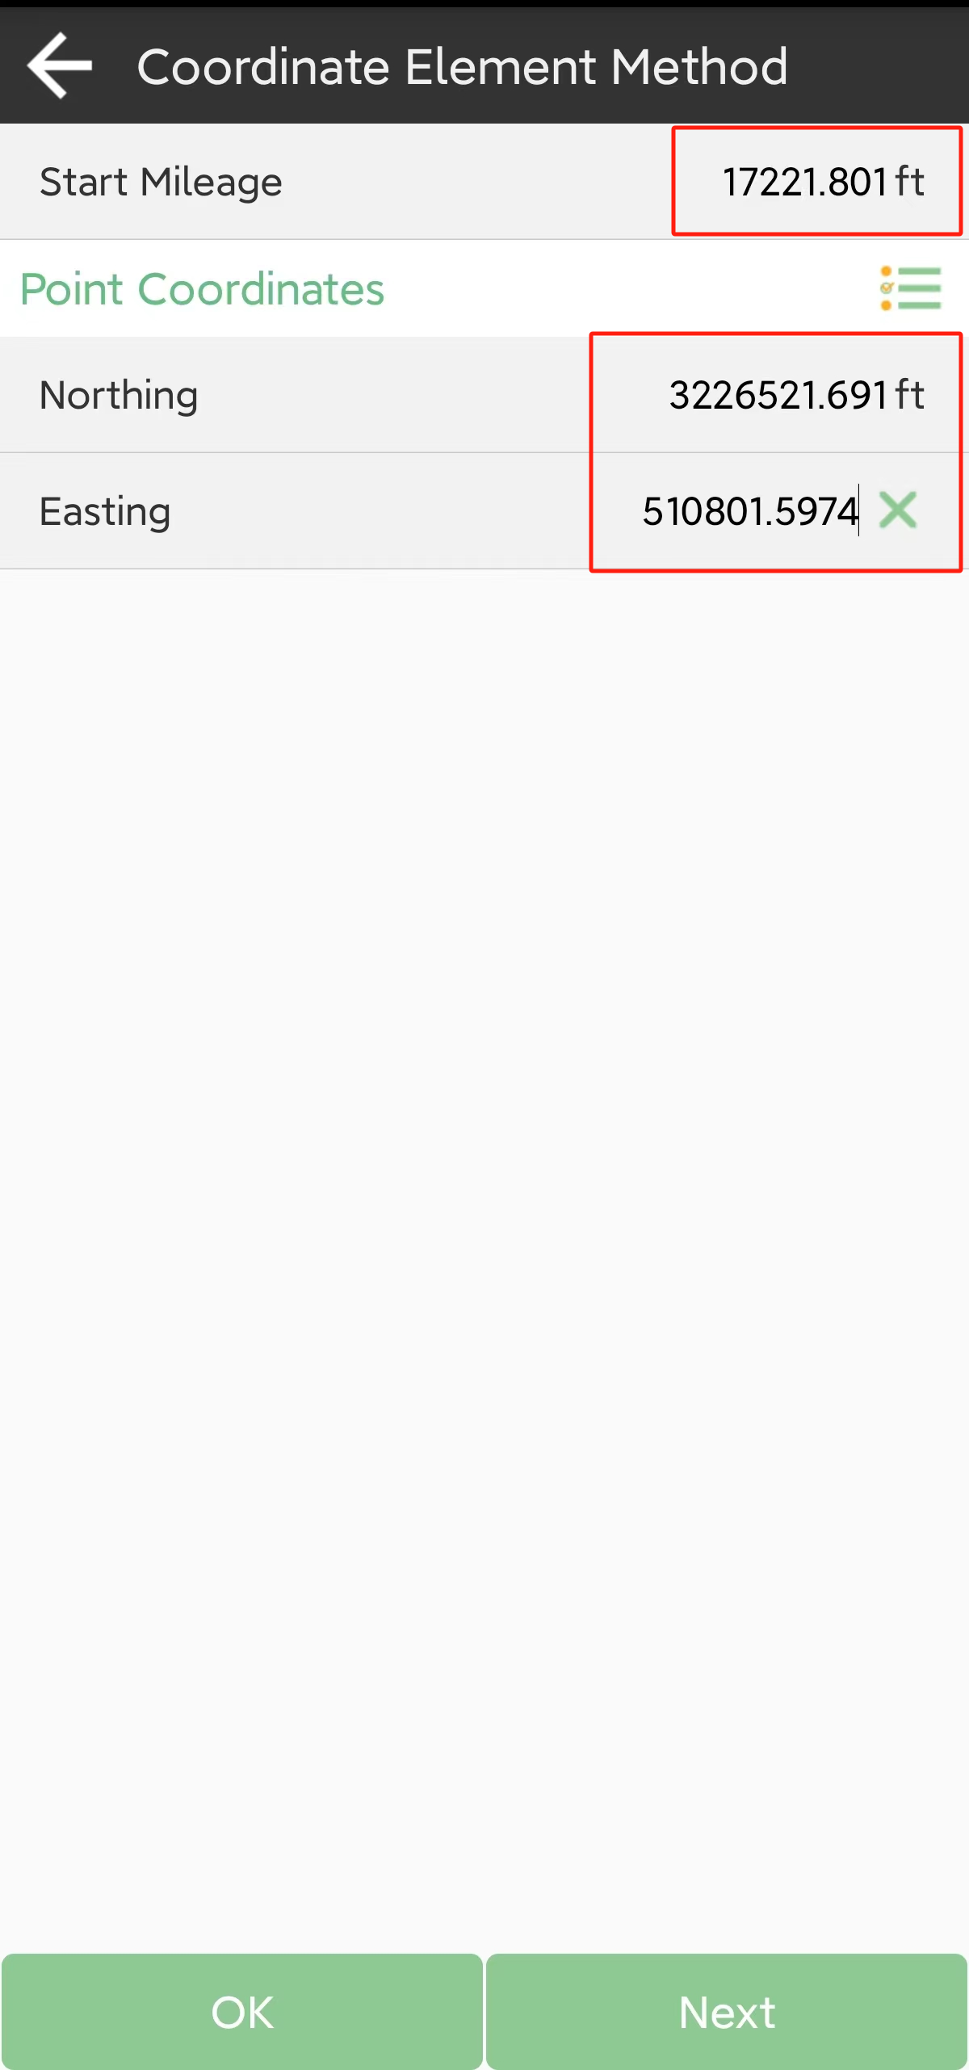 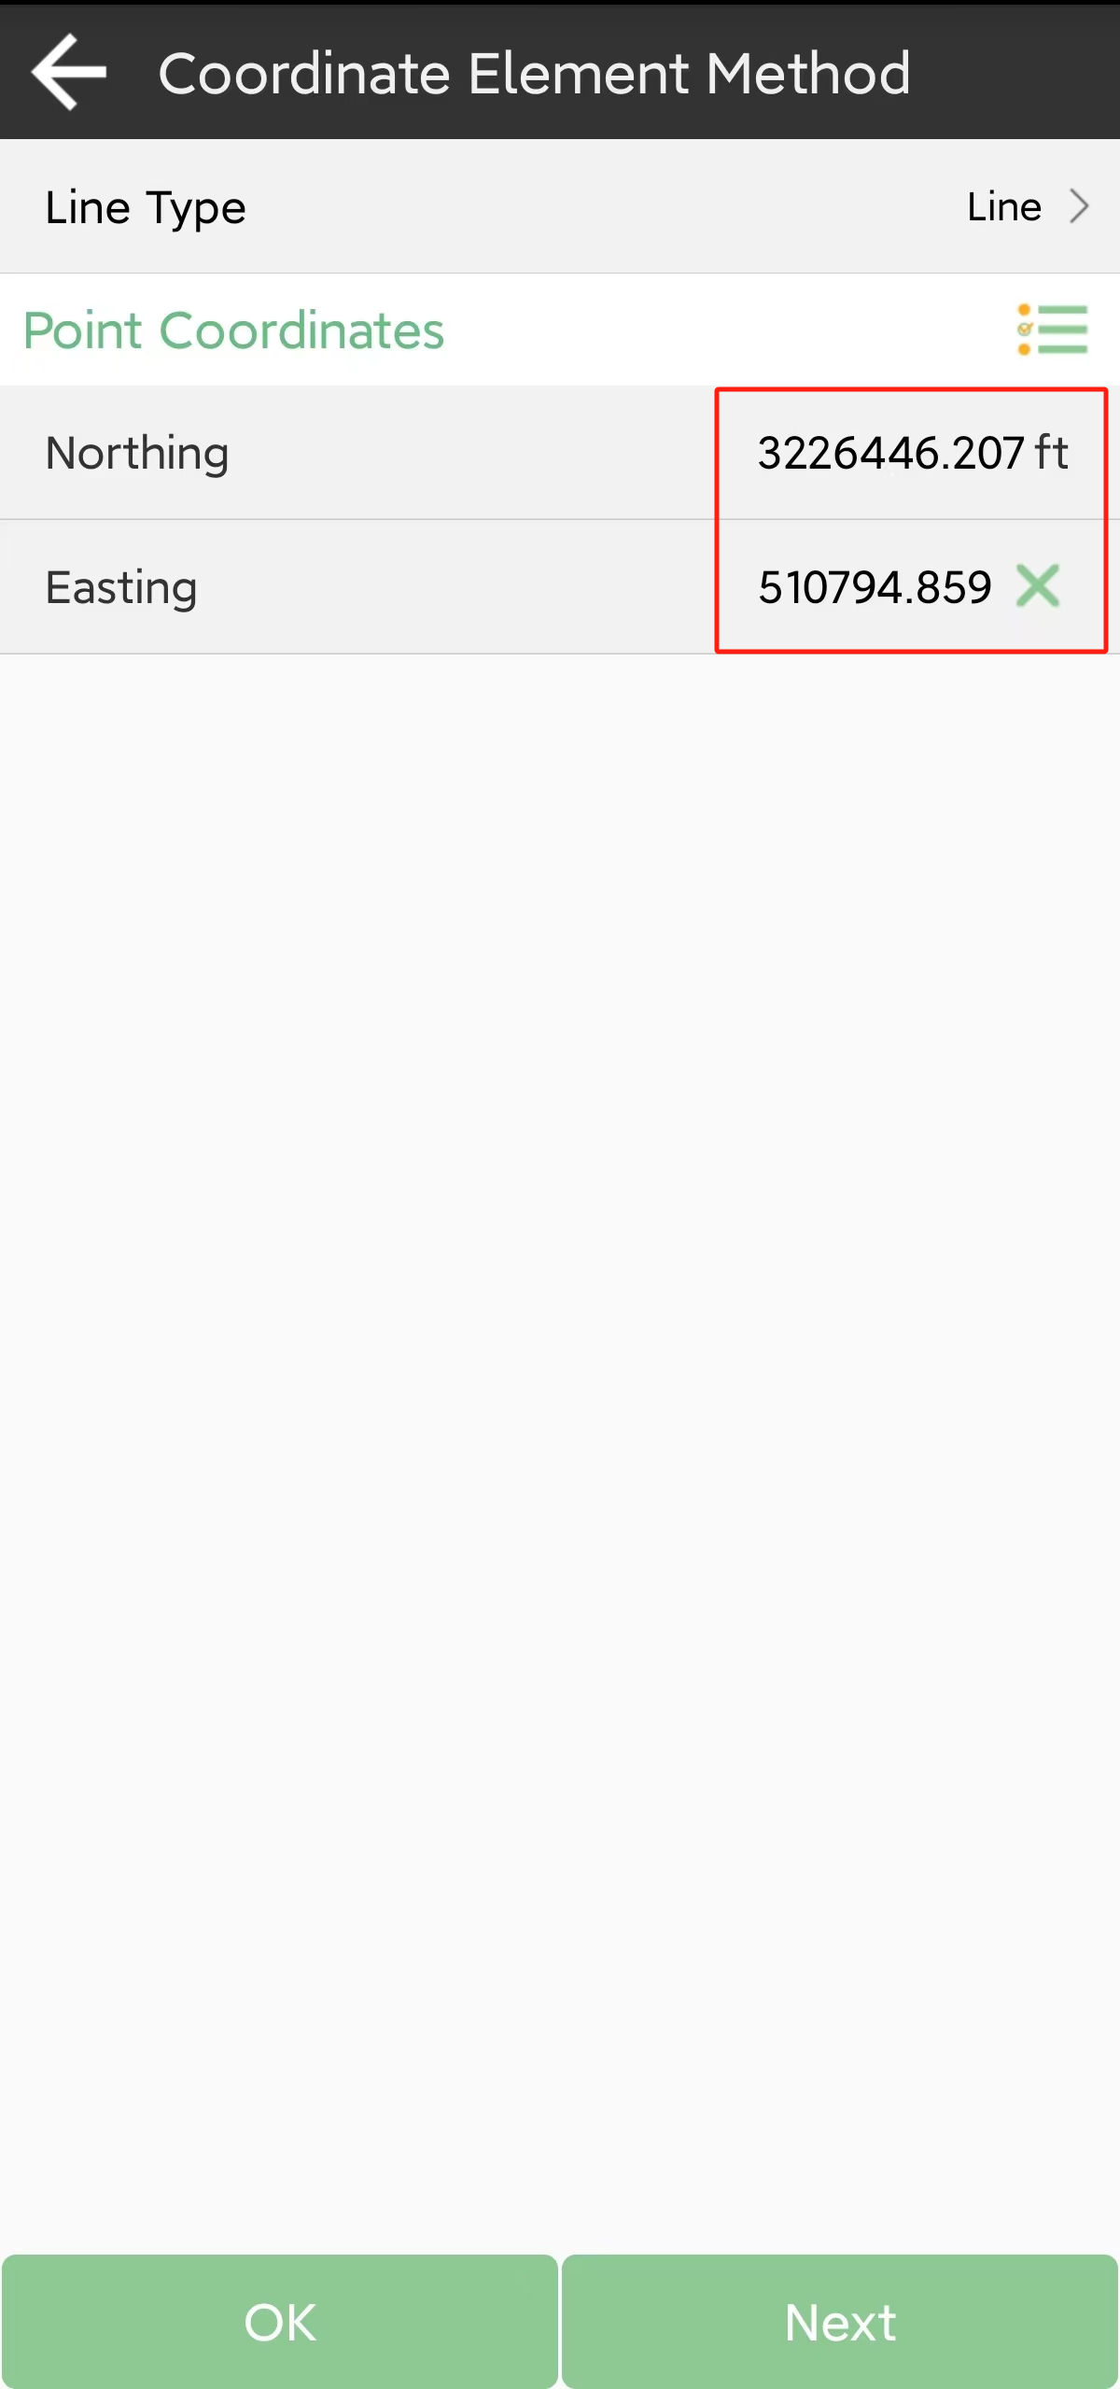

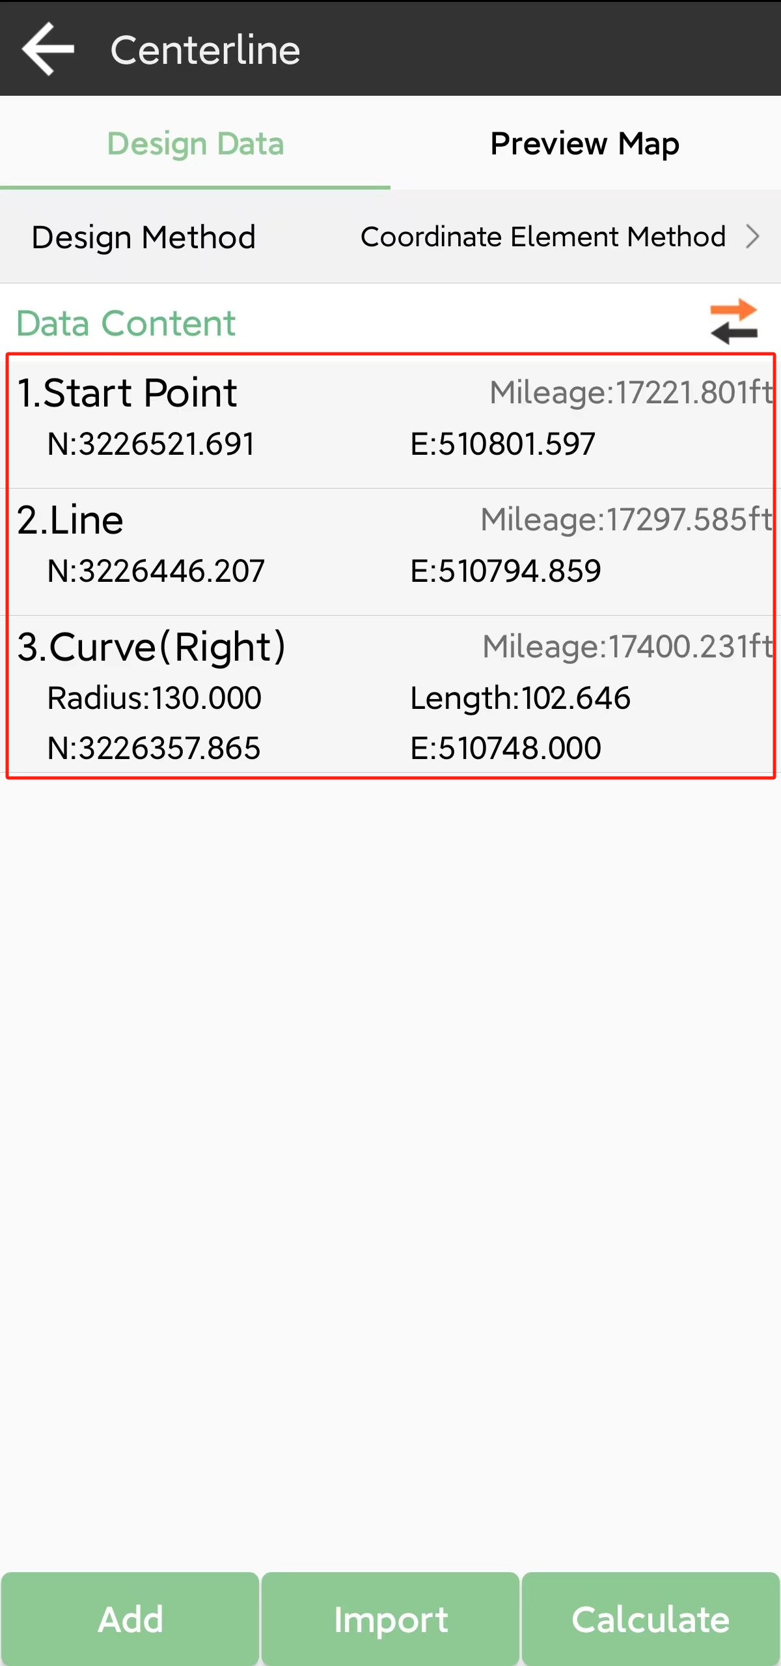

You can calculate and edit it in the center line interface. You can design roads by importing files of road. There are abundant formats you can choose. Also, you can create a new one.

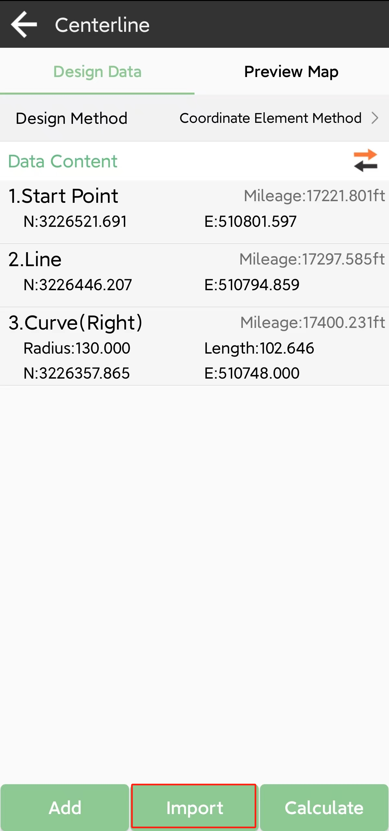 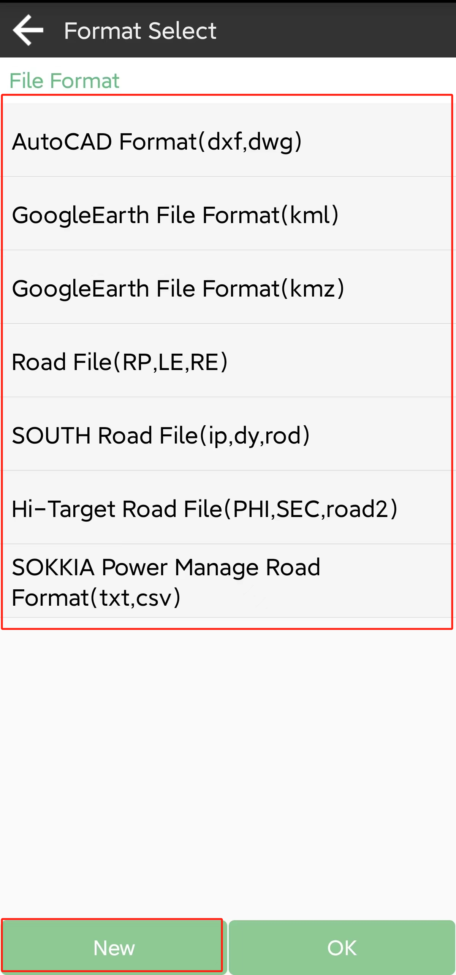

### Vertical Profile

Vertical profile contains grade breaks, there are two methods, you can choose, enter the elevation data in each station and check.

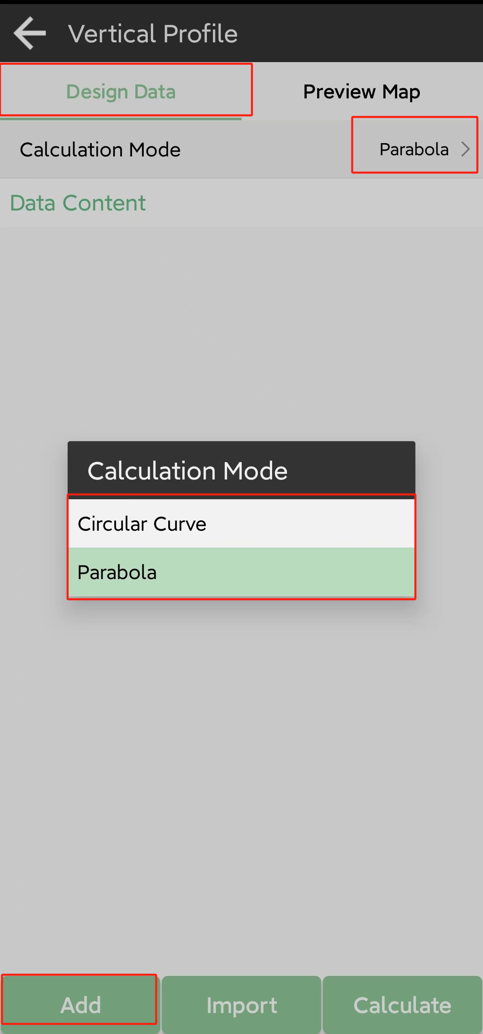 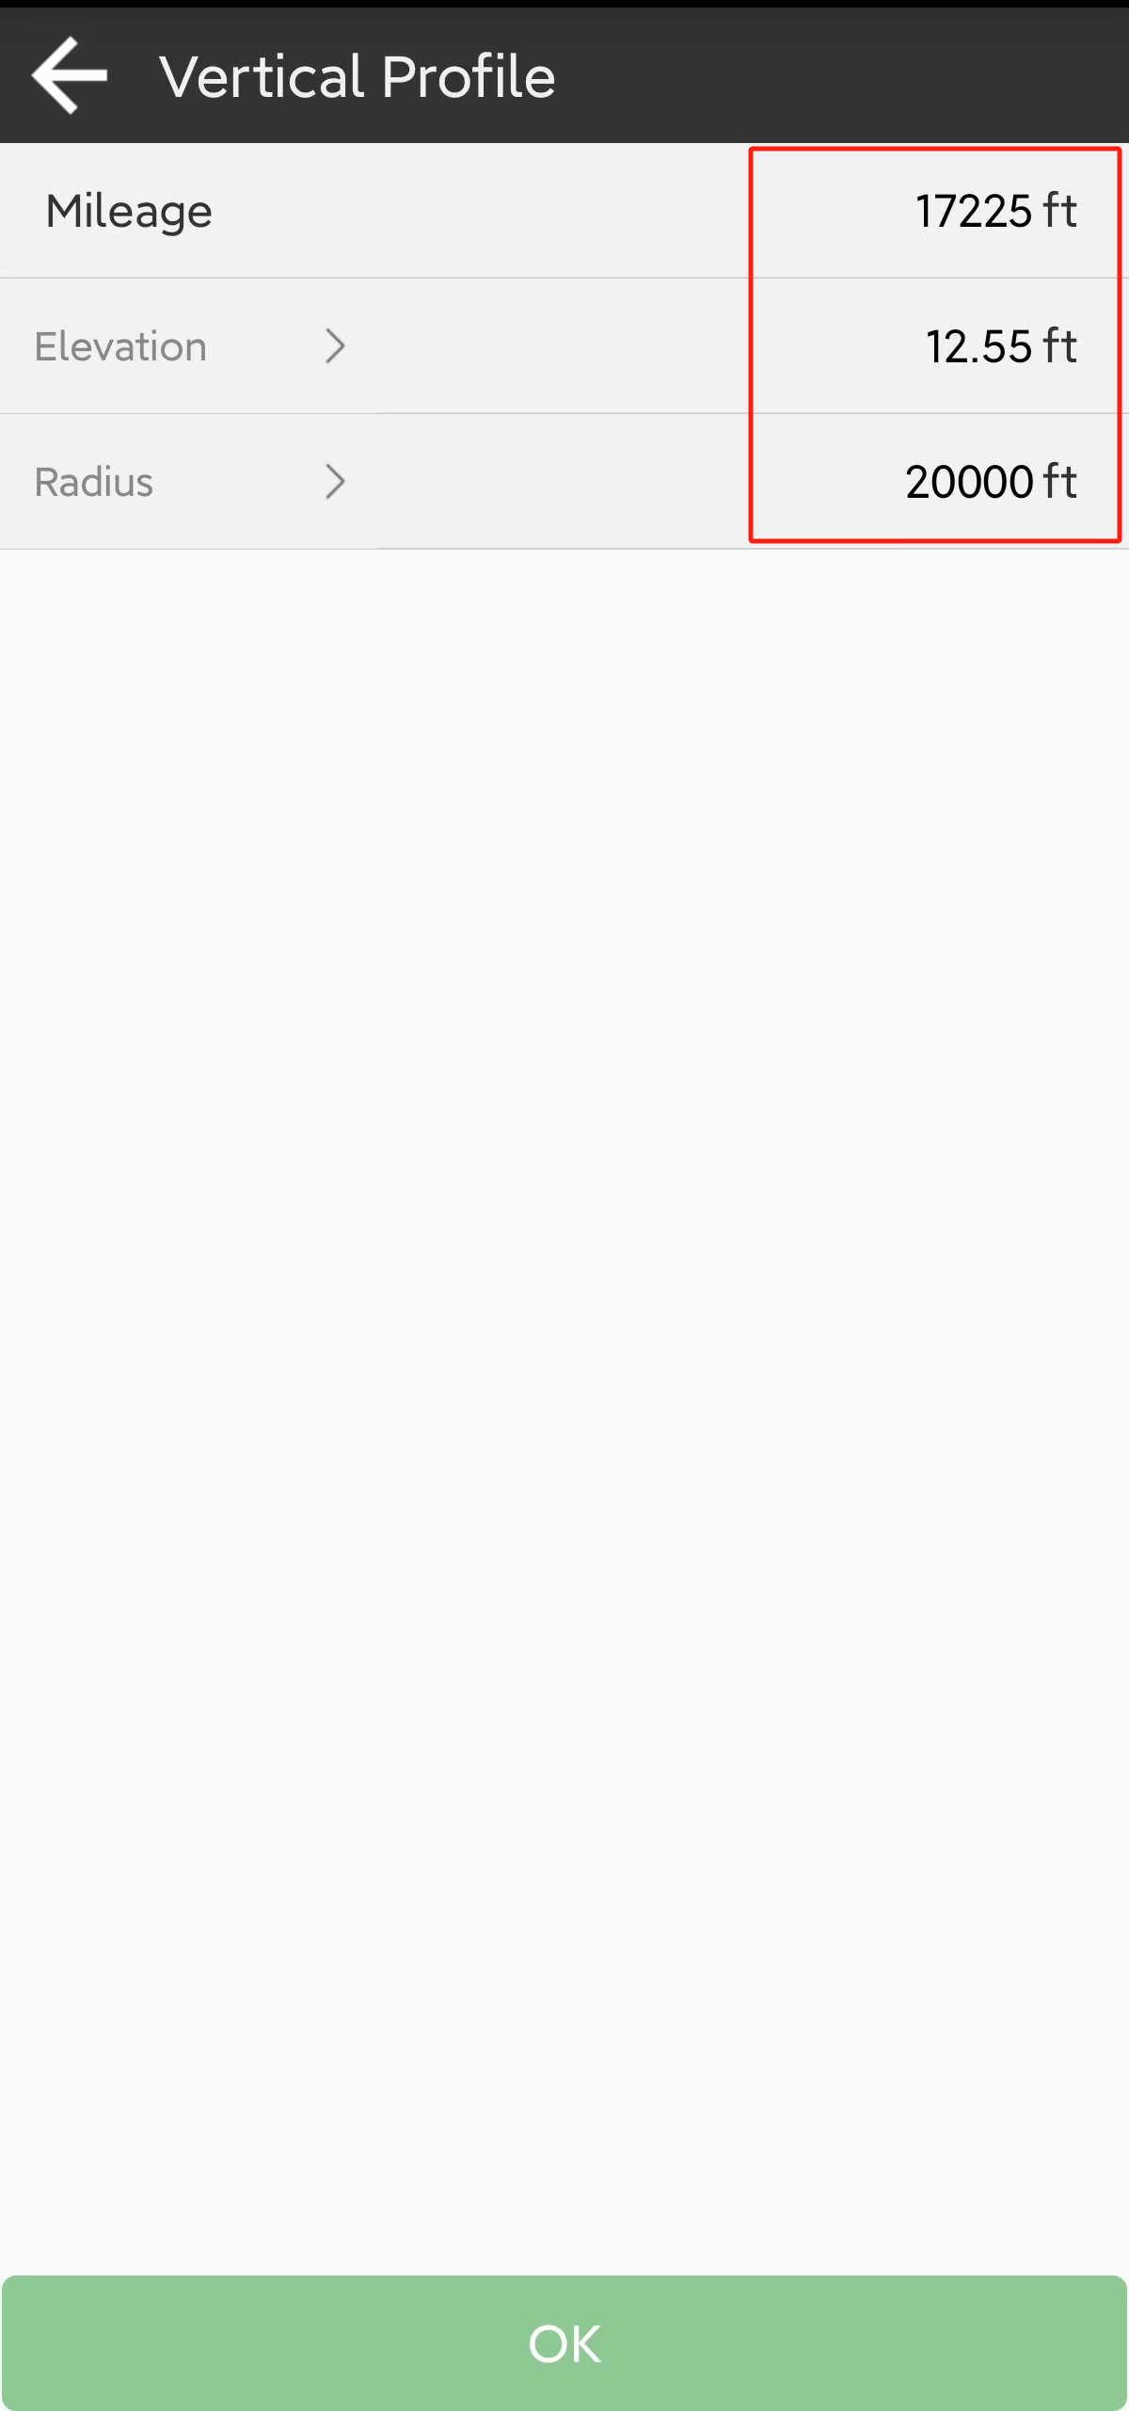

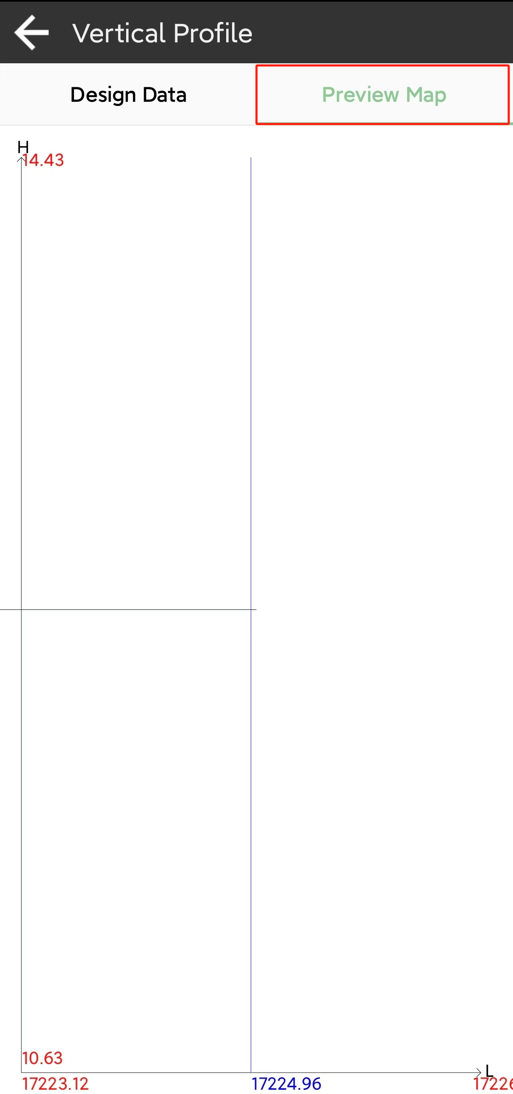

### Standard cross section

You can import cross section files. Each cross section has two parts, the left section and right section.

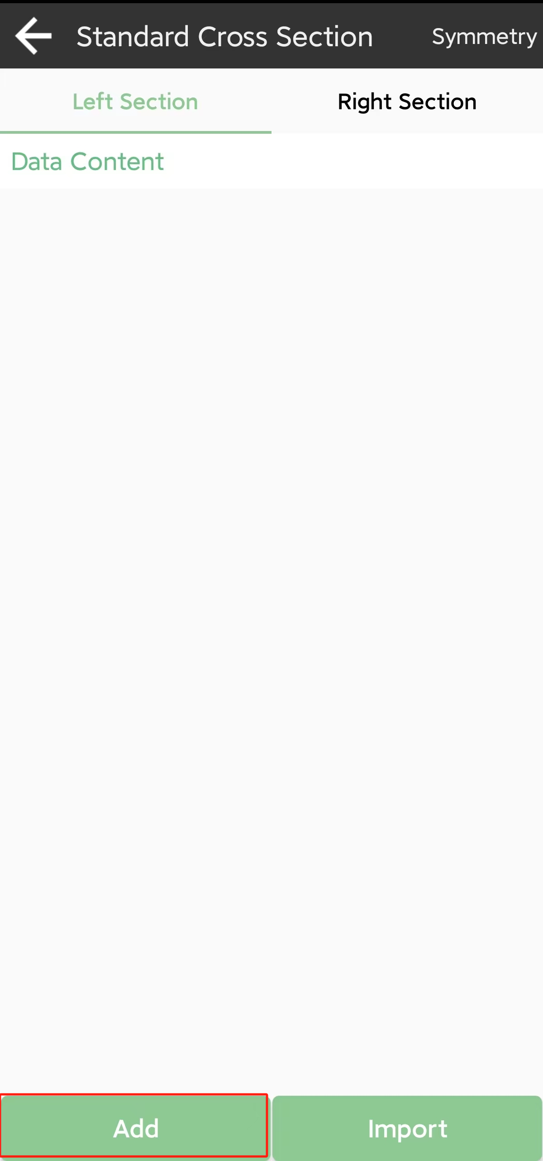 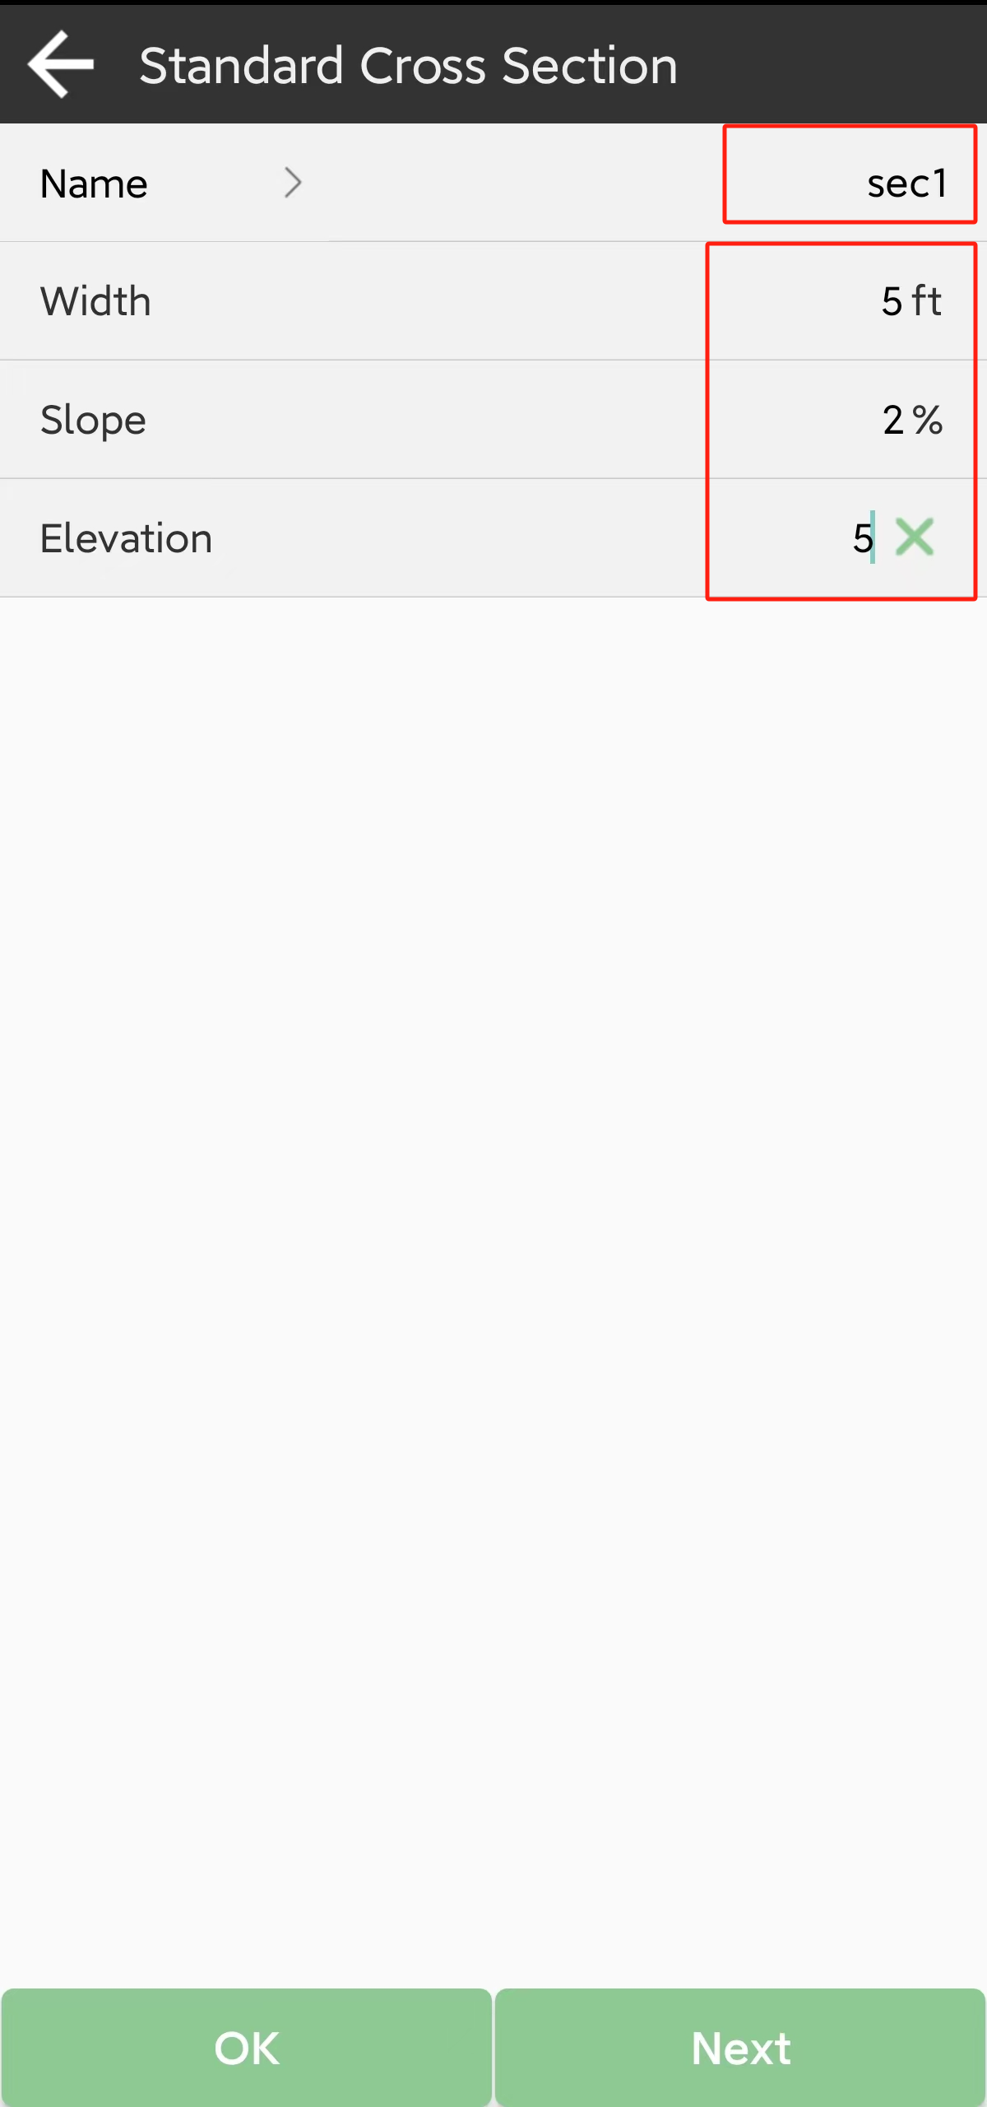

Usually we edit the left section first, enter parameters of width, slop and elevation data, and tap OK to save or tap next to enter the next one. The unit is meters

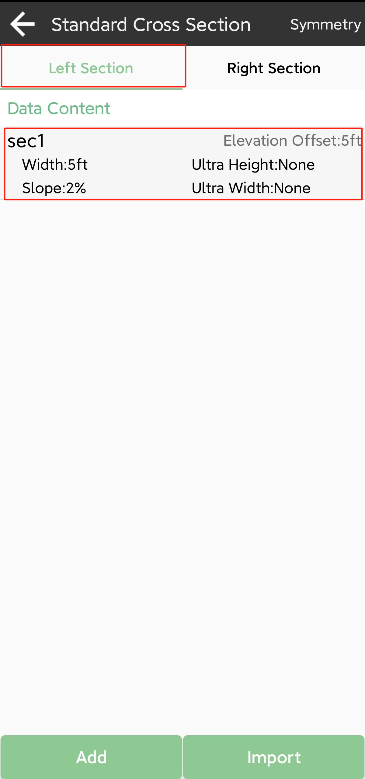

If the right section was same with left section, just tap the symmetry in the right section interface, it will get the right section automatically. If not, enter the right one.

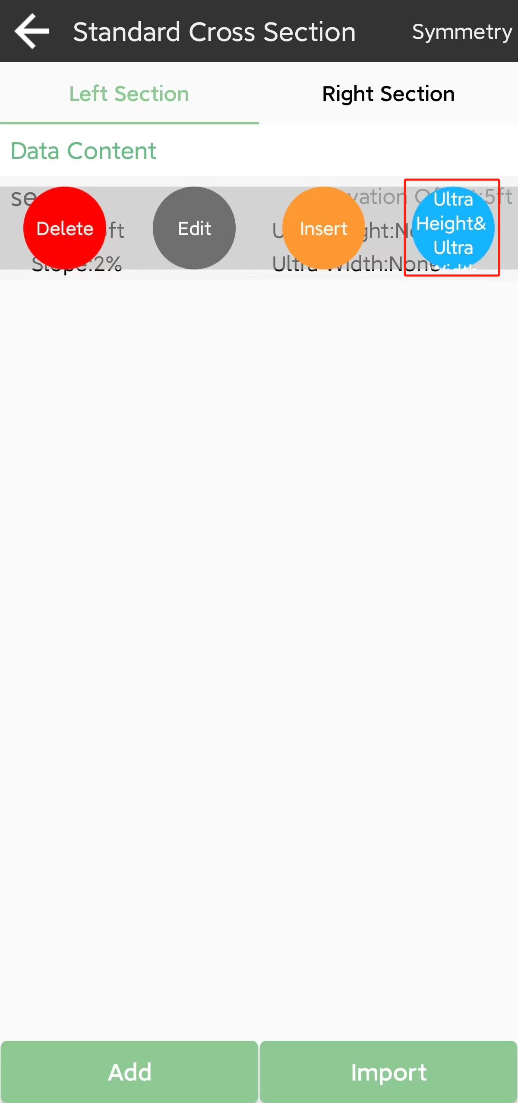 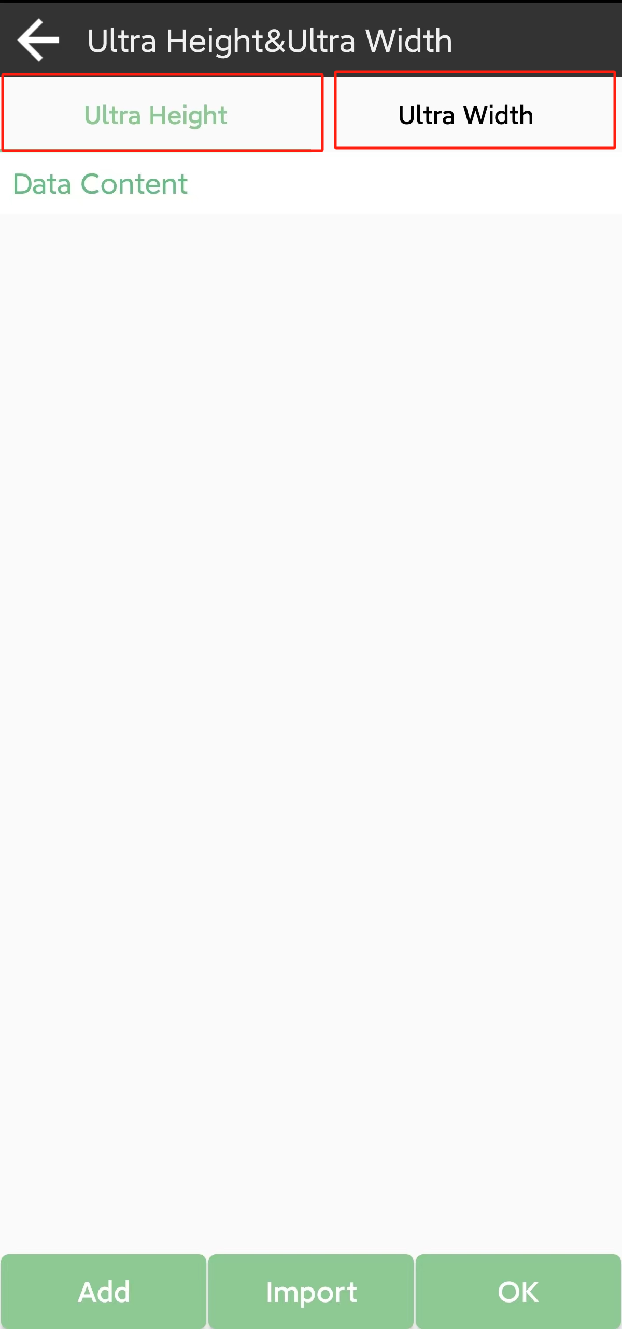

If you need to enter ultra-height and ultra-width data, tap the cross section data you have already entered in the content list, and enter them.

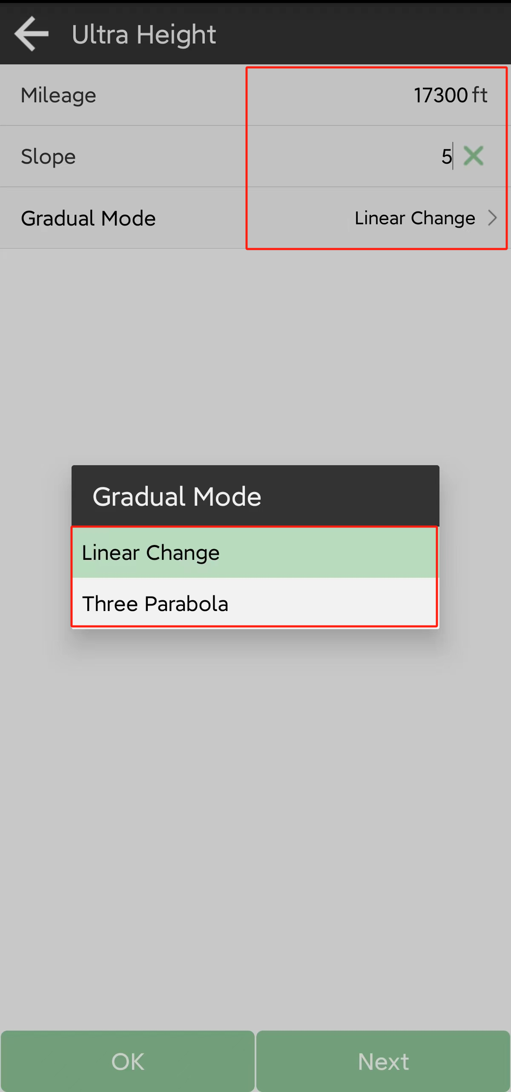 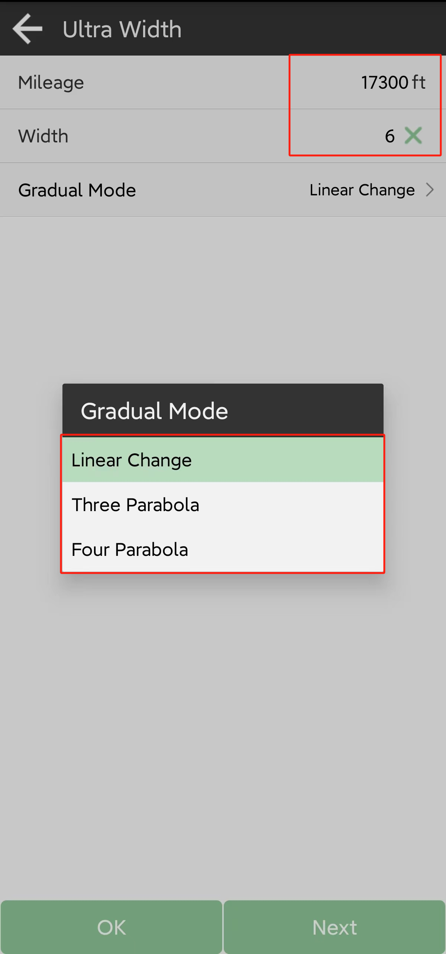

### Slope data

Enter cut or fill data of each station if you need.

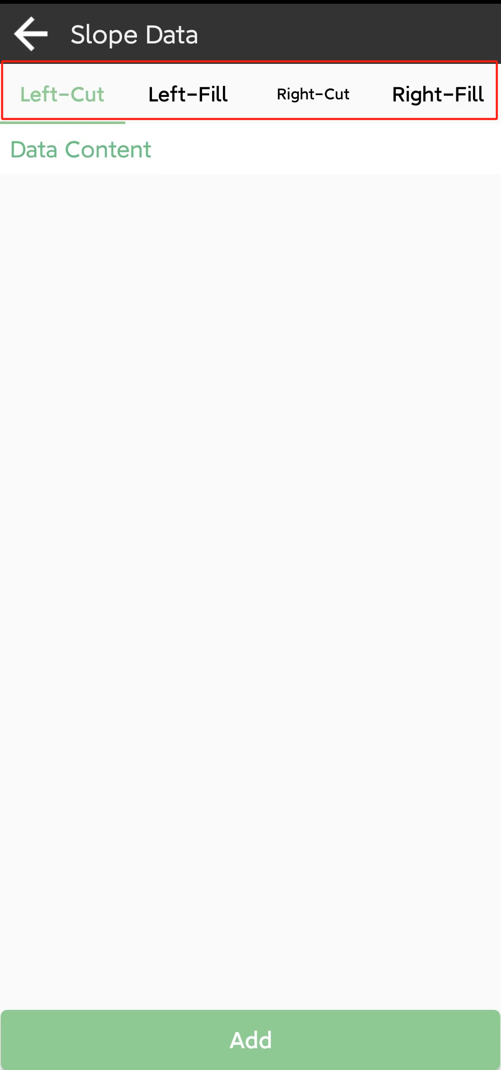 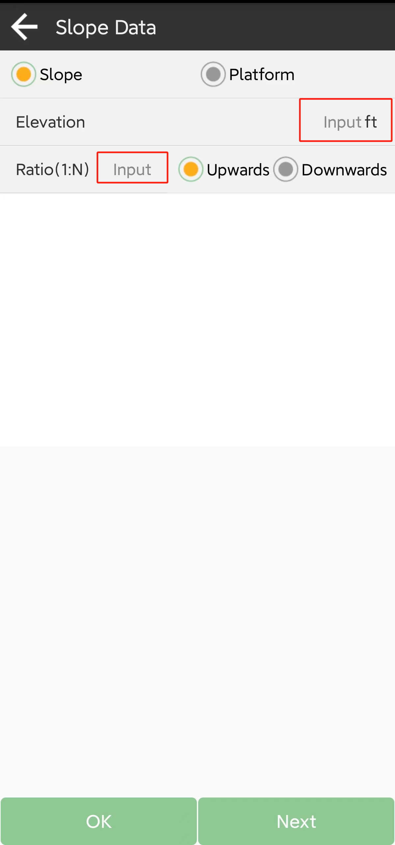

### Bridges and Culverts

Add Bridges and Culverts.

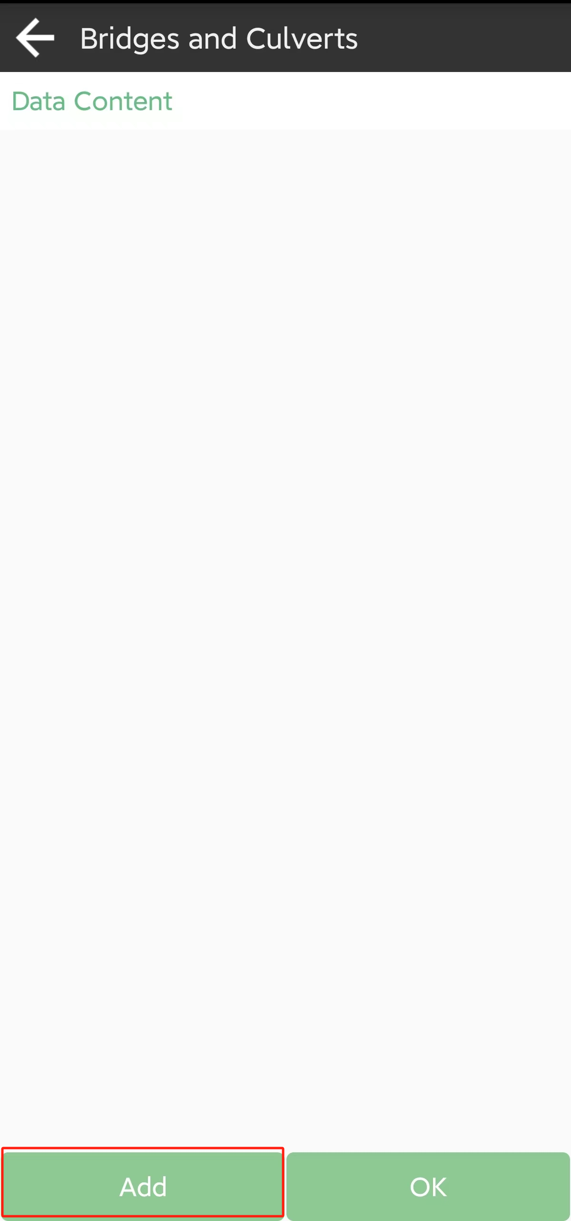 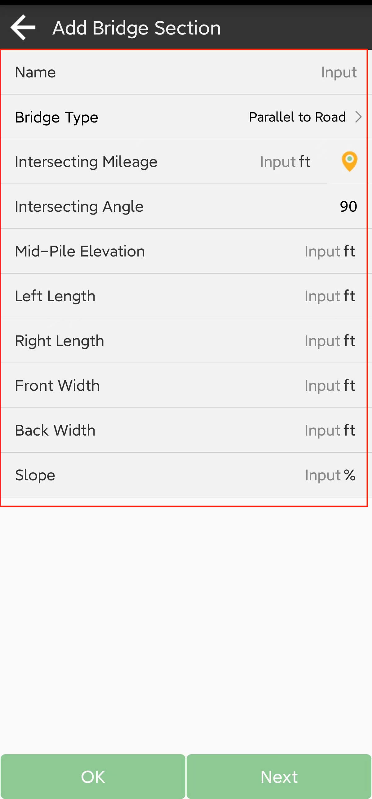

### Conical Slope

Add Conical Slope

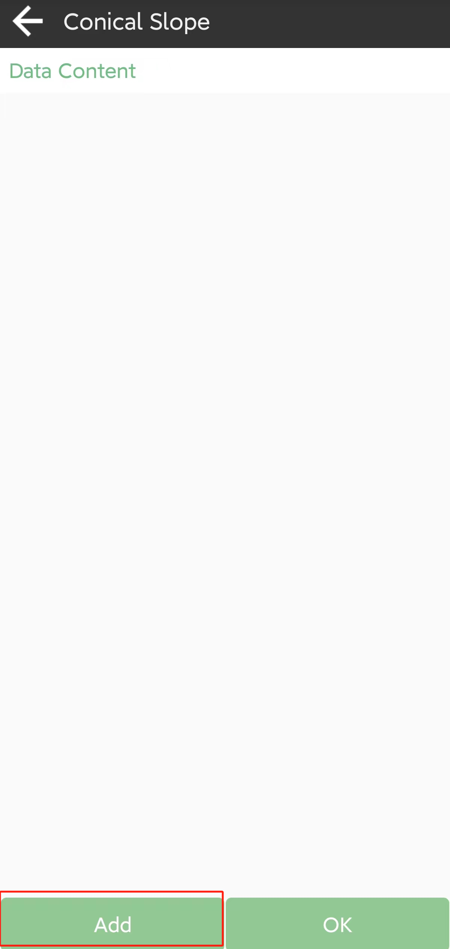 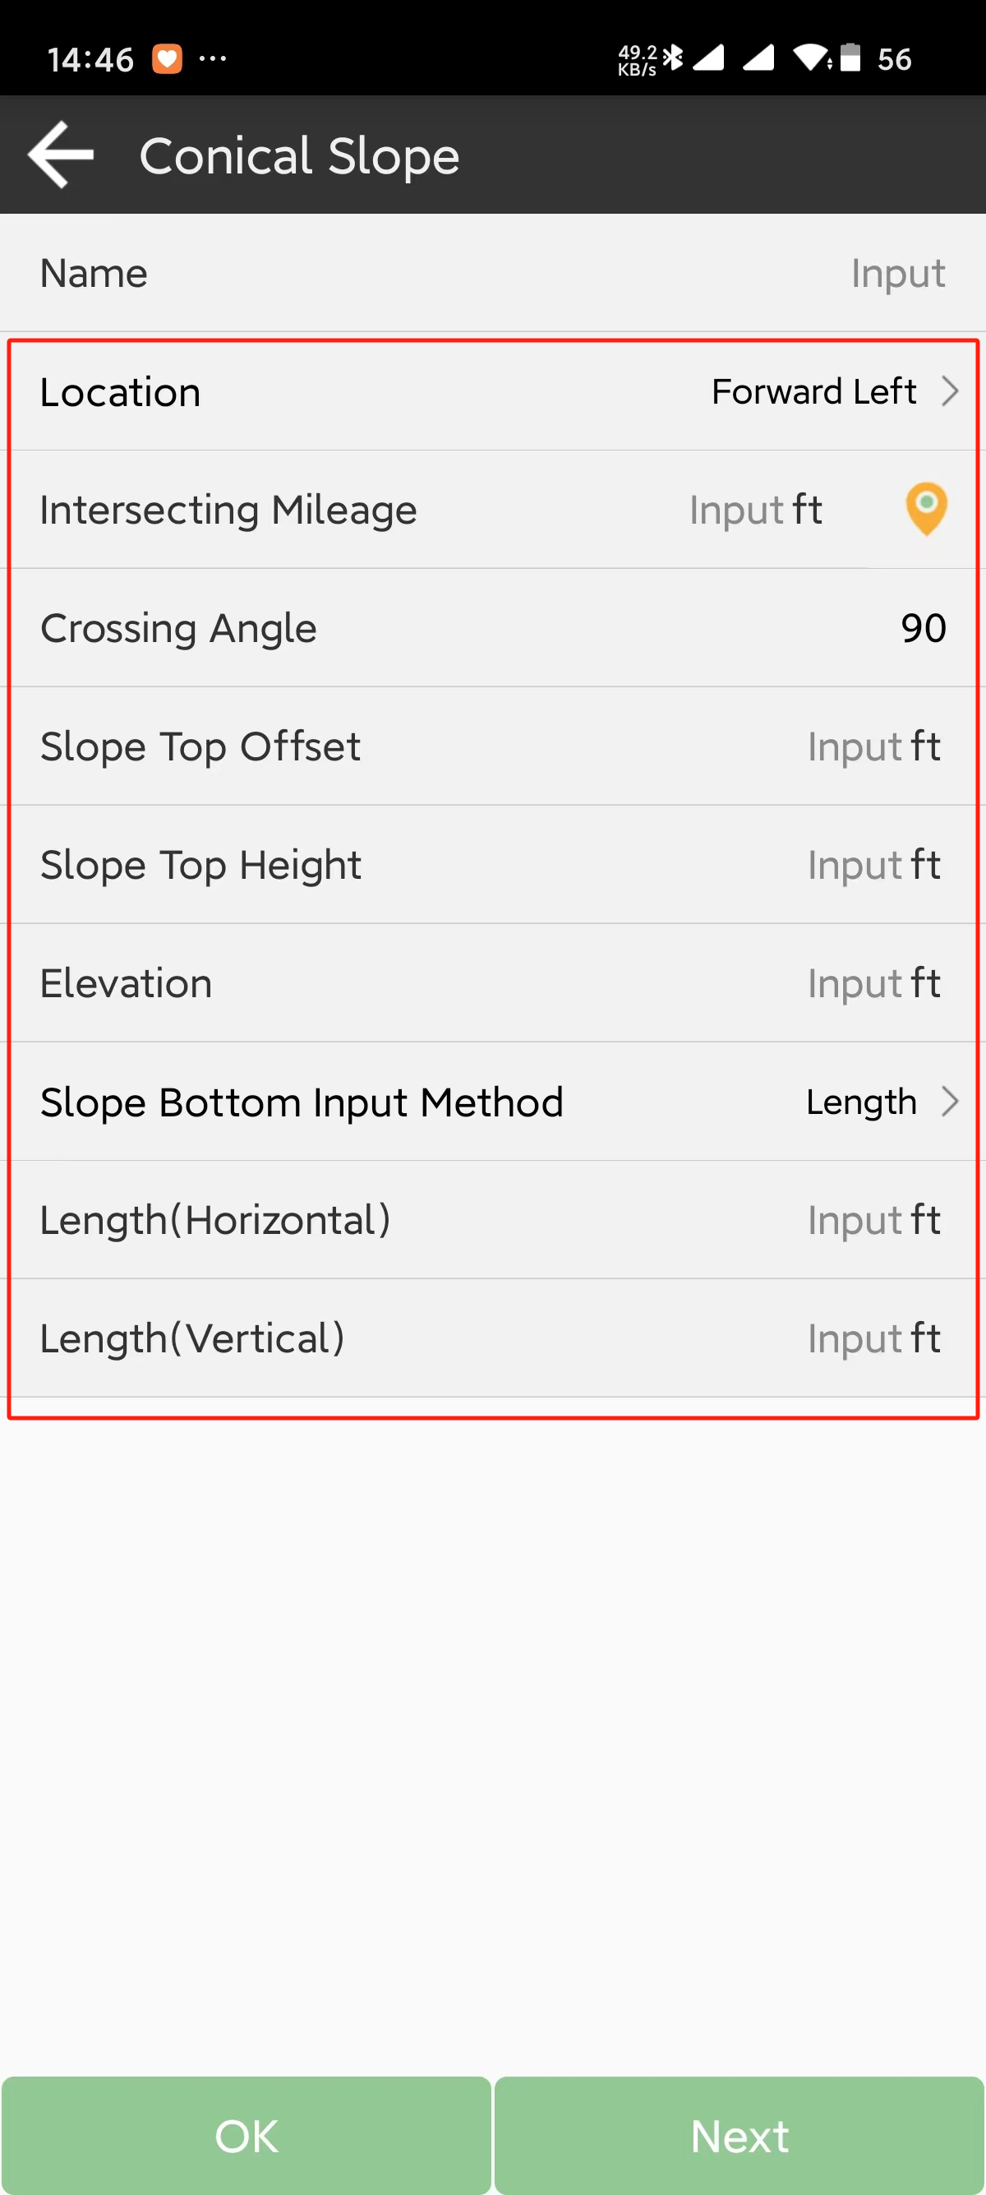

### Road stakeout

After design the road, click and stake it out in the roads database interface, it will auto add the start point of the road to the target stake point, follow the navigation information shown on the map.

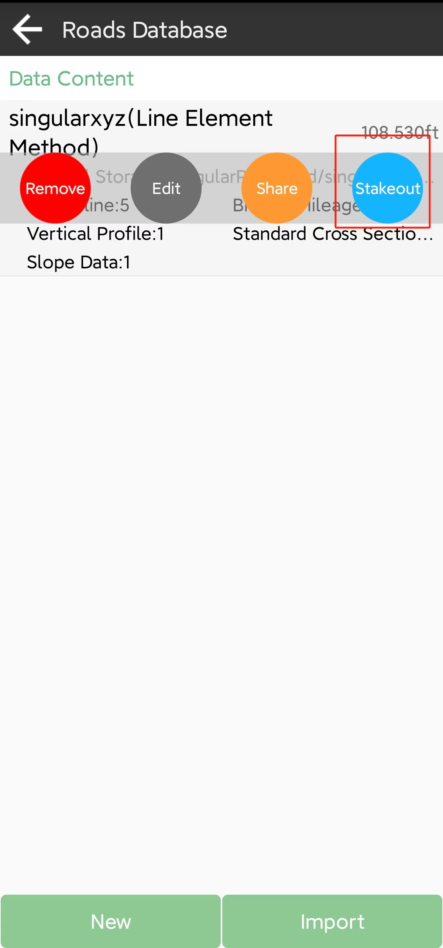 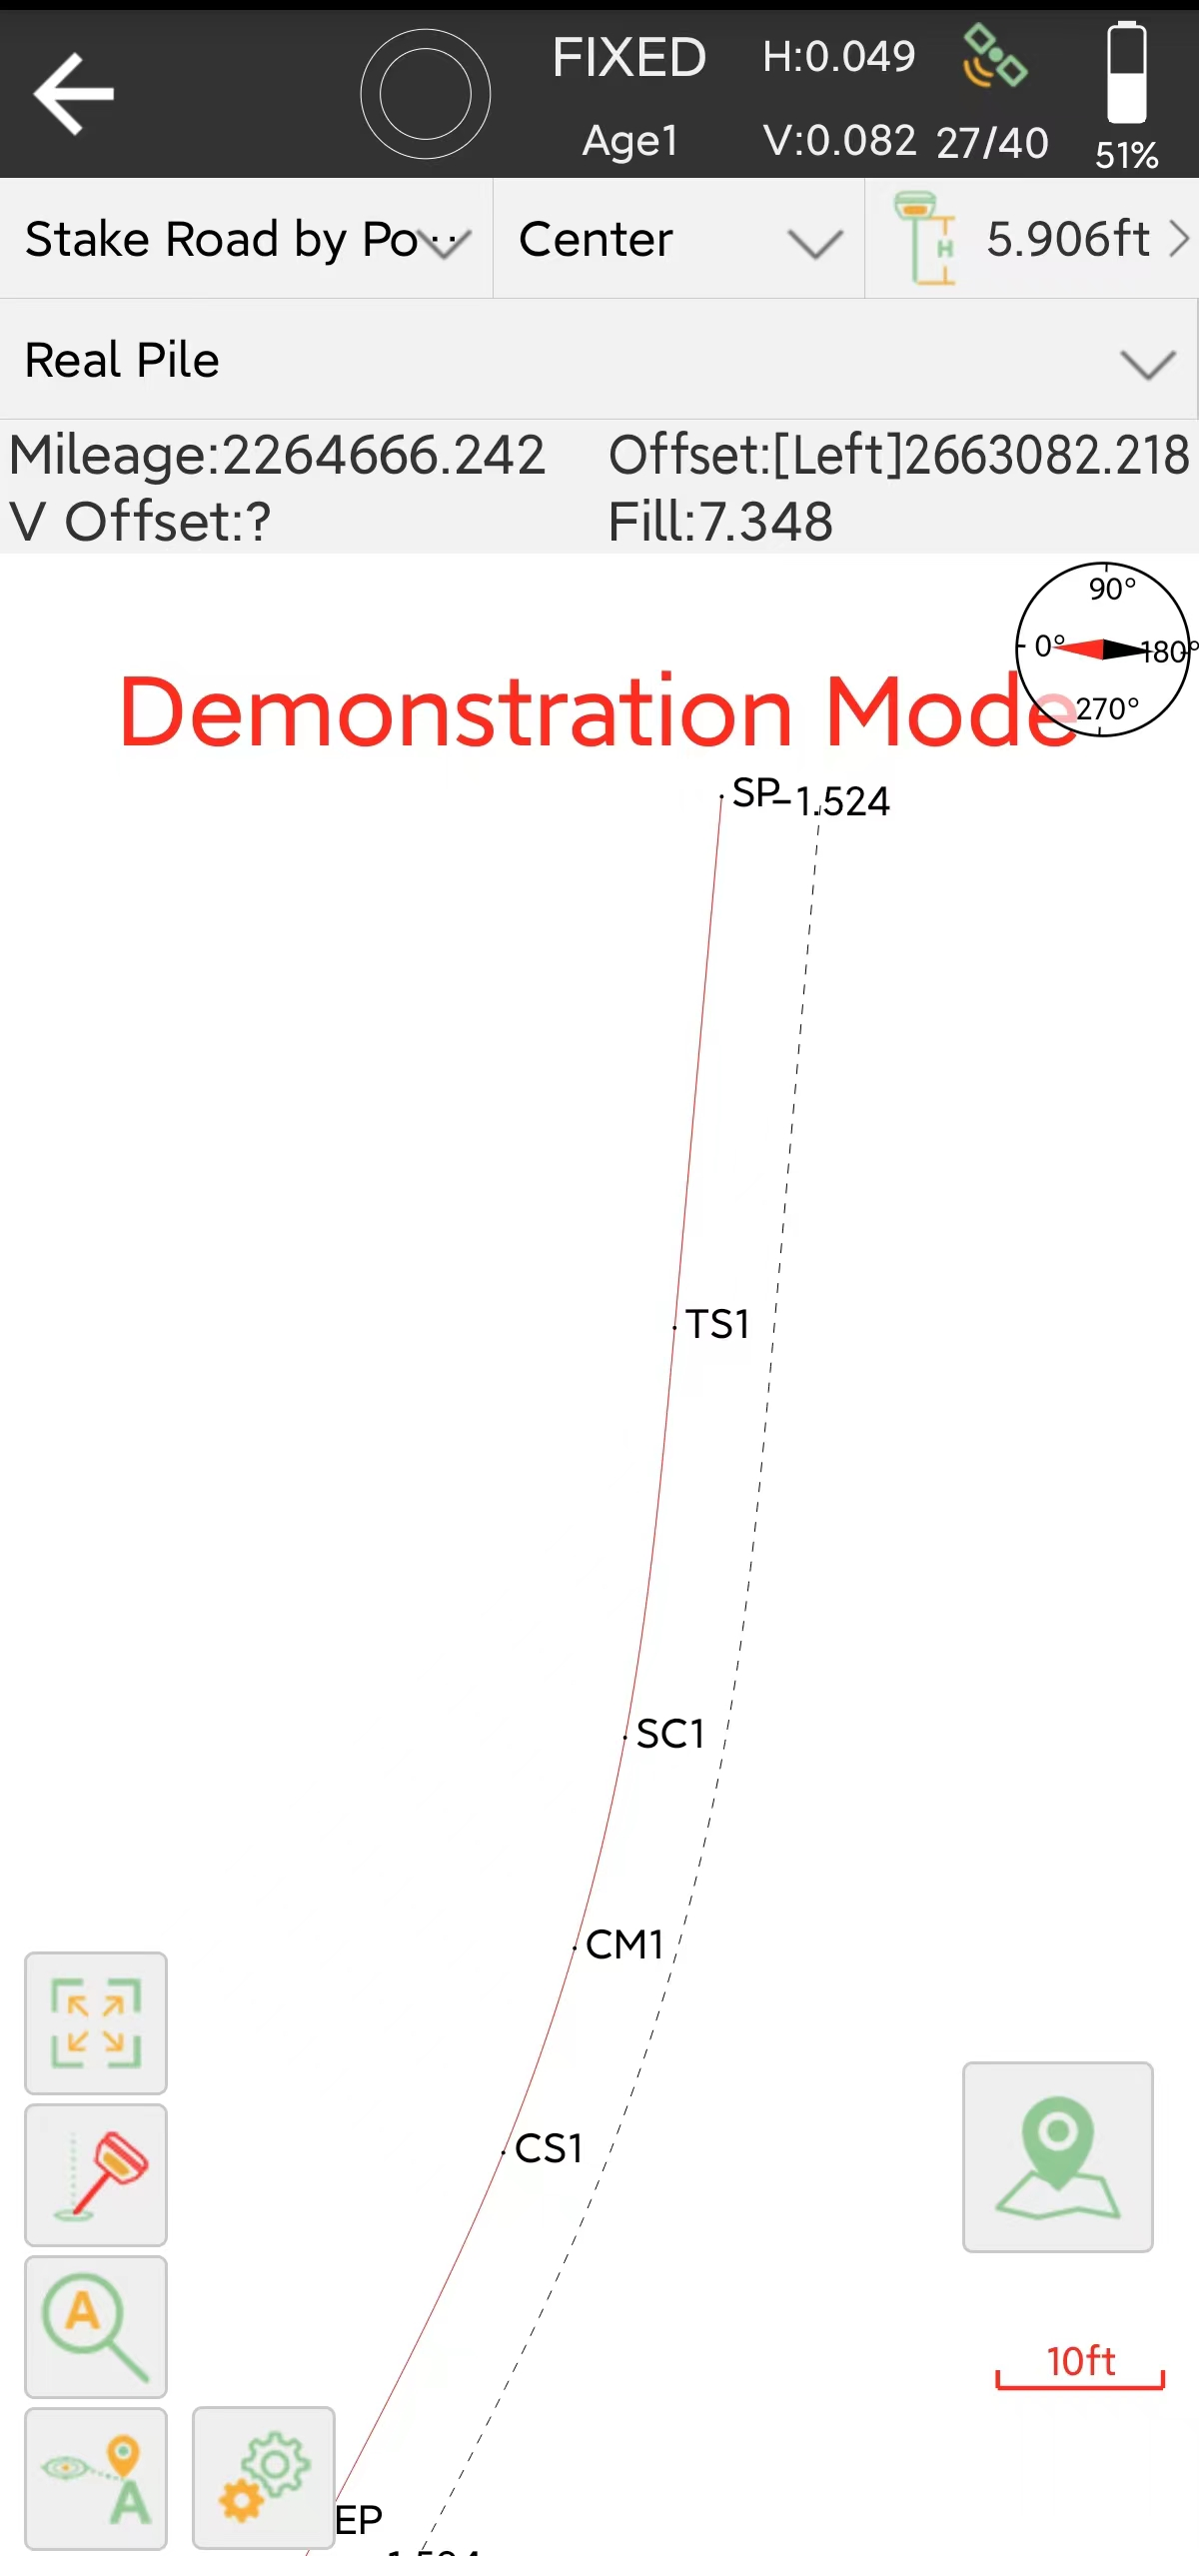

When go near the target point, the map will show big circle as below, and when the accuracy high enough to stake the point, SingularPad will alarm to let you know, then pressto finish this point stake, and there serial modes you can choose in different situation.

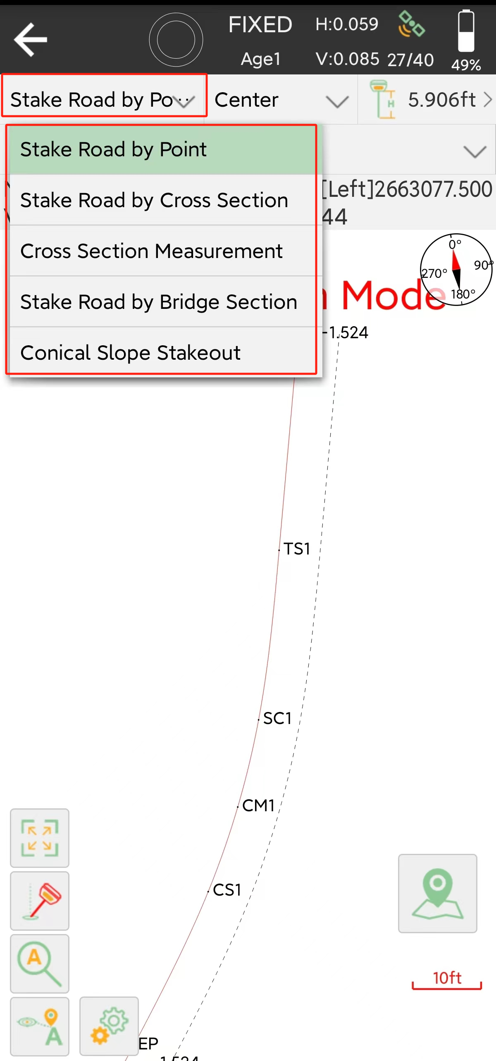

• Stake road by line: Default mode, when you get close to the road, it will guide you towards the road vertically. Just follow the row and stake it out.

• Stake road by point: Before your work, you need to enter the parameters to calculate the points you will stake next.

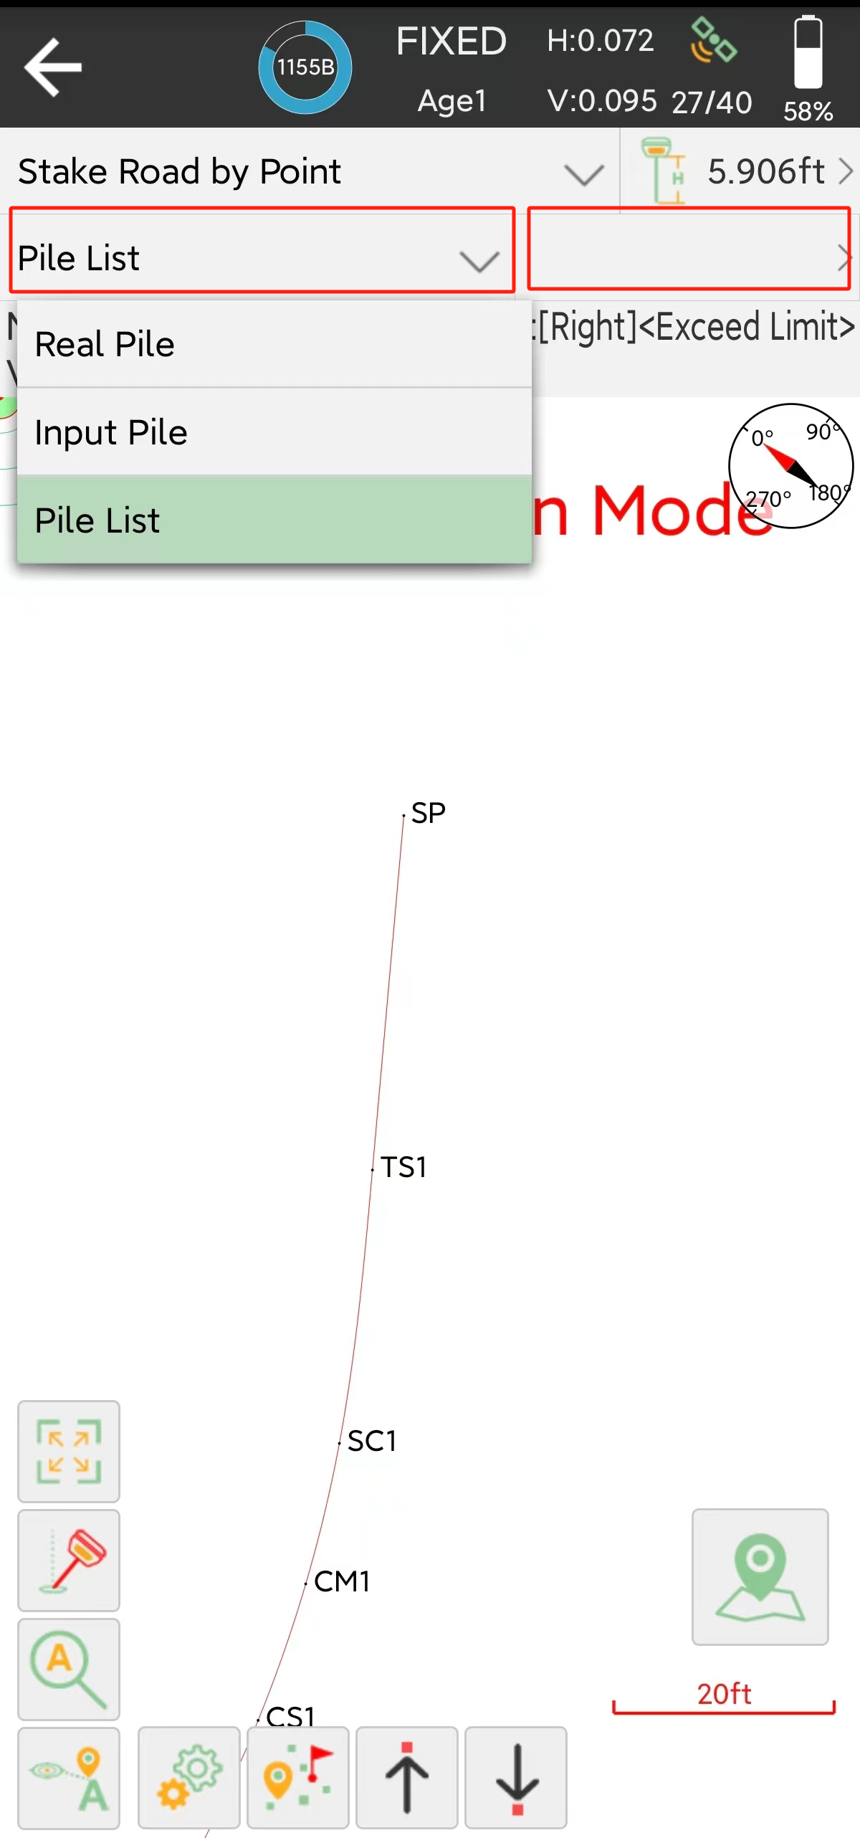 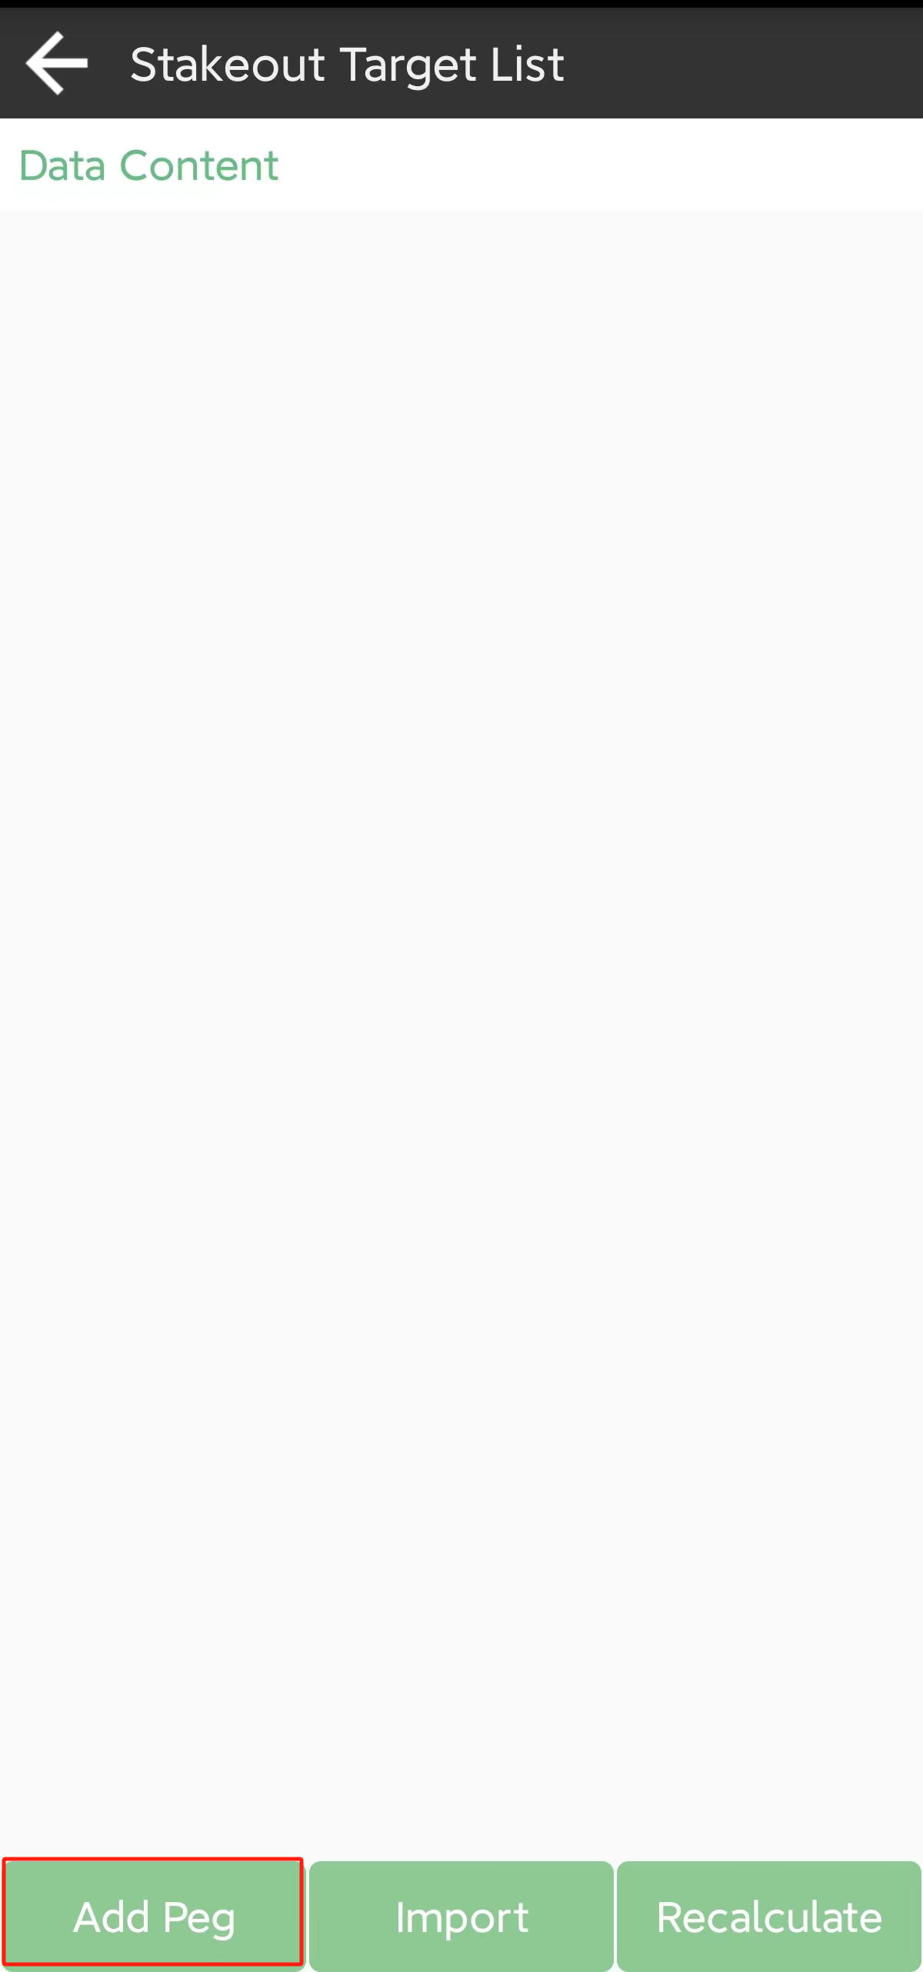

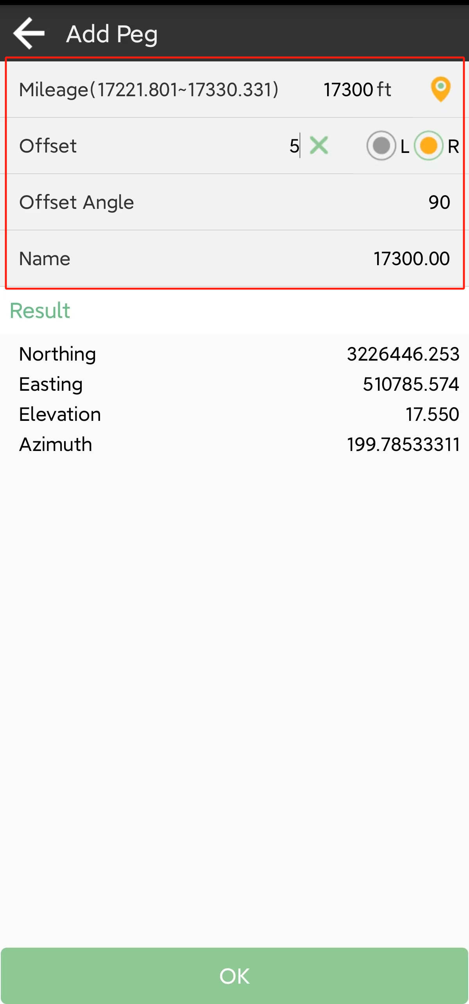

• Add peg: Calculate a point one time, enter the station and offset distance, enter positive distance, the point will be on the life side of the road. Enter negative distance, the point will be on the right side of the road.

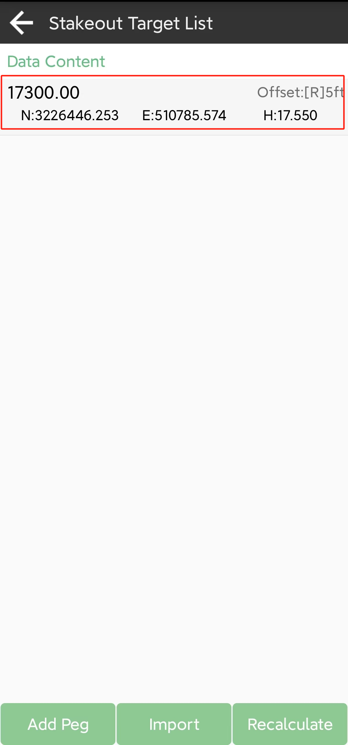 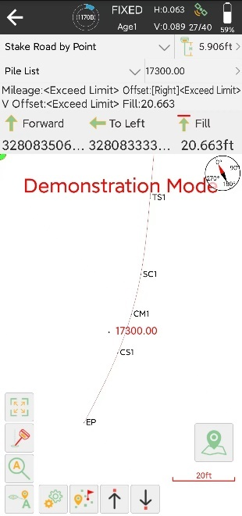

Choose one point and follow the navigation information to stake it out,

• Recalculate: Calculate points with interval and offset distance, it will calculate points at one time according to the set parameters.

### Electric Line Survey

Click【Survey】->【Electric Line Survey】.Function of Electric Line Survey is to stake out electric line meanwhile collect ground data near the electric line such as building, ground elevation, tree etc. Exporting survey result to professional electric software，the software will check the format and quality of the survey data.

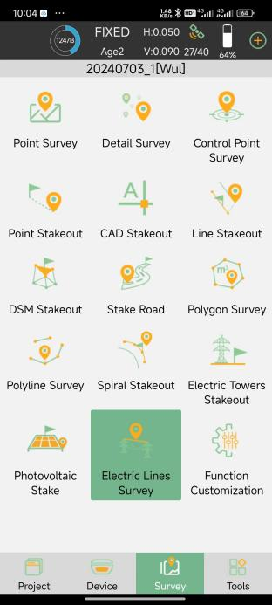 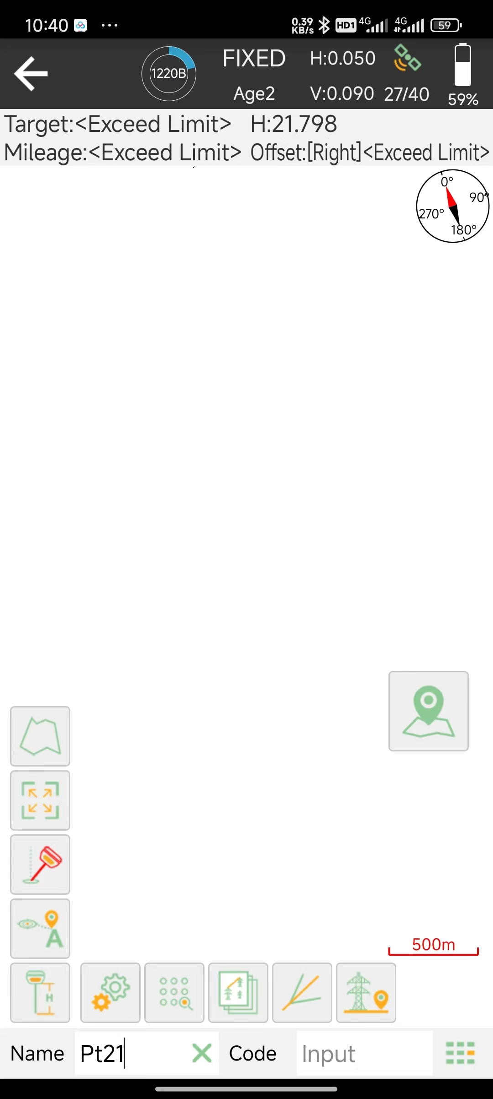

Click，to enter settings，Click【Electric Lines Survey】，You can edit the storage type and stake out Settings for electrical line survey data. Edir Remind Range Setting, and you can see three aux-line on each side to indicate offset distance you near the power line.

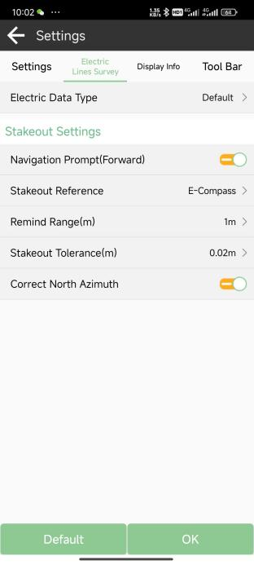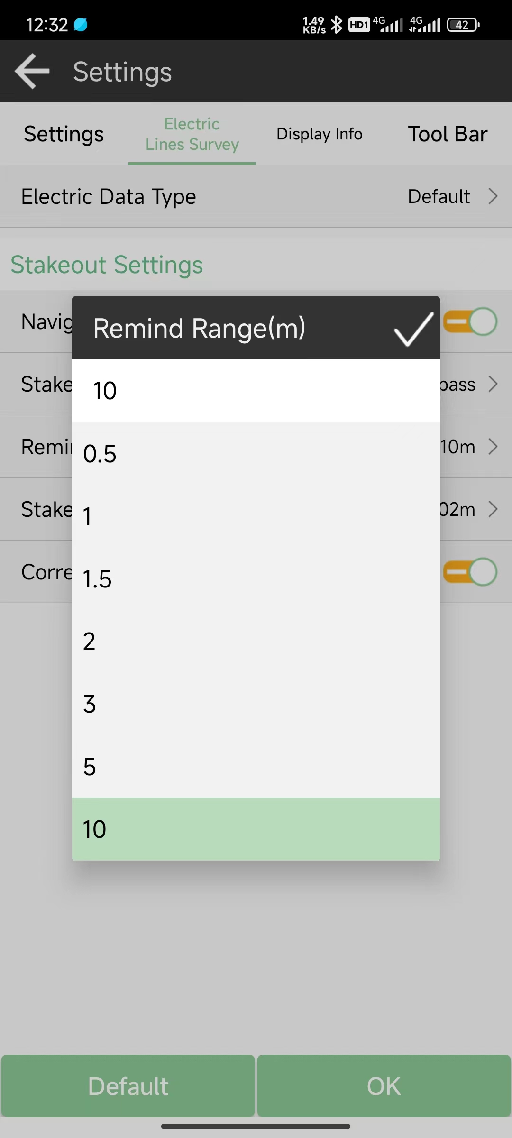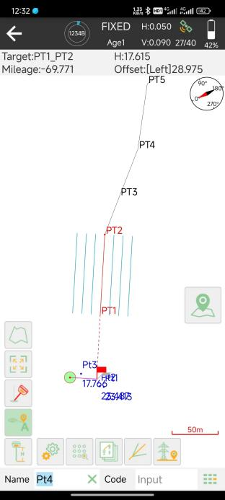

Click【Electronic Data Type】to open electronic data type database, it supports the customization of ground feature data of data types, creating, editing, managing, sharing and application of data types and so on.

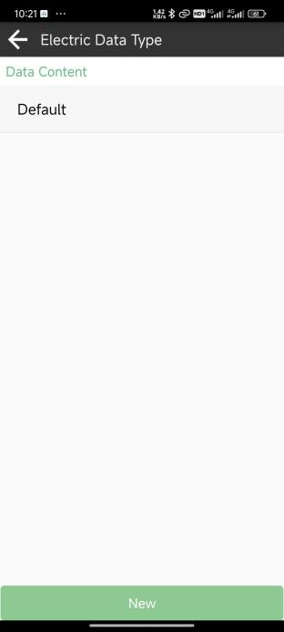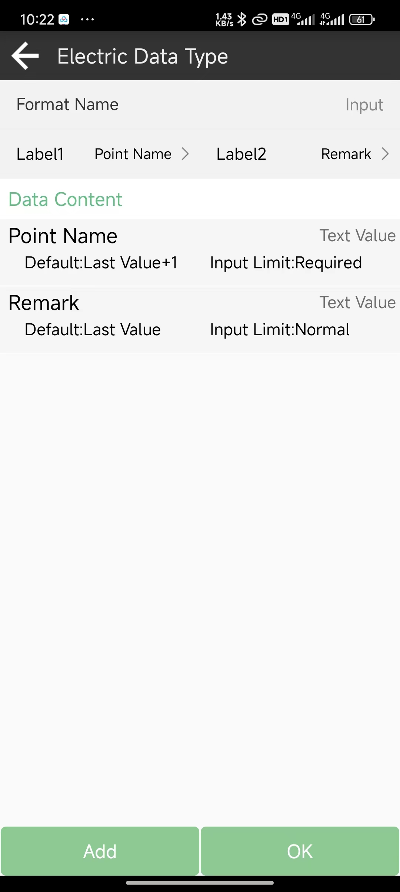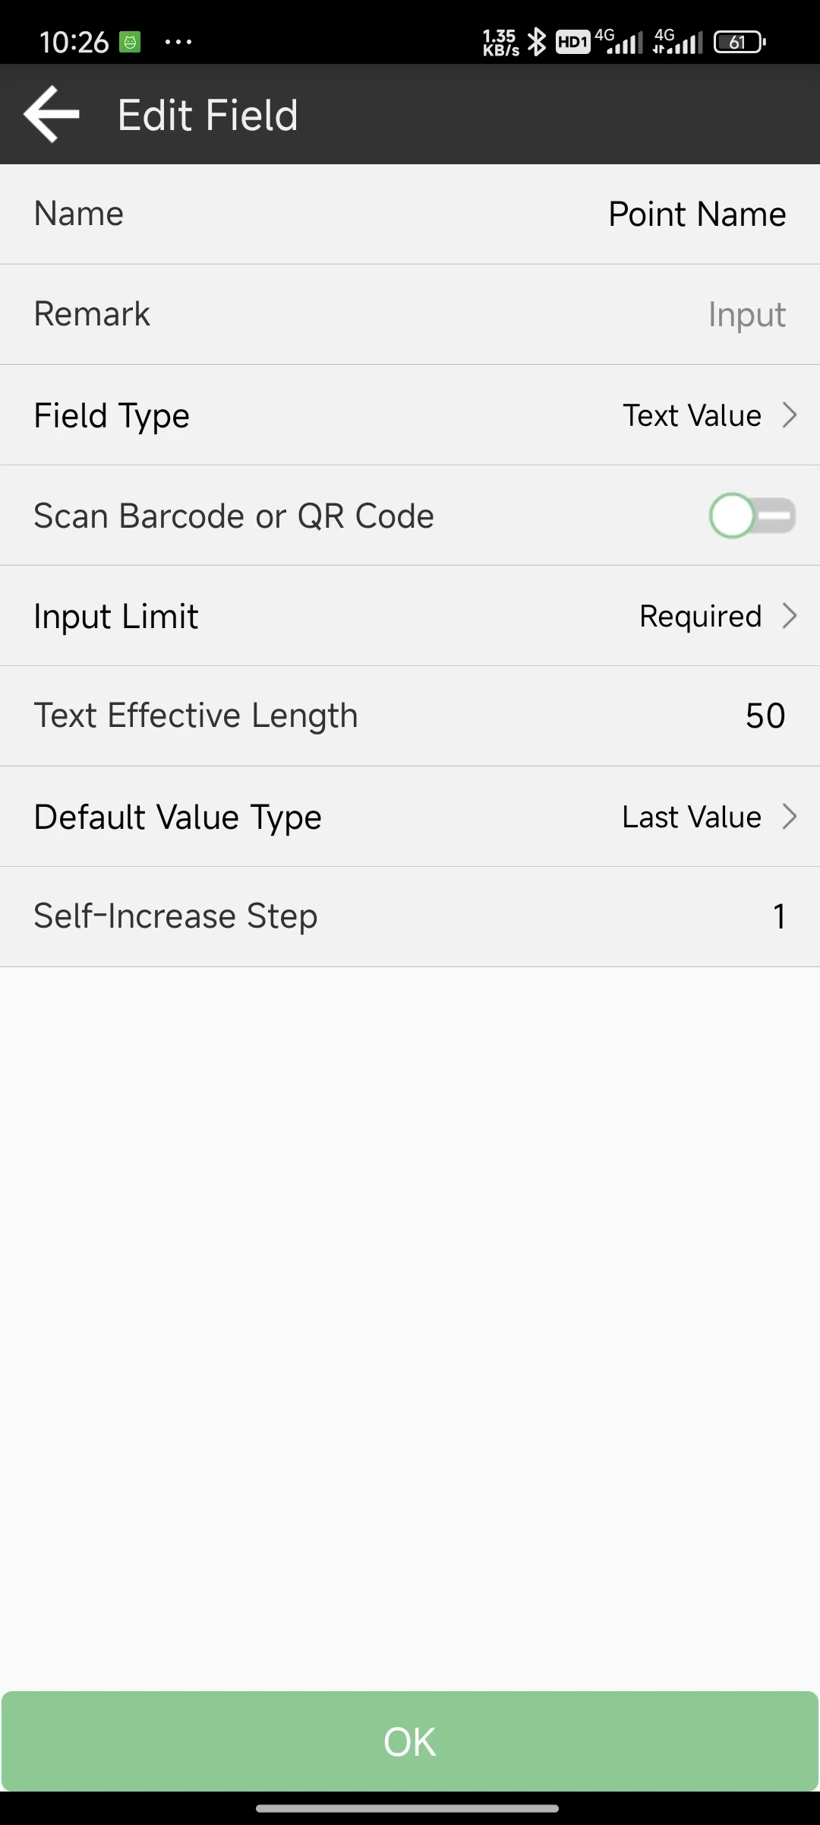

Click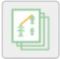，access the power line vault, And click, Enter the power line library management, In this interface, you can create, import, edit, and delete power lines. Click【Add】, input name, start mileage, click【Database】to choose point from database constructing a power line, You can also import a power line from file storage directory.

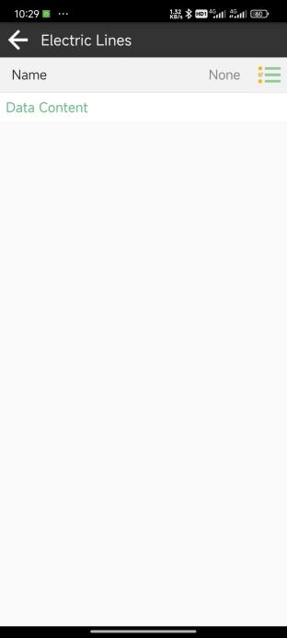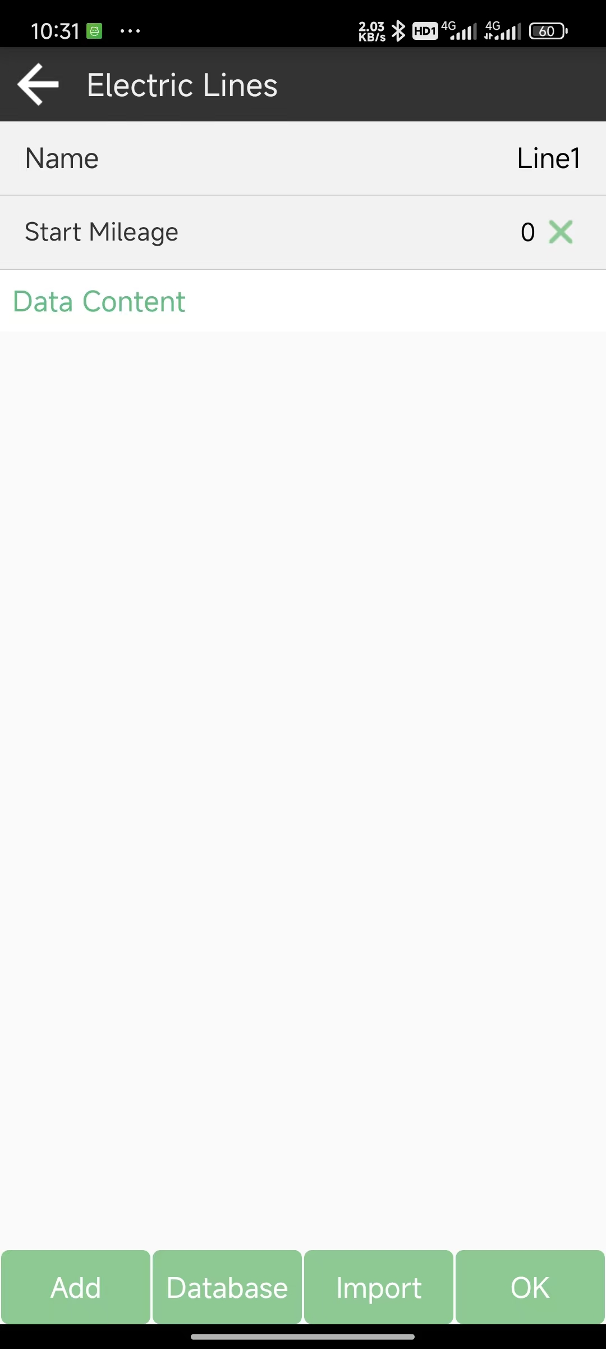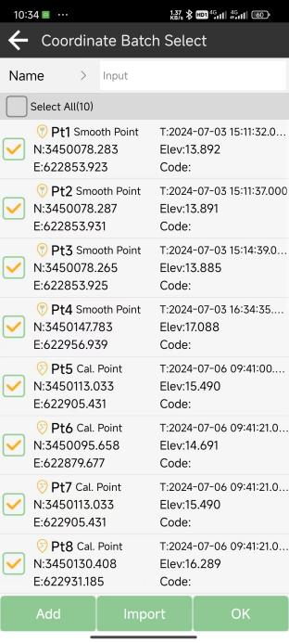

Click，enter the bisector stakeout. Click 【Electric Tower Point】 to choose point section of power line. And you can see the parameters calculated after point is selected. Click 【Stakeout】 on the bottom, you will see an angle constructed by PT1 -PT2-PT3 with PT2 as center point bisected by red line PT2(-50) - PT2(50). Go to position of PT2(-50) and PT2(50), survey point respectively, and the bisector line of angle PT1-PT2-PT3 is surveyed.

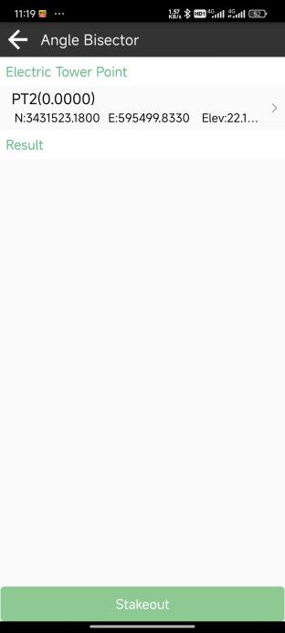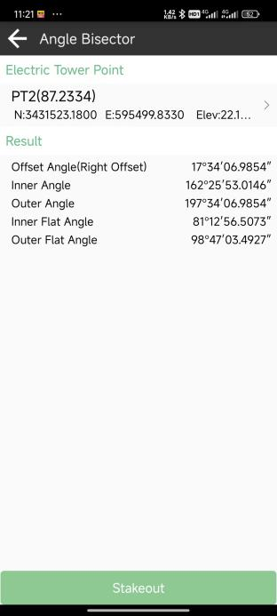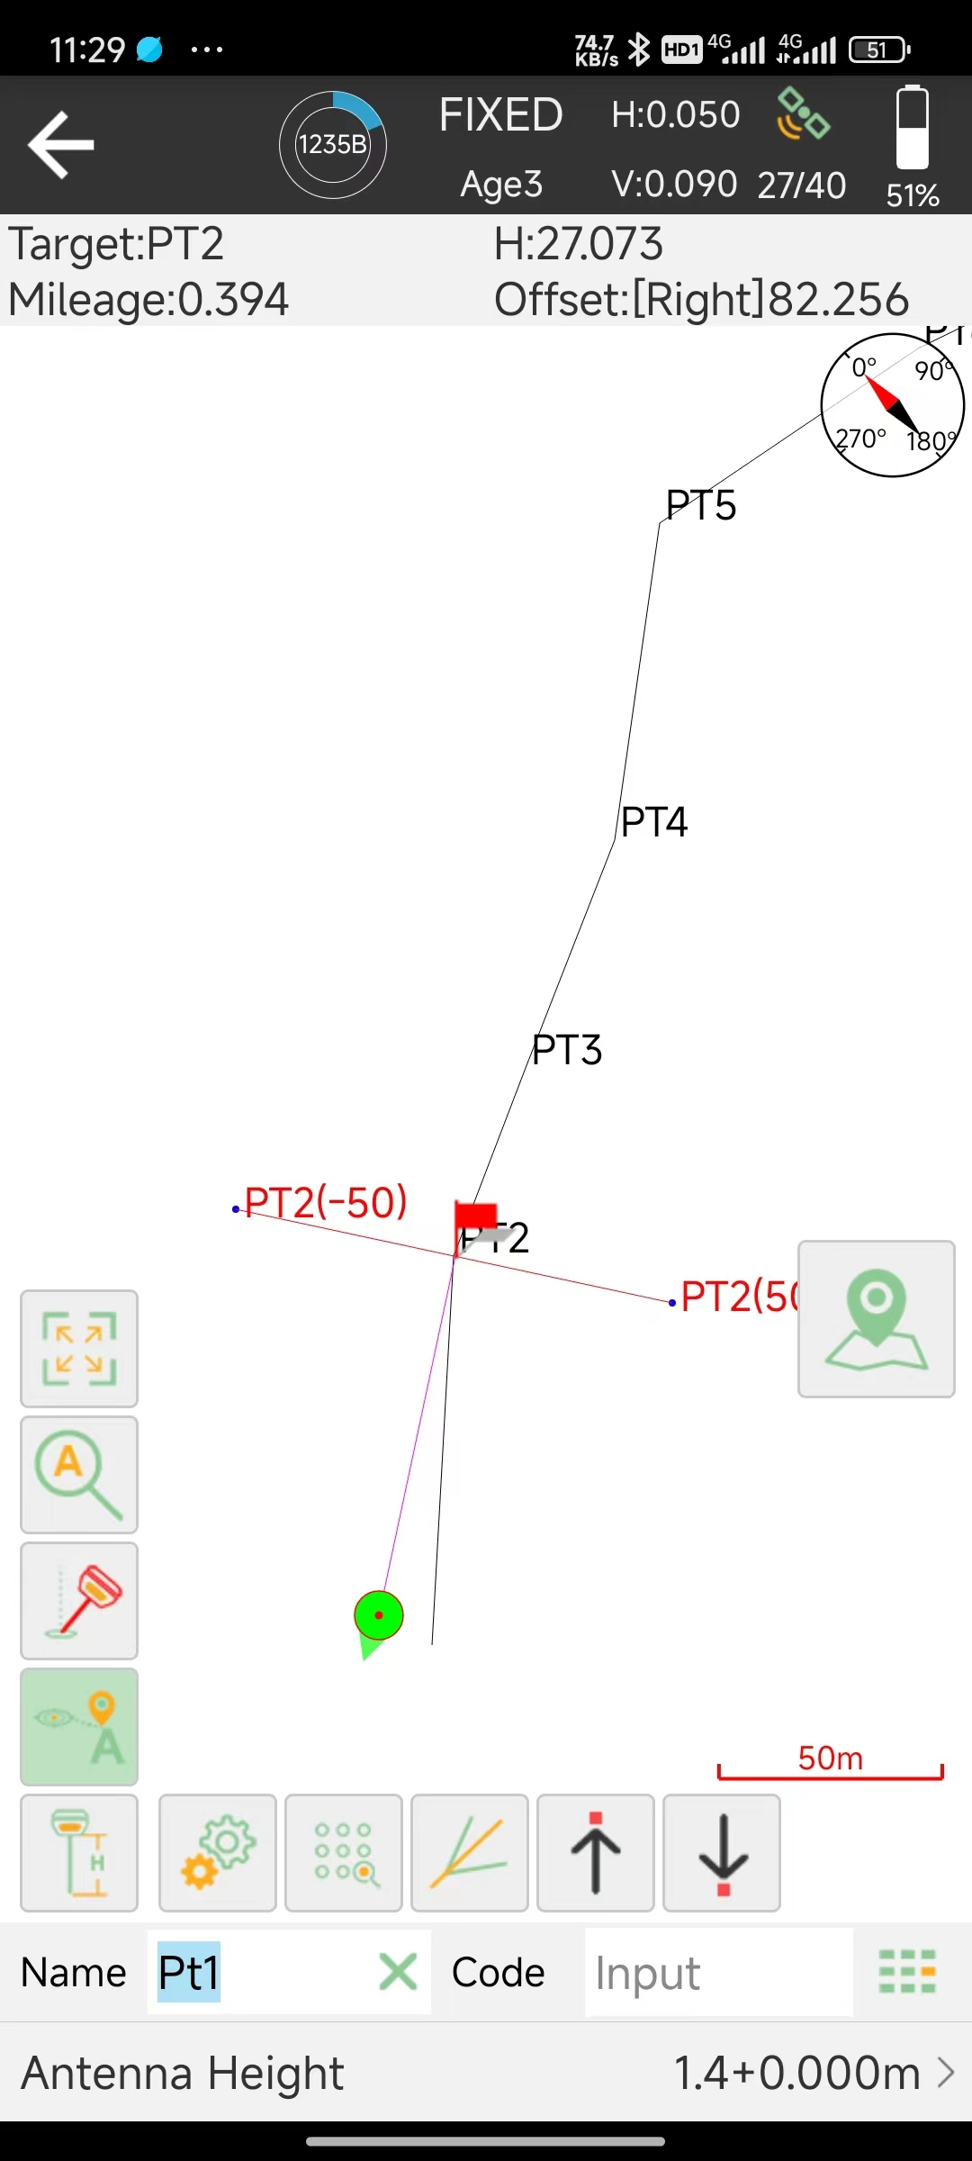

Click or 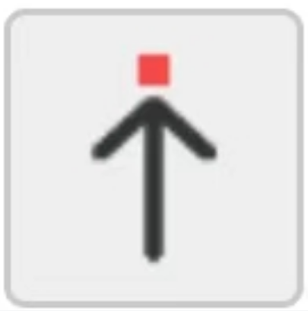 to go to next angle, the bisector shows correspondingly.

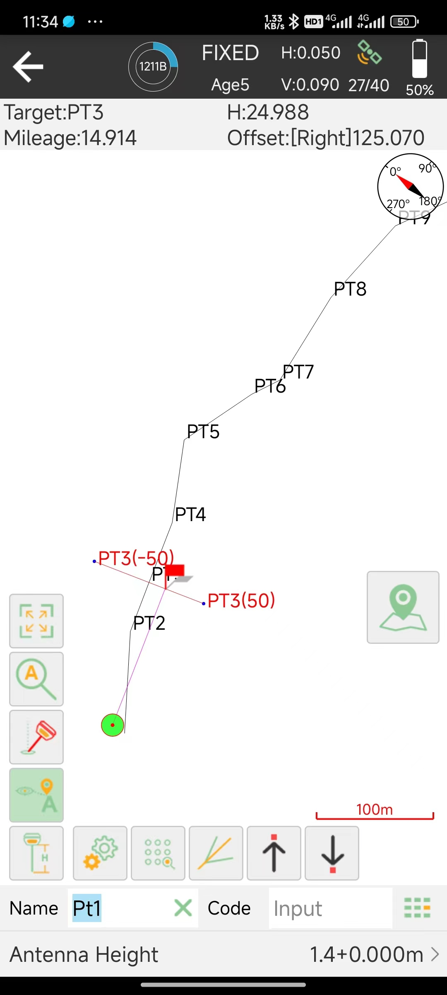

Click ，to stake out Electric Tower.

Click 【Eletric Tower Point】 to choose position where Electric Tower to be stake .

Click【Calculating Parameter】to choose the number of section of Electric Tower, here are two models to be choose,with 4-Cross-Section or 8-Cross-Section.

Two patterns to build Electric Tower Model :

1.Input Lenth(OA) and With(AP) .

2.Click【Calculate】to enter BC and AB and click ok to automatically calculate OA and AP.

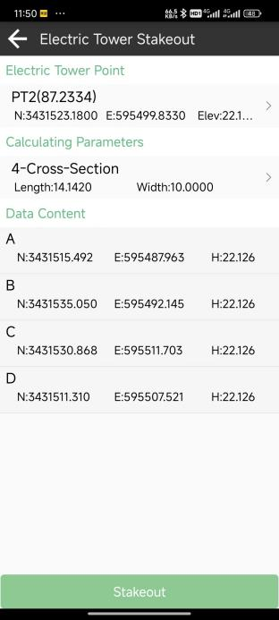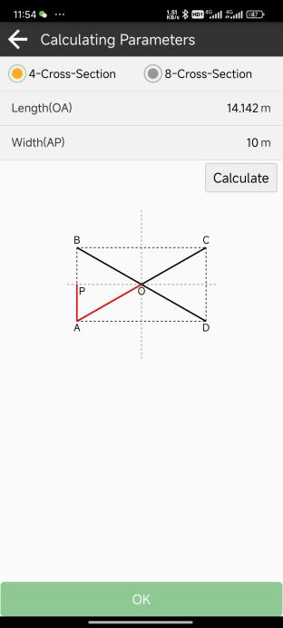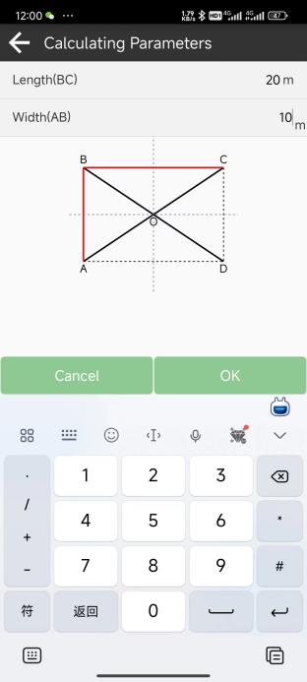

After choose 4-section model and calculating Parameters , Choose Data Content Point A. Click ok. Click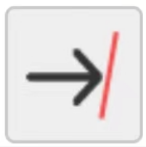or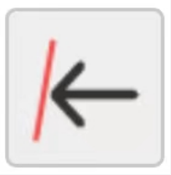 to go to next() or previous (D).

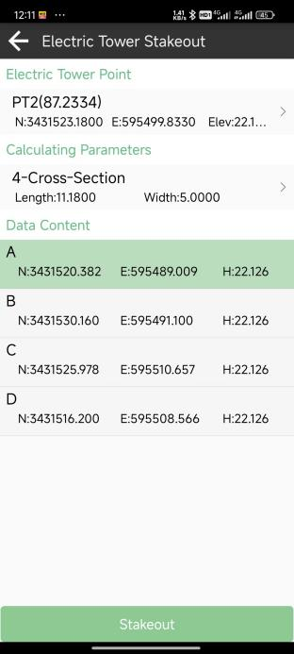 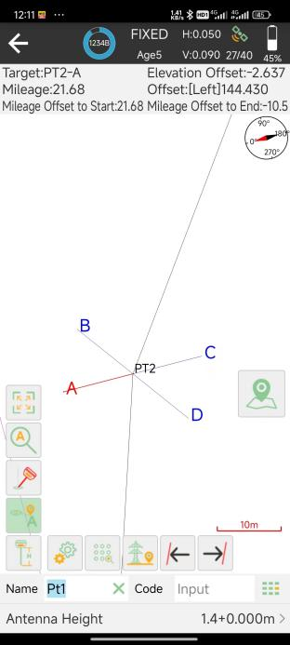

## Points database

The points, which are surveyed, staked, added, imported, and input from display map, will be stored in point database. The surveyed points will be shown under one base while surveying. Also, no matter where you need to select a point, all the points of the database are available.

You can enter database in two means:

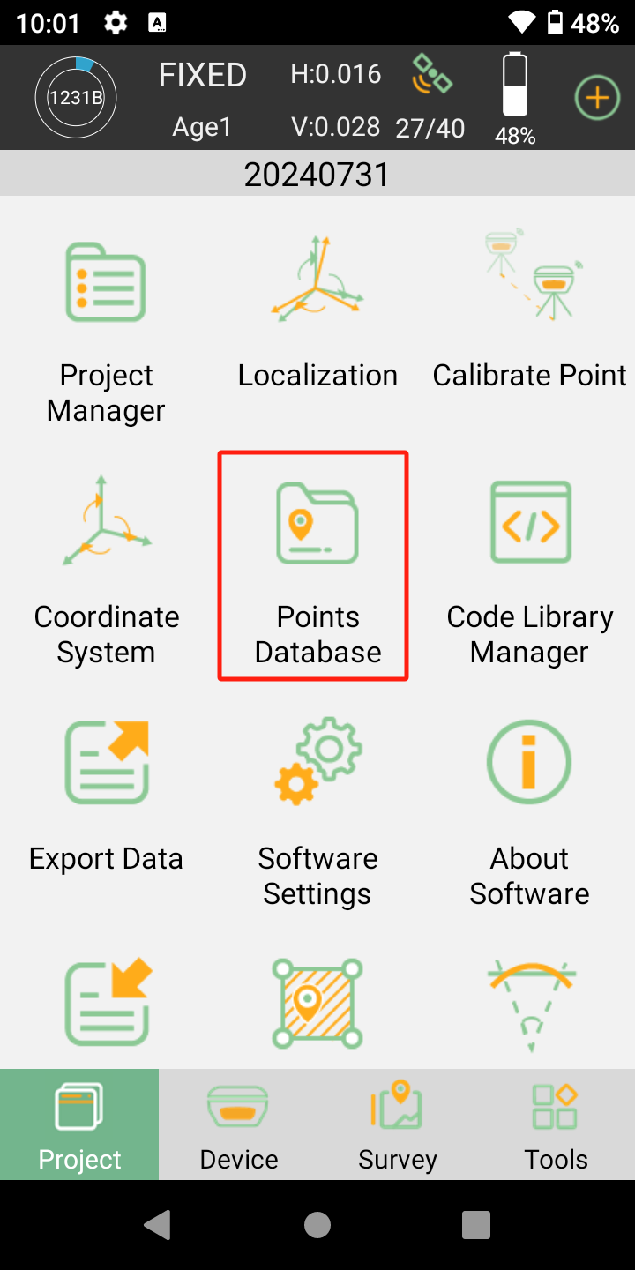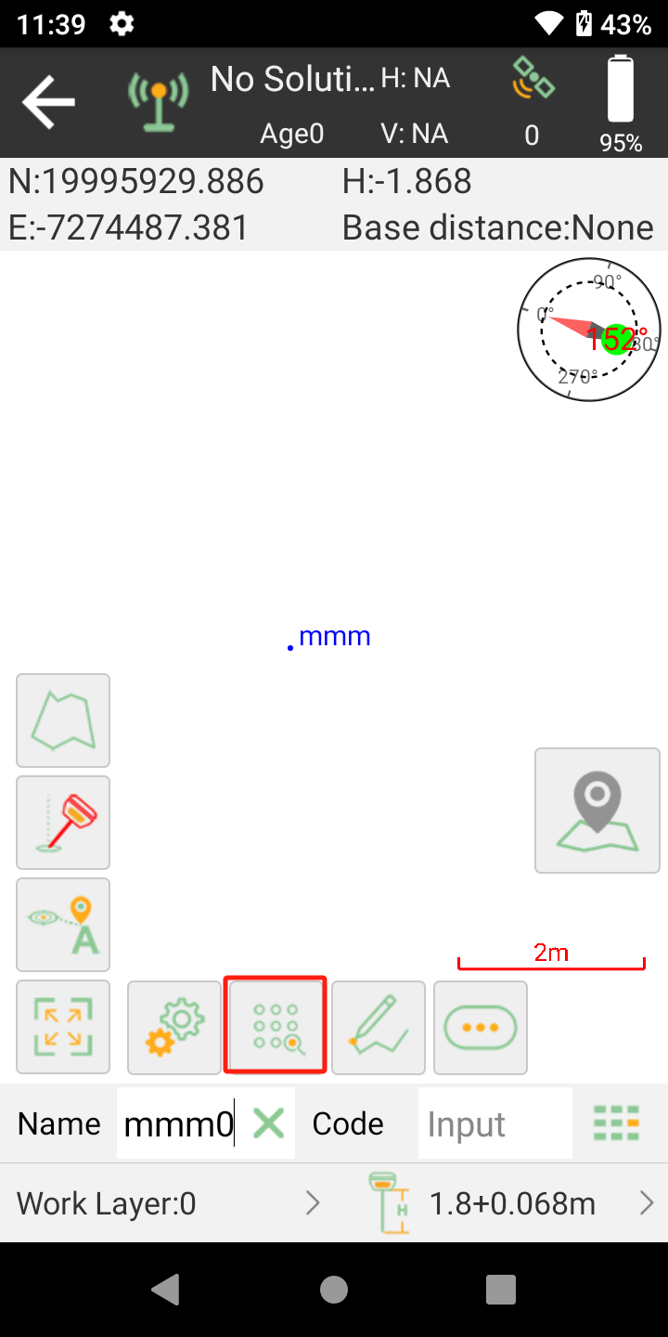

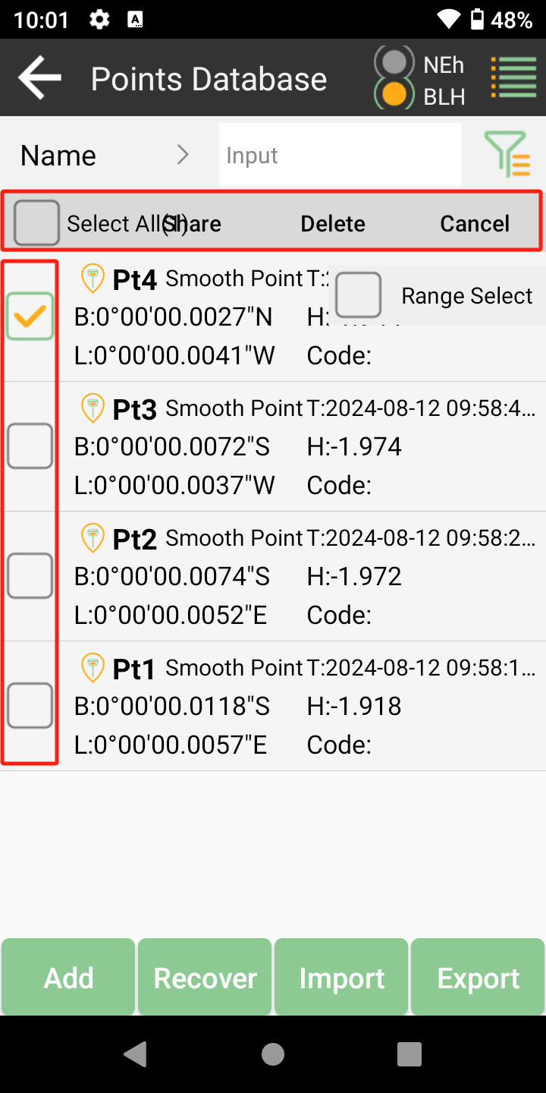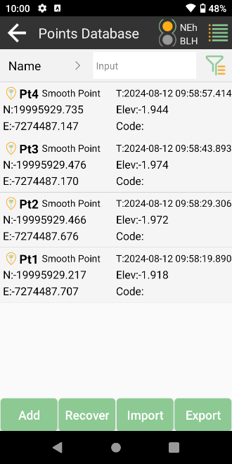

• Add: Supports to add Input Point, and Display type Supports Local coordinate and geodetic coordinate

• Recover: After delete the points, you can recover them in deleted points interface

• Import: Import points by different formats of files

• Export: Export points by different formats of files

• Search: Enter the name of the point you want to inspect and show it out

• Share/Delete: Long press to choose the point you want share or delete

•Click 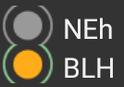, can switch latitude, longitude and height to BLH.

Tap a point to check the information about the base coordinate. The information includes antenna height, solution status, WGS84 Coordinate, local grid coordinate, base id and measure time. if you had calibrated the point, it will display offset parameters.

## Data export/import

SingularPad supports to import/export data including grid coordinate, Lat/Lon coordinate with various data format, support import dat/csv/kml file and export result of DXF/KML/shp/xls/csv.

### Import points data

Tap Import data in project interface, there are some predefined data formats, click More to get more predefined formats.

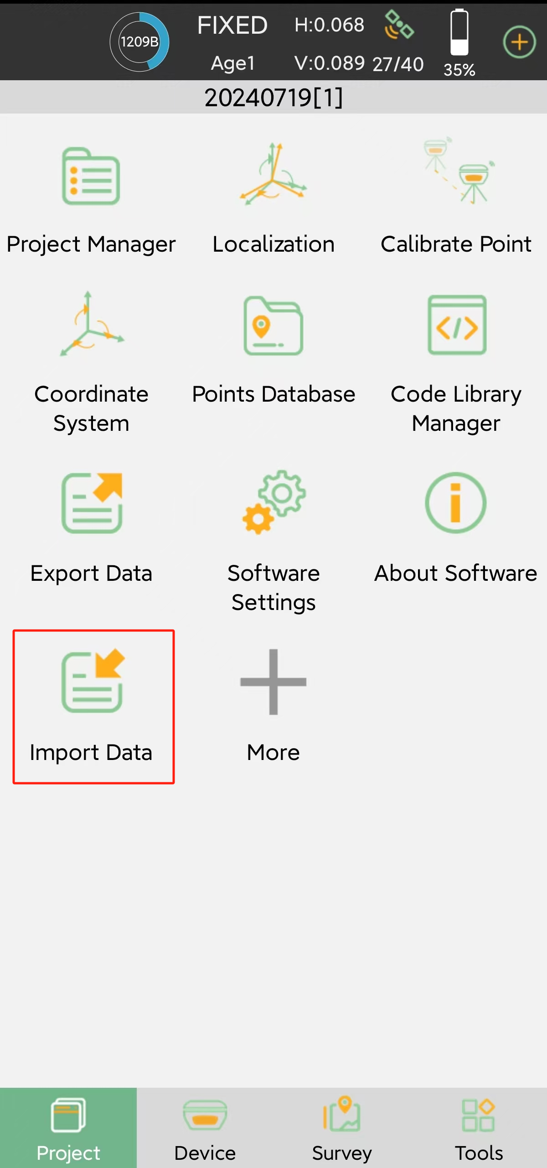

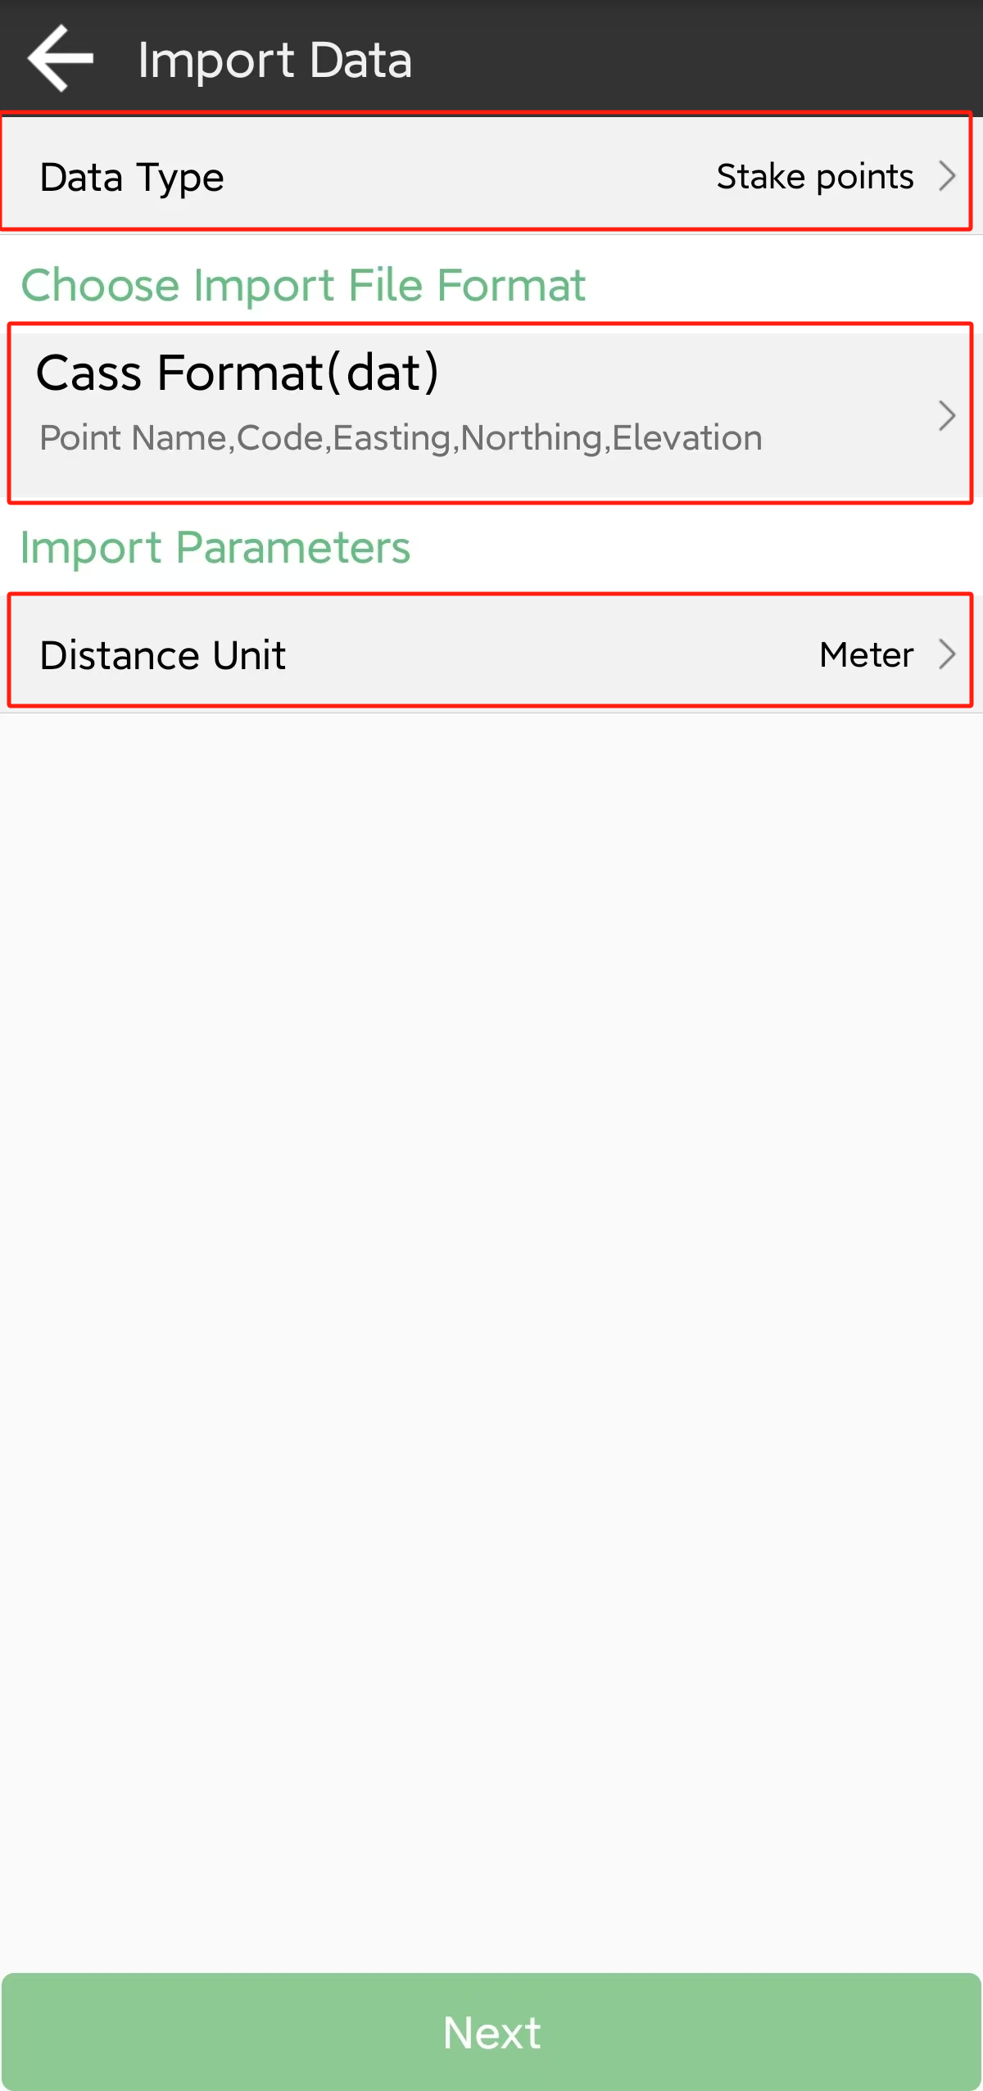 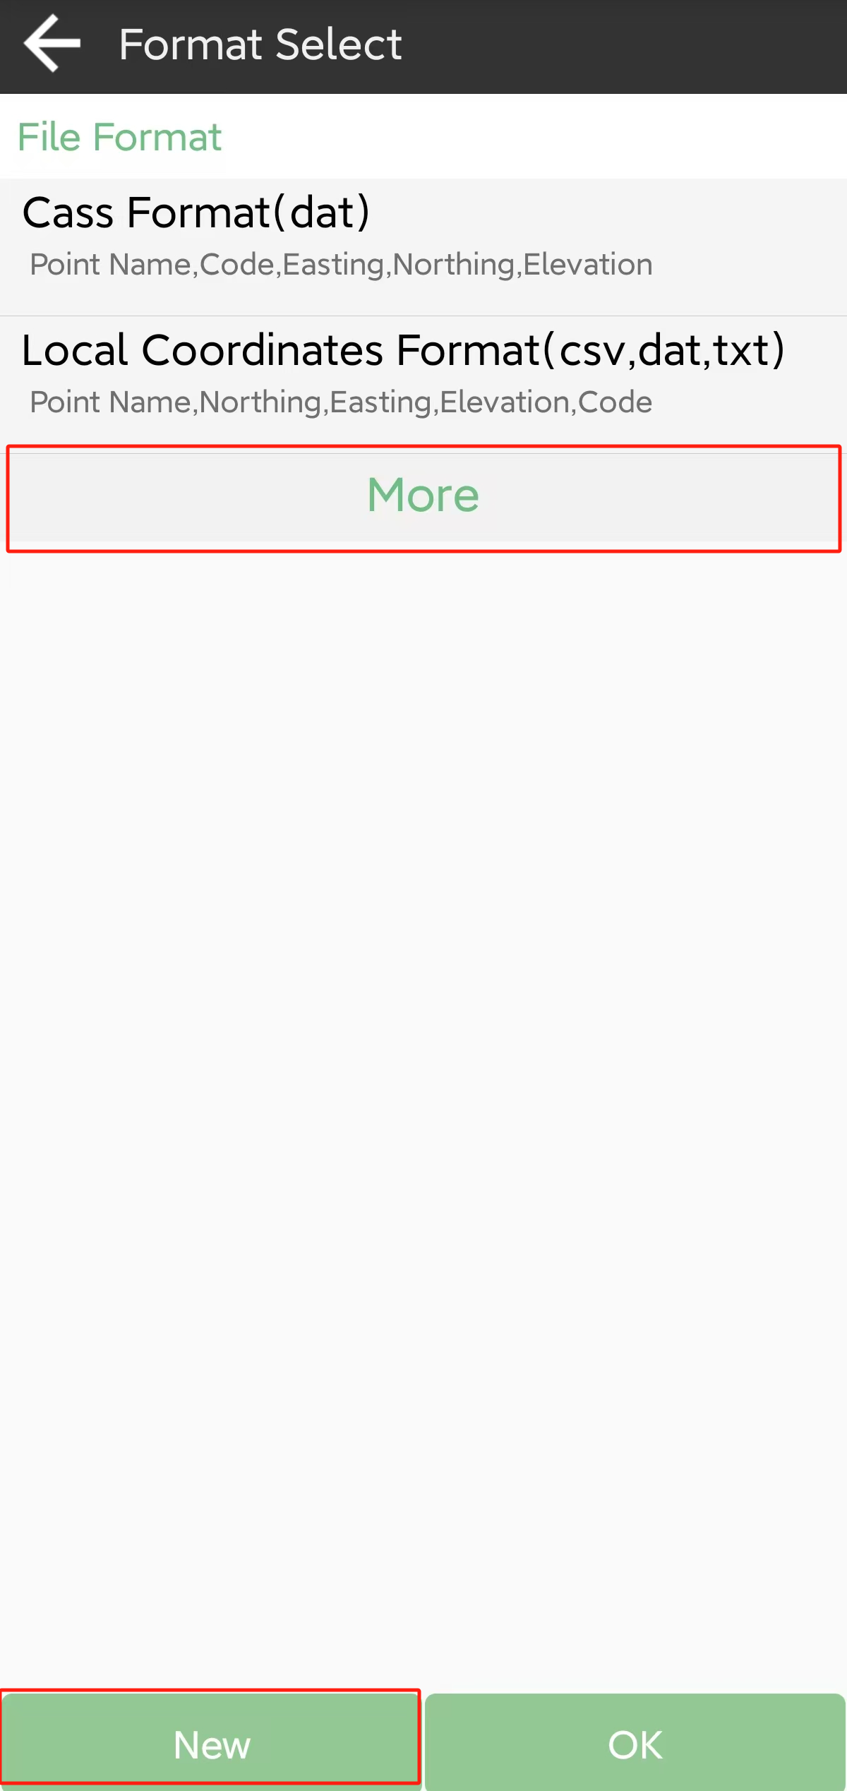

• Data Type: support point database, line data base, transformation parameters file and code library

• Import File Format: support *.csv, *.dat, *.txt, *.kml format etc.

• Distance Unit: support meter,US survey feet and international feet

Besides, you can click new to create a User defined type.

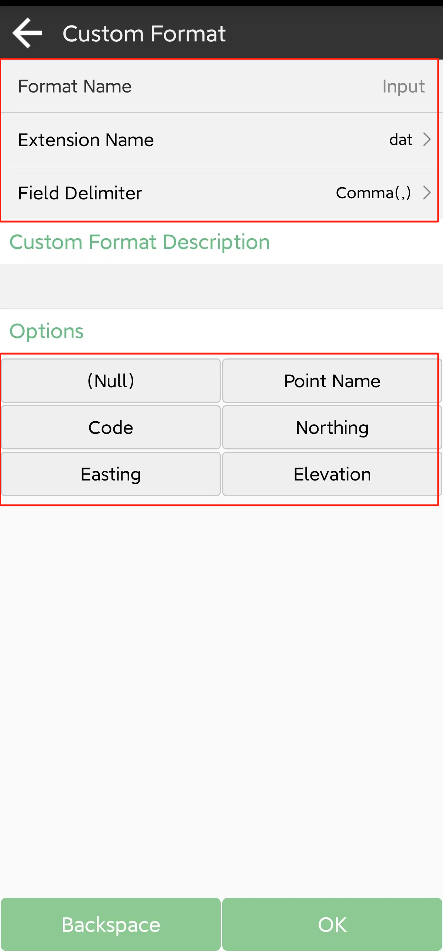

• Format name: Enter the name for the format

• Extension name: support *.csv, *.dat, *.txt, *.xls,*.xlsx format

• Delimiter: support comma (,), semicolon (;), space ( ), tab (Tab)

Click to choose elements in the options list. Click backspace to eliminate the previous element selected. The elements include: code, name, northing, easting, elevation, latitude, longitude, altitude.

Choose one format to import data. The default export path is internal storage/ SingularPad / import. You can also change to any other path where the file is. Click preview to take an inspection whether the format is right.

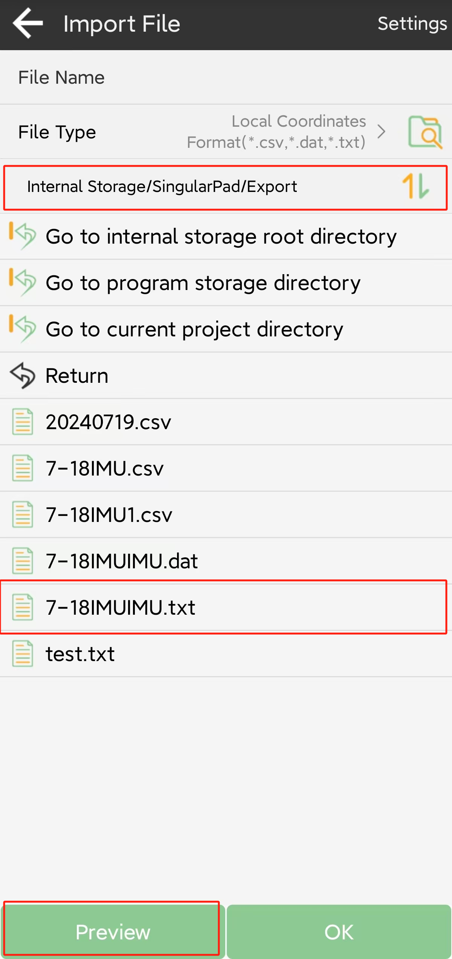 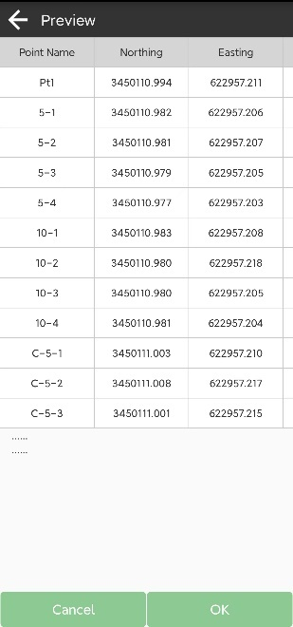

### Export points data

Tap Export in Project interface to export simple data of survey points. Also, click More formats to export the survey points with detailed information or other formats like stake points/lines, DXF, SHP, KML, RAW, RW5, HTML, CASS feature result.

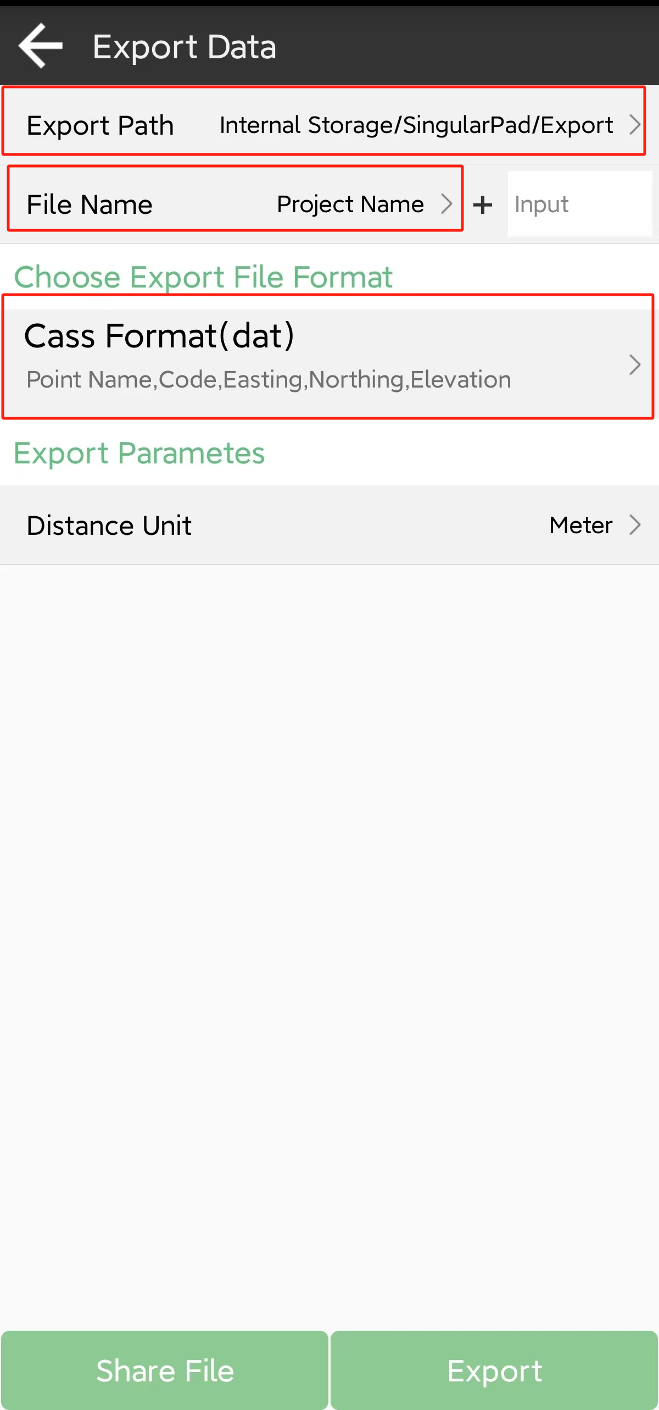 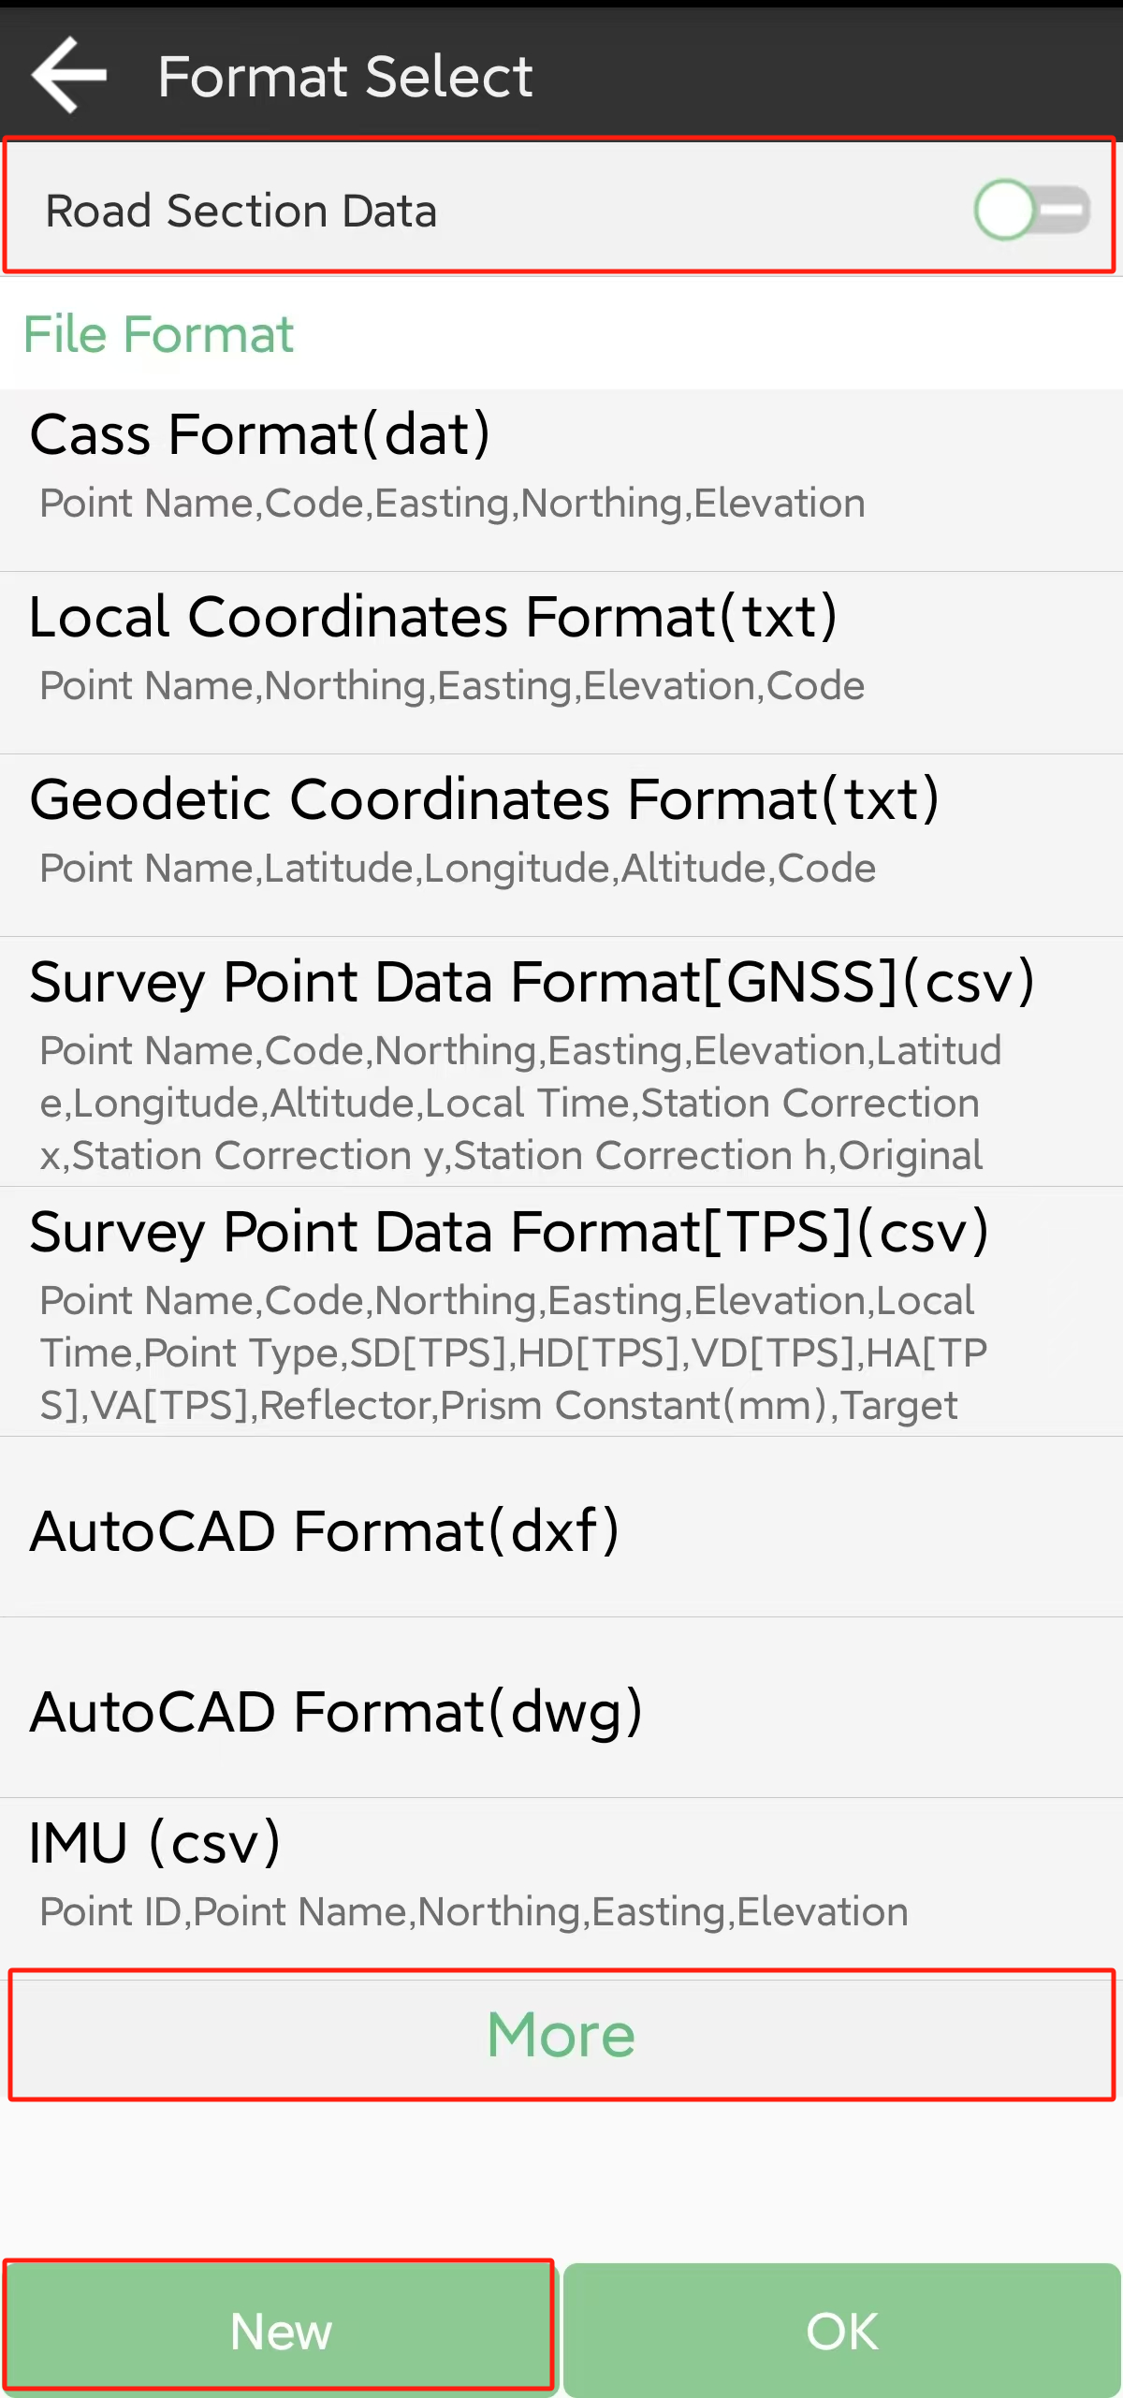

• Export Path: the default export path is internal storage/ SingularPad/export; you can also change to any other path where the file is.

• File Name: support project name, operator, date, data time

• Export File Format: support *.csv, *.dat, *.txt, *.kml format etc.

• Distance Unit: support meter, US survey feet and international feet

• Distance Unit: open to export road section data

Besides, you can click New to create a user defined type. The elements include: id, name, code, latitude, longitude, altitude, northing , easting, elevation, N, E, Z, type, local time, UTC time, solution status, AGE, max delay, min delay, used satellites, tracked satellites, cut-off angle, mount point, measurement method, repeat, start data, end time, RMS, HRMS, VRMS, PDOP, VDOP, speed, heading, antenna type, measuring type, measuring height, antenna height, base id, base latitude, base longitude, base altitude, distance to ref, original latitude, original longitude, original altitude, undulation height, station correction x, station correction y, station correction h, inclination correction, pitch, roll, yaw, inclined angle, projected angle, stakeout type, target, station, offset, north diff, east diff, elevation diff.

For the points, lines and polygons you surveyed in point survey, you can export dxf file, then you can edit them in third party CAD software, or import to basemap to check, or import to CAD to stake. Choose the data that you want to export including survey point, input point, control point, stake point, base, line and polygon, and the layer properties includes name, code and height.

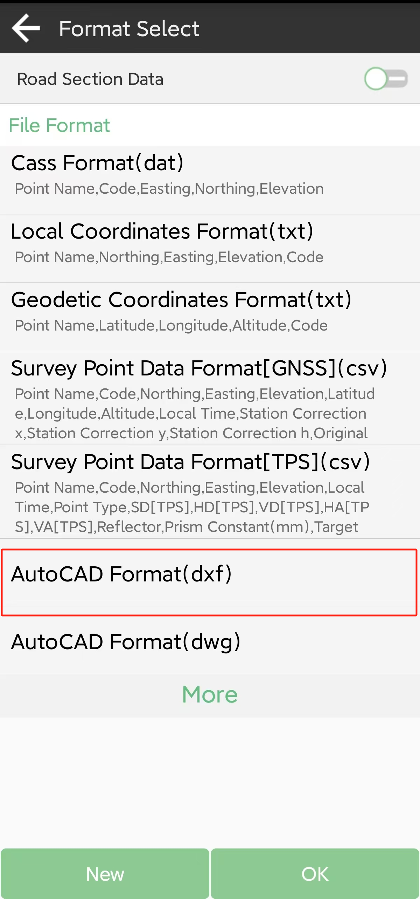

# Total Station

SingularPad also can work with our TS1000 total station, and realize point survey, stakeout, CAD, etc.

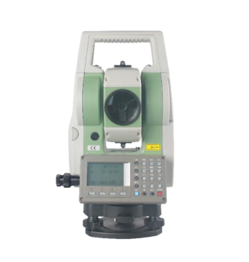

## Connect to total station

Click Connection. You can connect TS1000 total station to SingularPad. Choose device type as total station, and enable Bluetooth of TS1000 and connect.

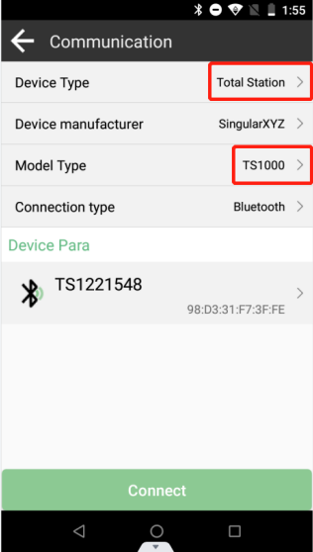 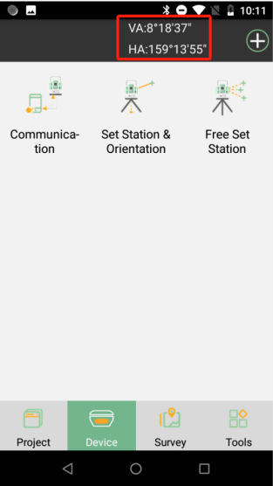

After connecting TS1000, you can see the parameters showing in the window, VA (vertical angle) and HA (horizontal angle).

## Set station

There are two methods you can set the station: Set station & orientation and free set station.

# Frequently asked functions

This chapter will show some frequently used functions, including device Information, localization, calibrate point.

## Device Information

Go device information, click to check hardware version, firmware version, current data link, battery power and any other information of the device after connecting Bluetooth.

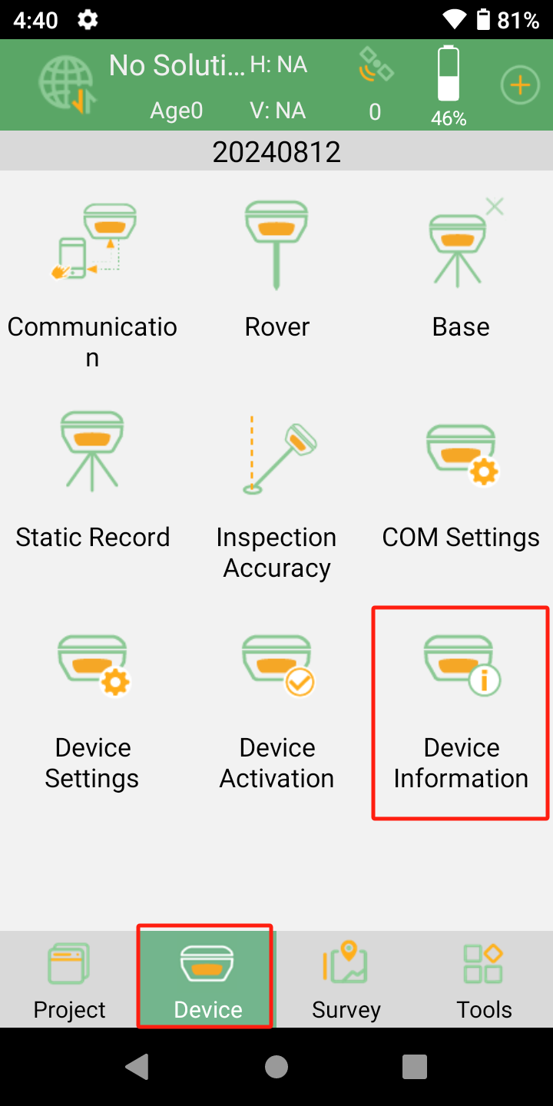

## Device Activation

Active your device, through SingularPAD

1. Enter <Device> interface
2. Click Device Activation
3. Enter your register code or scan QR code

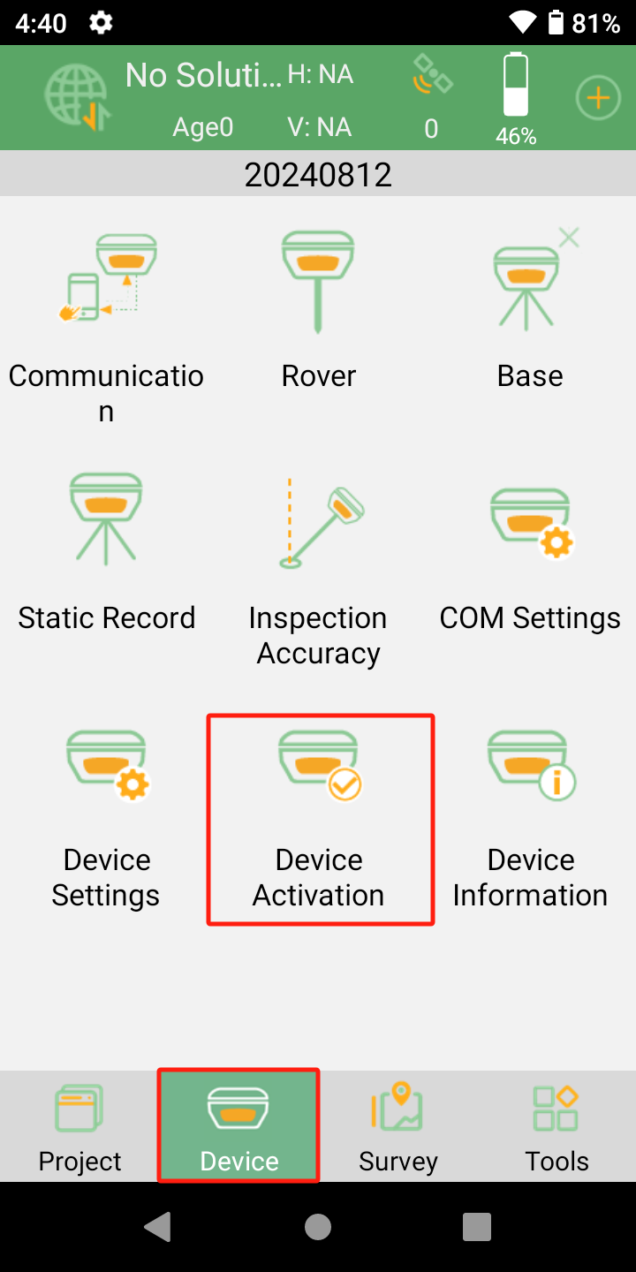 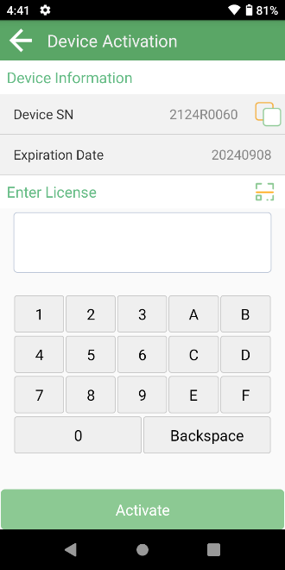

## SingularPAD Activation

SingularPAD software Activation’s steps:

1. Enter <Project> interface
2. Click <About Software> to enter Software information’s interface
3. Click <Software Activation> to register your device.

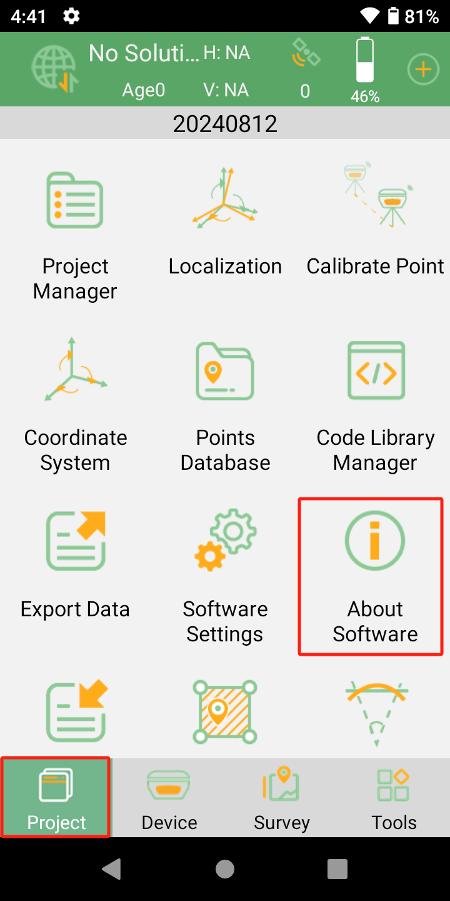 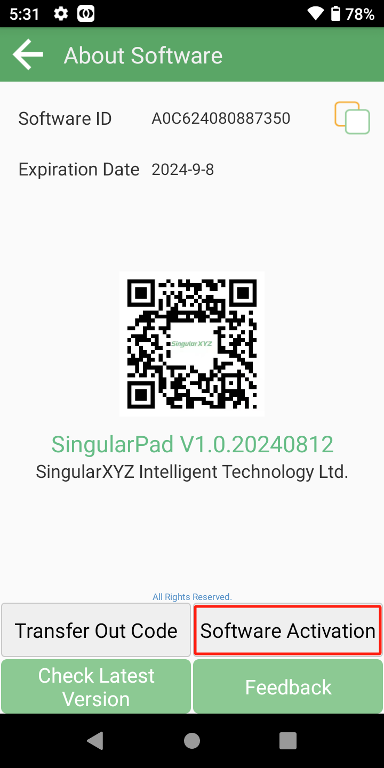

## Location

Location is commonly needed once in one project, and all the points will be collected based on calibrated datum system. Enter at least three groups’ point to compute (for example, take K1, K2, K3 as known points, take A1, A2, A3 as measured points). After click calculate, the software will calibrate automatically.

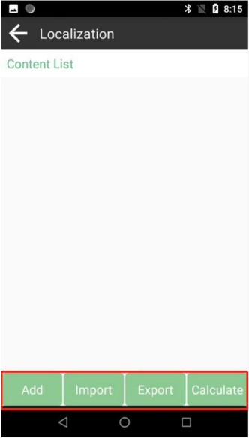 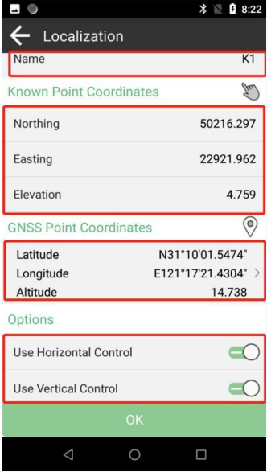

• Add: Enter the coordinates of corresponding known point and GNSS point

• Import/Export: Support *.loc format

• Calculate: Calculate conversion parameters

• Name: Enter name

• Use horizontal/vertical control: Open to calculate the parameters to convert

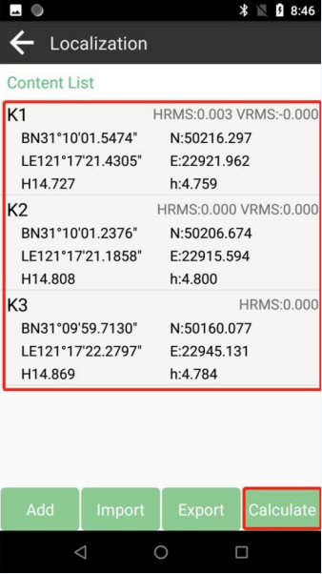 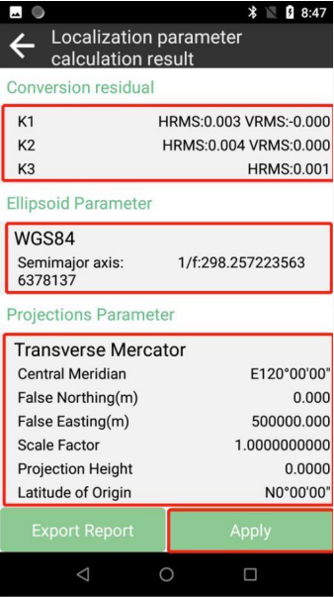

After calculation, you can inspect the details in result interface, including conversion residual ((H. ≤ 0.02, and V ≤ 0.05), ellipsoid parameter, projections parameter, horizontal adjustment and vertical adjustment parameter. Click Apply to confirm to replace datum.

## Calibrate point

Calibrate Point function is applied when you need to change the position of Base station in the same project.

Click Calibrate Point in project interface, add known point coordinate, and measure GNSS point coordinate. The software will calibrate automatically. Apply to complete grid shift, all rover points will upgrade the coordinate.

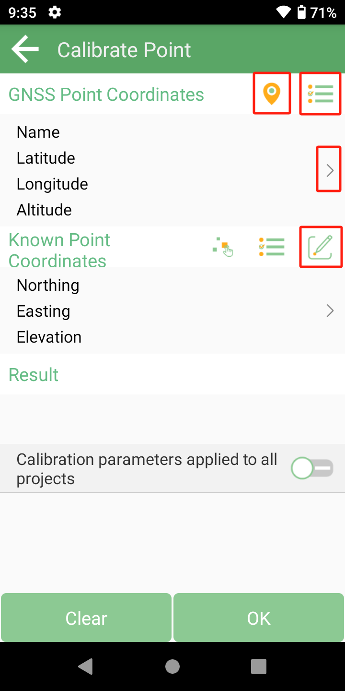 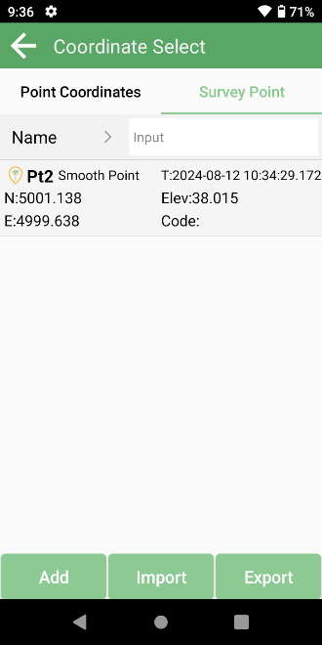

• Click  to choose a point from database map

• Click  to start or stop collecting data

• Click  to choose a point from points database

• Click  to edit the coordinate

• Click <Clear> to delete conversion parameters

## Code library manager

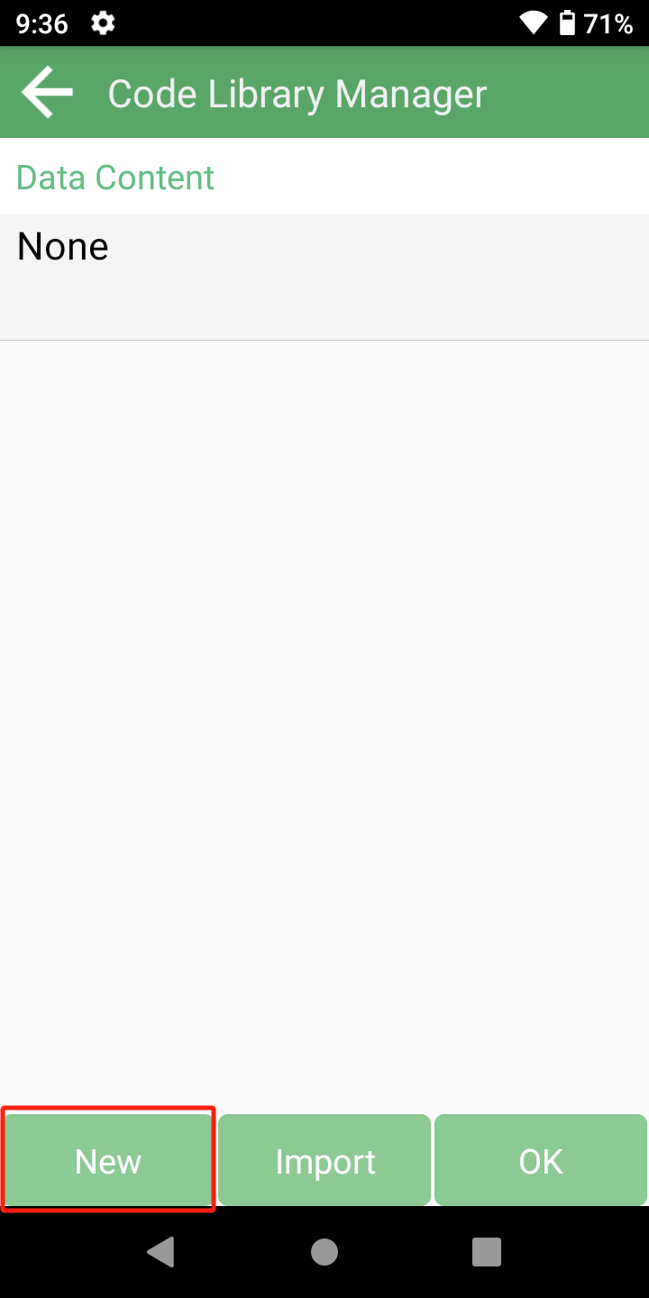 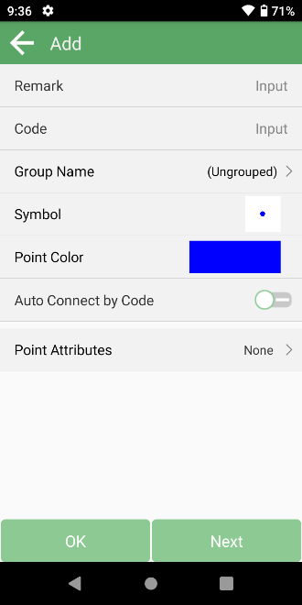 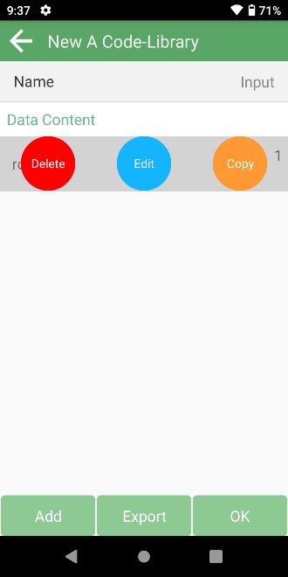

Input group name and code for layers, open auto connect by code, and choose data type and color, supporting line and polyline, you can scan the code you have created in edit interface, don’t forget apply it.

Tips:

1. When you add a code library in the point interface, it will not apply in line or polygon interface.

2. You can enter a new code in the Survey and Stake surface, when you survey the point, the code will be stored in the current code list.

# How to Contact US

If you have any question and cannot find the answer in this manual, please contact us from

SingularXYZ Website: [www.singularxyz.com](http://www.singularxyz.com)

Technical support email: [support@singularxyz.com](mailto:support@singularxyz.com)

Your feedback about this manual will help us improve it with future revisions.